Machine Learning

**Index**

|  |  |  |  |
| --- | --- | --- | --- |
| Sr. No. | Title | Date | Sign |
| 1a | Design a simple machine learning model to train  the training instances and test the same. |  |  |
| 1b | Implement and demonstrate the FIND-S algorithm for finding the most specific hypothesis based on a given set of training data  samples. Read the training data from a .CSV file |  |  |
| 2a | Perform Data Loading, Feature selection (Principal Component analysis) and Feature  Scoring and Ranking. |  |  |
| 2b | For a given set of training data examples stored in a .CSV file, implement and demonstrate the Candidate-Elimination algorithm to output a description of the set of all hypotheses  consistent with the training examples. |  |  |
| 3a | Write a program to implement the naïve Bayesian classifier for a sample training data set stored as a .CSV file. Compute the accuracy of  the classifier, considering few test data sets |  |  |
| 3b | Write a program to implement Decision Tree  and Random forest with Prediction, Test Score and Confusion Matrix. |  |  |
| 4a | For a given set of training data examples stored in a .CSV file implement Least Square Regression  algorithm |  |  |
| 4b | For a given set of training data examples stored in a .CSV file implement Logistic Regression  algorithm. |  |  |
| 5a | Write a program to demonstrate the working of the decision tree based ID3 algorithm. Use an appropriate data set for building the decision tree and apply this knowledge to classify a new  sample. |  |  |
| 5b | Write a program to implement k-Nearest  Neighbour algorithm to classify the iris data set. |  |  |
| 6a | Implement the different Distance methods (Euclidean) with Prediction, Test Score and  Confusion Matrix. |  |  |
| 6b | Implement the classification model using clustering for the following techniques with K means clustering with Prediction, Test Score and  Confusion Matrix. |  |  |

|  |  |  |  |
| --- | --- | --- | --- |
| 7 | Implement the classification model using clustering for the following techniques with hierarchical clustering with Prediction, Test  Score and Confusion Matrix |  |  |
| 8a | Exploratory Data Analysis (EDA) |  |  |
| 8b | Time Series Analysis |  |  |
| 9 | Assuming a set of documents that need to be classified, use the naïve Bayesian Classifier  model to perform this task. |  |  |
| 10 | Perform Text pre-processing, Text clustering,  classification with Prediction, Test Score and Confusion Matrix |  |  |

# Practical 1

## Design a simple machine learning model to train the training instances and test the same.

In [1]:

*# Generating the Training Set*

*# python library to generate random numbers*

**from** random **import** randint

*# the limit within which random numbers are generated*

TRAIN_SET_LIMIT **=** 1000

*# to create exactly 100 data items*

TRAIN_SET_COUNT **=** 100

*# list that contains input and corresponding output*

TRAIN_INPUT **=** list() TRAIN_OUTPUT **=** list()

In [4]:

*# loop to create 100 data items with three columns each*

**for** i **in** range(TRAIN_SET_COUNT):

a **=** randint(0, TRAIN_SET_LIMIT)

b **=** randint(0, TRAIN_SET_LIMIT)

c **=** randint(0, TRAIN_SET_LIMIT)

*# creating the output for each data item*

op **=** a **+** (2 **\*** b) **+** (3 **\*** c)

TRAIN_INPUT**.**append([a, b, c])

*# adding each output to output list*

TRAIN_OUTPUT**.**append(op)

In [6]:

*# printing first 10 records*

TRAIN_OUTPUT[:10]

Out[6]:

In [7]:

*# printing first 10 records*

TRAIN_INPUT[:10]

[1122, 2518, 5291, 3471, 3522, 4008, 4547, 3760, 4414, 1890]

Out[7]:

|  |  |  |
| --- | --- | --- |
| [[306, | 270, | 92], |
| [477, | 233, | 525], |
| [514, | 908, | 987], |
| [576,  [517, | 84, 909],  664, 559], | |
| [652, | 424, | 836], |
| [672, | 559, | 919], |
| [805, | 210, | 845], |
| [221, | 763, | 889], |
| [300, | 666, | 86]] |

The Model can be created in two steps:-

1. Training the model with Training Data
2. Testing the model with Test Data

In [8]:

*# Training the Model*

*# The data that was created using the above code is used to train the model*

*# Sk-Learn contains the linear regression model*

**from** sklearn.linear_model **import** LinearRegression

*# Initialize the linear regression model*

predictor **=** LinearRegression(n_jobs **=-**1)

*# Fill the Model with the Data*

predictor**.**fit(X **=** TRAIN_INPUT, y **=** TRAIN_OUTPUT)

Out[8]:

In [9]:

LinearRegression(n_jobs=-1)

Testing the Data

The testing is done Manually. Testing can be done using some random data and testing if the model gives the correct result for the input data.

Outcome : [140.]

*# Random Test data*

X_TEST **=** [[ 10, 20, 30 ]] *#---> 10 + 20*2 + 30*3 = 140.*

*# Predict the result of X_TEST which holds testing data*

outcome **=** predictor**.**predict(X **=** X_TEST)

*# Predict the coefficients*

coefficients **=** predictor**.**coef_

*# Print the result obtained for the test data*

print('Outcome : {}\nCoefficients : {}'**.**format(outcome, coefficients))

Coefficients : [1. 2. 3.]

In [ ]:

## Implement and demonstrate the FIND-S algorithm for finding the most specific hypothesis based on a given set of training data samples. Read the training data from a .CSV file.

In [2]:

**import** random

**import** csv

attributes **=** [['Sunny','Rainy'],

['Warm','Cold'],

['Normal','High'],

['Strong','Weak'],

['Warm','Cool'],

['Same','Change']]

num_attributes **=** len(attributes)

In [3]:

print (" \n The most general hypothesis : ['?','?','?','?','?','?']\n")

print ("\n The most specific hypothesis : ['0','0','0','0','0','0']\n")

The most general hypothesis : ['?','?','?','?','?','?']

The most specific hypothesis : ['0','0','0','0','0','0']

In [4]:

a **=** []

print("\n The Given Training Data Set \n")

**with** open('/content/data.csv', 'r') **as** csvFile: reader **=** csv**.**reader(csvFile)

**for** row **in** reader: a**.**append (row) print(row)

The Given Training Data Set

['Sunny', 'Warm', 'Normal', 'Strong', 'Warm', 'Same', 'Yes']

['Sunny', 'Warm', 'High', 'Strong', 'Warm', 'Same', 'Yes']

['Rainy', 'Cold', 'High', 'Strong', 'Warm', 'Change', 'No']

['Sunny', 'Warm', 'High', 'Strong', 'Cool', 'Change', 'Yes']

In [5]:

print("\n The initial value of hypothesis: ") hypothesis **=** ['0'] **\*** num_attributes

print(hypothesis)

*# Comparing with First Training Example*

**for** j **in** range(0,num_attributes): hypothesis[j] **=** a[0][j];

*# Comparing with Remaining Training Examples of Given Data Set*

print("\n Find S: Finding a Maximally Specific Hypothesis\n")

**for** i **in** range(0,len(a)):

**if** a[i][num_attributes]**==**'Yes':

**for** j **in** range(0,num_attributes):

**if** a[i][j]**!=**hypothesis[j]: hypothesis[j]**=**'?'

**else** :

hypothesis[j]**=** a[i][j]

print(" For Training Example No :{0} the hypothesis is "**.**format(i),hypothesis)

print("\n The Maximally Specific Hypothesis for a given Training Examples :\n") print(hypothesis)

The initial value of hypothesis:

['0', '0', '0', '0', '0', '0']

Find S: Finding a Maximally Specific Hypothesis

For Training Example No :0 the hypothesis is ['Sunny', 'Warm', 'Normal', 'Stron g', 'Warm', 'Same']

For Training Example No :1 the hypothesis is ['Sunny', 'Warm', '?', 'Strong', 'W arm', 'Same']

For Training Example No :2 the hypothesis is ['Sunny', 'Warm', '?', 'Strong', 'W

arm', 'Same']

For Training Example No :3 the hypothesis is ['Sunny', 'Warm', '?', 'Strong', '?', '?']

The Maximally Specific Hypothesis for a given Training Examples : ['Sunny', 'Warm', '?', 'Strong', '?', '?']

In [ ]:

# Practical 2

## Perform Data Loading, Feature selection (Principal Component analysis) and Feature Scoring and Ranking.

Principal component analysis, or PCA, is a statistical technique to convert high dimensional data to low dimensional data by selecting the most important features that capture

maximum information about the dataset. The features are selected on the basis of variance

that they cause in the output. The feature that causes highest variance is the first principal component. The feature that is responsible for second highest variance is considered the second principal component, and so on. It is important to mention that principal

components do not have any correlation with each other.

In [22]:

**import** numpy **as** np

**import** pandas **as** pd

In [23]:

url **=** "https://archive.ics.uci.edu/ml/machine-learning-databases/iris/iris.data" names **=** ['sepal-length', 'sepal-width', 'petal-length', 'petal-width', 'Class'] dataset **=** pd**.**read_csv(url, names**=**names)

In [24]:

dataset**.**head()

|  |  |  |  |  |  |
| --- | --- | --- | --- | --- | --- |
| Out[24]: | **sepal-length** | **sepal-width** | **petal-length** | **petal-width** | **Class** |
|  | **0** 5.1 | 3.5 | 1.4 | 0.2 | Iris-setosa |
|  | **1** 4.9 | 3.0 | 1.4 | 0.2 | Iris-setosa |
|  | **2** 4.7 | 3.2 | 1.3 | 0.2 | Iris-setosa |
|  | **3** 4.6 | 3.1 | 1.5 | 0.2 | Iris-setosa |
|  | **4** 5.0 | 3.6 | 1.4 | 0.2 | Iris-setosa |

Preprocessing

The first preprocessing step is to divide the dataset into a feature set and corresponding labels. The following script performs this task:

In [25]:

X **=** dataset**.**drop('Class', 1) y **=** dataset['Class']

<ipython-input-25-a134714d2c8b>:1: FutureWarning: In a future version of pandas al l arguments of DataFrame.drop except for the argument 'labels' will be keyword-onl y

X = dataset.drop('Class', 1)

In [26]:

y

Out[26]:

In [27]:

*# Splitting the dataset into the Training set and Test set*

**from** sklearn.model_selection **import** train_test_split

X_train, X_test, y_train, y_test **=** train_test_split(X, y, test_size**=**0.2, random_st

1. Iris-setosa
2. Iris-setosa
3. Iris-setosa
4. Iris-setosa
5. Iris-setosa

...

1. Iris-virginica
2. Iris-virginica
3. Iris-virginica
4. Iris-virginica
5. Iris-virginica

Name: Class, Length: 150, dtype: object

The script above stores the feature sets into the X variable and the series of corresponding labels in to the y variable.

The next preprocessing step is to divide data into training and test sets. Execute the following script to do so:

PCA performs best with a normalized feature set. We will perform standard scalar normalization to normalize our feature set. To do this, execute the following code:

In [28]:

**from** sklearn.preprocessing **import** StandardScaler

sc **=** StandardScaler()

X_train_s **=** sc**.**fit_transform(X_train) X_test_s **=** sc**.**transform(X_test)

Applying PCA

It is only a matter of three lines of code to perform PCA using Python's Scikit-Learn library. The PCA class is used for this purpose. PCA depends only upon the feature set and not the label data. Therefore, PCA can be considered as an unsupervised machine learning

technique.

Performing PCA using Scikit-Learn is a two-step process:

Initialize the PCA class by passing the number of components to the constructor. Call the fit and then transform methods by passing the feature set to these methods. The transform

method returns the specified number of principal components.

In [29]:

**from** sklearn.decomposition **import** PCA

pca **=** PCA()

X_train **=** pca**.**fit_transform(X_train_s) X_test **=** pca**.**transform(X_test_s)

In the code above, we create a PCA object named pca.

We did not specify the number of components in the constructor. Hence, all four of the features in the feature set will be returned for both the training and test sets.

The PCA class contains explained_variance*ratio* which returns the variance caused by each of the principal components.

Execute the following line of code to find the "explained variance ratio".

In [30]:

explained_variance **=** pca**.**explained_variance_ratio_

In [31]:

Out[31]:

In [32]:

**from** sklearn.decomposition **import** PCA

pca **=** PCA(n_components**=**1)

X_train **=** pca**.**fit_transform(X_train) X_test **=** pca**.**transform(X_test)

array([0.72226528, 0.23974795, 0.03338117, 0.0046056 ])

explained_variance

It can be seen that first principal component is responsible for 72.22% variance. Similarly, the second principal component causes 23.9% variance in the dataset.

Collectively we can say that (72.22 + 23.9) 96.21% percent of the classification information contained in the feature set is captured by the first two principal components.

Let's first try to use 1 principal component to train our algorithm. To do so, execute the following code:

Training and Making Predictions

In this case we'll use random forest classification for making the predictions.

In [33]:

**from** sklearn.ensemble **import** RandomForestClassifier

classifier **=** RandomForestClassifier(max_depth**=**2, random_state**=**0) classifier**.**fit(X_train, y_train)

*# Predicting the Test set results*

y_pred **=** classifier**.**predict(X_test)

In [34]:

*#Performance Evaluation*

**from** sklearn.metrics **import** confusion_matrix

**from** sklearn.metrics **import** accuracy_score

cm **=** confusion_matrix(y_test, y_pred) print(cm)

print()

print('Accuracy', accuracy_score(y_test, y_pred))

|  |  |  |
| --- | --- | --- |
| [[11 | 0 | 0] |
| [ 0 | 12 | 1] |
| [ 0 | 1 | 5]] |

Accuracy 0.9333333333333333

It can be seen from the output that with only one feature, the random forest algorithm is able to correctly predict 28 (11+12+5) out of 30 instances, resulting in 93.33% accuracy.

Now lets check, Results with 2 and 3 Principal Components

In [44]:

*# Splitting the dataset into the Training set and Test set*

**from** sklearn.model_selection **import** train_test_split

X_train, X_test, y_train, y_test **=** train_test_split(X, y, test_size**=**0.2, random_st

In [45]:

**from** sklearn.preprocessing **import** StandardScaler

sc **=** StandardScaler()

X_train_s **=** sc**.**fit_transform(X_train) X_test_s **=** sc**.**transform(X_test)

In [46]:

**from** sklearn.decomposition **import** PCA

pca **=** PCA()

X_train **=** pca**.**fit_transform(X_train_s) X_test **=** pca**.**transform(X_test_s)

In [48]:

explained_variance **=** pca**.**explained_variance_ratio_ explained_variance

|  |  |  |  |
| --- | --- | --- | --- |
| Out[48]: | | array([0.72226528, 0.23974795, 0.03338117, 0.0046056 | ]) |
| In | [49]: | *# 2 components*  **from** sklearn.decomposition **import** PCA | |
|  |  | pca **=** PCA(n_components**=**2) | |
|  |  | X_train **=** pca**.**fit_transform(X_train) | |
|  |  | X_test **=** pca**.**transform(X_test) | |
|  |  |  | |
| In | [50]: | **from** sklearn.ensemble **import** RandomForestClassifier | |
|  |  | classifier **=** RandomForestClassifier(max_depth**=**2, random_state**=**0) | |
|  |  | classifier**.**fit(X_train, y_train) | |
|  |  | *# Predicting the Test set results* | |
|  |  | y_pred **=** classifier**.**predict(X_test) | |
| In | [51]: |  | |

|  |  |  |
| --- | --- | --- |
| [[11 | 0 | 0] |
| [ 0 | 9 | 4] |
| [ 0 | 2 | 4]] |

Accuracy 0.8

*#Performance Evaluation*

**from** sklearn.metrics **import** confusion_matrix

**from** sklearn.metrics **import** accuracy_score

cm **=** confusion_matrix(y_test, y_pred) print(cm)

print()

print('Accuracy', accuracy_score(y_test, y_pred))

Now for 3 components same process

In [52]:

*# Splitting the dataset into the Training set and Test set*

**from** sklearn.model_selection **import** train_test_split

|  |  |  |  |
| --- | --- | --- | --- |
|  |  | X_train, X_test, y_train, y_test **=** train_test_split(X, y, test_size**=**0.2, random_st | |
|  |  | |
| In | [53]: | **from** sklearn.preprocessing **import** StandardScaler | |
|  |  | sc **=** StandardScaler() | |
|  |  | X_train_s **=** sc**.**fit_transform(X_train) | |
|  |  | X_test_s **=** sc**.**transform(X_test) | |
|  |  |  | |
| In | [54]: | **from** sklearn.decomposition **import** PCA | |
|  |  | pca **=** PCA() | |
|  |  | X_train **=** pca**.**fit_transform(X_train_s) | |
|  |  | X_test **=** pca**.**transform(X_test_s) | |
|  |  |  | |
| In | [55]: | explained_variance **=** pca**.**explained_variance_ratio_ explained_variance | |
| Out[55]: | | array([0.72226528, 0.23974795, 0.03338117, 0.0046056 | ]) |
| In | [56]: | *# 3 components*  **from** sklearn.decomposition **import** PCA | |
|  |  | pca **=** PCA(n_components**=**3) | |
|  |  | X_train **=** pca**.**fit_transform(X_train) | |
|  |  | X_test **=** pca**.**transform(X_test) | |
|  |  |  | |
| In | [57]: | **from** sklearn.ensemble **import** RandomForestClassifier | |
|  |  | classifier **=** RandomForestClassifier(max_depth**=**2, random_state**=**0) | |
|  |  | classifier**.**fit(X_train, y_train) | |
|  |  | *# Predicting the Test set results* | |
|  |  | y_pred **=** classifier**.**predict(X_test) | |
| In | [58]: |  | |

|  |  |  |
| --- | --- | --- |
| [[11 | 0 | 0] |
| [ 0 | 8 | 5] |
| [ 0 | 1 | 5]] |

Accuracy 0.8

*#Performance Evaluation*

**from** sklearn.metrics **import** confusion_matrix

**from** sklearn.metrics **import** accuracy_score

cm **=** confusion_matrix(y_test, y_pred) print(cm)

print()

print('Accuracy', accuracy_score(y_test, y_pred))

In [ ]:

## For a given set of training data examples stored in a .CSV file, implement and demonstrate the Candidate-Elimination algorithm to output a description of the set of all hypotheses consistent with the training examples.

Step1:Load Data set

Step2: Initialize General Hypothesis and Specific Hypothesis. Step3: For each training example

Step4: If example is positive example if attribute_value == hypothesis_value:

Do nothing

else:

replace attribute value with '?' (Basically generalizing it) Step5: If example is Negative example

Make generalize hypothesis more specific.

In [1]:

**import** csv

**with** open("trainingexamples.csv") **as** f: csv_file **=** csv**.**reader(f)

data **=** list(csv_file)

specific **=** data[1][:**-**1]

general **=** [['?' **for** i **in** range(len(specific))] **for** j **in** range(len(specific))]

**for** i **in** data:

**if** i[**-**1] **==** "Yes":

**for** j **in** range(len(specific)):

**if** i[j] **!=** specific[j]: specific[j] **=** "?"

general[j][j] **=** "?"

**elif** i[**-**1] **==** "No":

**for** j **in** range(len(specific)):

**if** i[j] **!=** specific[j]:

general[j][j] **=** specific[j]

**else**:

general[j][j] **=** "?"

print("\nStep " **+** str(data**.**index(i)**+**1) **+** " of Candidate Elimination Algori print(specific)

print(general)

gh **=** [] *# gh = general Hypothesis*

**for** i **in** general:

**for** j **in** i:

**if** j **!=** '?':

gh**.**append(i)

**break**

print("\nFinal Specific hypothesis:\n", specific) print("\nFinal General hypothesis:\n", gh)

Step 1 of Candidate Elimination Algorithm

['Sunny', 'Warm', 'Normal', 'Strong', 'Warm', 'Same']

[['?', '?', '?', '?', '?', '?'], ['?', '?', '?', '?', '?', '?'], ['?', '?', '?',

'?', '?', '?'], ['?', '?', '?', '?', '?', '?'], ['?', '?', '?', '?', '?', '?'], ['?', '?', '?', '?', '?', '?']]

Step 2 of Candidate Elimination Algorithm

['Sunny', 'Warm', 'Normal', 'Strong', 'Warm', 'Same']

[['?', '?', '?', '?', '?', '?'], ['?', '?', '?', '?', '?', '?'], ['?', '?', '?',

'?', '?', '?'], ['?', '?', '?', '?', '?', '?'], ['?', '?', '?', '?', '?', '?'], ['?', '?', '?', '?', '?', '?']]

Step 3 of Candidate Elimination Algorithm

['Sunny', 'Warm', '?', 'Strong', 'Warm', 'Same']

[['?', '?', '?', '?', '?', '?'], ['?', '?', '?', '?', '?', '?'], ['?', '?', '?',

'?', '?', '?'], ['?', '?', '?', '?', '?', '?'], ['?', '?', '?', '?', '?', '?'], ['?', '?', '?', '?', '?', '?']]

Step 4 of Candidate Elimination Algorithm

['Sunny', 'Warm', '?', 'Strong', 'Warm', 'Same']

[['Sunny', '?', '?', '?', '?', '?'], ['?', 'Warm', '?', '?', '?', '?'], ['?', '?',

'?', '?', '?', '?'], ['?', '?', '?', '?', '?', '?'], ['?', '?', '?', '?', '?', '?'], ['?', '?', '?', '?', '?', 'Same']]

Step 5 of Candidate Elimination Algorithm ['Sunny', 'Warm', '?', 'Strong', '?', '?']

[['Sunny', '?', '?', '?', '?', '?'], ['?', 'Warm', '?', '?', '?', '?'], ['?', '?',

'?', '?', '?', '?'], ['?', '?', '?', '?', '?', '?'], ['?', '?', '?', '?', '?', '?'], ['?', '?', '?', '?', '?', '?']]

Final Specific hypothesis:

['Sunny', 'Warm', '?', 'Strong', '?', '?']

Final General hypothesis:

[['Sunny', '?', '?', '?', '?', '?'], ['?', 'Warm', '?', '?', '?', '?']]

In [ ]:

# Practical 3

### Write a program to implement the naïve Bayesian classifier for a sample training data set stored as a .CSV file. Compute the accuracy of the classifier, considering few test data sets.

In [2]:

**import** numpy **as** np

**import** pandas **as** pd

**import** matplotlib.pyplot **as** plt

**import** seaborn **as** sns

In [4]:

df**=**pd**.**read_csv('train.csv') df**.**head()

Out[4]:

|  |  |  |  |
| --- | --- | --- | --- |
| **2** | 3 | 1 | Heikkinen, STON/O2.  3 Miss. female 26.0 0 0 3101282 7.9250 NaN  Laina |
| **3** | 4 | 1 | Futrelle,  Mrs.  1 Jacques female 35.0 1 0 113803 53.1000 C123 Heath |

|  |  |  |  |  |  |  |  |  |  |
| --- | --- | --- | --- | --- | --- | --- | --- | --- | --- |
|  | **0** | 1 | 0 | 3 | Braund, Mr. Owen | male | 22.0 | 1 | 0 A/5 7.2500 NaN  21171 |
|  |  |  |  | Harris |  |  |  |  |
|  |  |  |  | Cumings, Mrs. John |  |  |  |  |
|  | **1** 2 1 1 Bradley female 38.0 1 0 PC 17599 71.2833 C85  (Florence  Briggs Th... | | | | | | | | |

In [5]:

df**.**ndim

|  |  |  |  |  |  |  |  |  |  |  |  |
| --- | --- | --- | --- | --- | --- | --- | --- | --- | --- | --- | --- |
|  | | | | (Lily May  Peel) |  | | | | | | |
| **4** | 5 | 0 | 3 | Allen, Mr. William | male | 35.0 | 0 | 0 | 373450 | 8.0500 | NaN |
|  |  |  |  | Henry |  |  |  |  |  |  |  |

Out[5]: 2

**PassengerId Survived Pclass Name Sex Age SibSp Parch Ticket Fare Cabin**

In [6]:

Out[6]:

In [7]:

Out[7]:

(891, 12)

df**.**shape

df**.**columns

Index(['PassengerId', 'Survived', 'Pclass', 'Name', 'Sex', 'Age', 'SibSp', 'Parch', 'Ticket', 'Fare', 'Cabin', 'Embarked'],

dtype='object')

In [8]:

df**.**info()

<class 'pandas.core.frame.DataFrame'> RangeIndex: 891 entries, 0 to 890

Data columns (total 12 columns):

# Column Non-Null Count Dtype

|  |  |  |  |  |  |  |
| --- | --- | --- | --- | --- | --- | --- |
| 0 |  | PassengerId | 891 | non-null |  | int64 |
| 1 |  | Survived | 891 | non-null |  | int64 |
| 2 |  | Pclass | 891 | non-null |  | int64 |
| 3 |  | Name | 891 | non-null |  | object |
| 4 |  | Sex | 891 | non-null |  | object |
| 5 |  | Age | 714 | non-null |  | float64 |
| 6 |  | SibSp | 891 | non-null |  | int64 |
| 7 |  | Parch | 891 | non-null |  | int64 |
| 8 |  | Ticket | 891 | non-null |  | object |
| 9 |  | Fare | 891 | non-null |  | float64 |
| 10 |  | Cabin | 204 | non-null |  | object |
| 11 |  | Embarked | 889 | non-null |  | object |

dtypes: float64(2), int64(5), object(5) memory usage: 83.7+ KB

df**.**isna()**.**sum()

In [9]:

Out[9]:

In [10]:

Out[10]:

In [11]:

PassengerId 0

|  |  |
| --- | --- |
| Survived | 0 |
| Pclass | 0 |
| Name | 0 |
| Sex | 0 |
| Age | 177 |
| SibSp | 0 |
| Parch | 0 |
| Ticket | 0 |
| Fare | 0 |
| Cabin | 687 |
| Embarked  dtype: int64 | 2 |

df**.**isna()**.**any()

PassengerId False

Survived False

Pclass False

Name False

Sex False

Age True

SibSp False

Parch False

Ticket False

Fare False

Cabin True

Embarked True dtype: bool

df**.**describe()**.**transpose()

|  |  |  |  |  |  |  |  |  |  |
| --- | --- | --- | --- | --- | --- | --- | --- | --- | --- |
| Out[11]: |  | **count** | **mean** | **std** | **min** | **25%** | **50%** | **75%** | **max** |
|  | **PassengerId** | 891.0 | 446.000000 | 257.353842 | 1.00 | 223.5000 | 446.0000 | 668.5 | 891.0000 |
|  | **Survived** | 891.0 | 0.383838 | 0.486592 | 0.00 | 0.0000 | 0.0000 | 1.0 | 1.0000 |
|  | **Pclass** | 891.0 | 2.308642 | 0.836071 | 1.00 | 2.0000 | 3.0000 | 3.0 | 3.0000 |
|  | **Age** | 714.0 | 29.699118 | 14.526497 | 0.42 | 20.1250 | 28.0000 | 38.0 | 80.0000 |
|  | **SibSp** | 891.0 | 0.523008 | 1.102743 | 0.00 | 0.0000 | 0.0000 | 1.0 | 8.0000 |
|  | **Parch** | 891.0 | 0.381594 | 0.806057 | 0.00 | 0.0000 | 0.0000 | 0.0 | 6.0000 |
| In [12]: | **Fare** | 891.0 | 32.204208 | 49.693429 | 0.00 | 7.9104 | 14.4542 | 31.0 | 512.3292 |

null_df**=**pd**.**DataFrame()

null_df['Features']**=**df**.**isnull()**.**sum()**.**index

null_df['Null values']**=**df**.**isnull()**.**sum()**.**values

null_df['% Null values']**=**(df**.**isnull()**.**sum()**.**values **/** df**.**shape[0])**\***100 null_df**.**sort_values(by**=**'% Null values',ascending**=False**)

|  |  |  |  |
| --- | --- | --- | --- |
| Out[12]: | **Features** | **Null values** | **% Null values** |
|  | **10** Cabin | 687 | 77.104377 |
|  | **5** Age | 177 | 19.865320 |
|  | **11** Embarked | 2 | 0.224467 |
|  | **0** PassengerId | 0 | 0.000000 |
|  | **1** Survived | 0 | 0.000000 |
|  | **2** Pclass | 0 | 0.000000 |
|  | **3** Name | 0 | 0.000000 |
|  | **4** Sex | 0 | 0.000000 |
|  | **6** SibSp | 0 | 0.000000 |
|  | **7** Parch | 0 | 0.000000 |
|  | **8** Ticket | 0 | 0.000000 |
|  | **9** Fare | 0 | 0.000000 |

In [13]:

**import** missingno **as** no

no**.**bar(df,color**=**'lightblue') plt**.**show()

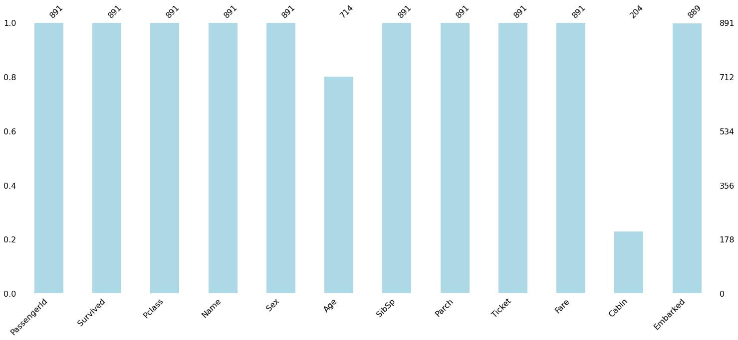

In [14]:

df['Age']**.**fillna(df**.**Age**.**median(),inplace**=True**) df**.**Age**.**isna()**.**any()

Out[14]:

In [15]:

df**.**drop(columns**=**'Cabin' , inplace**=True**)

False

In [16]:

df**.**dropna(subset**=**['Embarked'],inplace**=True**)

In [17]:

Out[17]:

In [18]:

Out[18]:

In [19]:

Out[19]:

(889, 11)

df**.**shape

df**.**isna()**.**sum()

PassengerId 0

Survived 0

Pclass 0

Name 0

Sex 0

Age 0

SibSp 0

Parch 0

Ticket 0

Fare 0

Embarked 0

dtype: int64

no**.**bar(df,color**=**'pink')

<matplotlib.axes._subplots.AxesSubplot at 0x7f5228f30460>

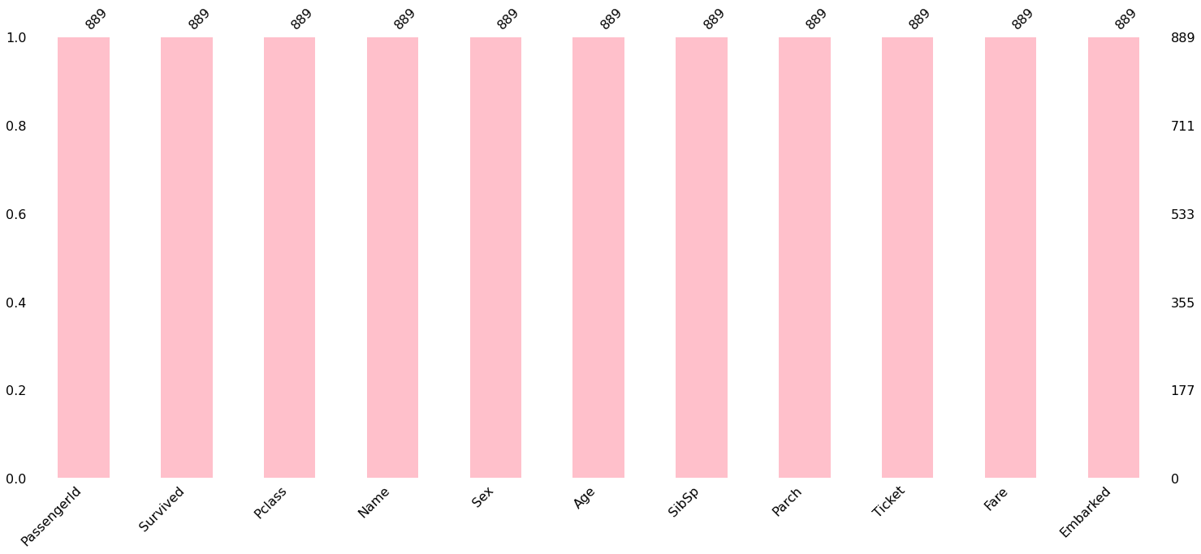

### Data Preprocessing

In [21]:

**import** yellowbrick

**from** sklearn.preprocessing **import** LabelEncoder label_Enc **=**LabelEncoder()

In [22]:

df**.**Sex **=**label_Enc**.**fit_transform(df**.**Sex)

In [23]:

Out[23]:

In [24]:

df**.**head()

array(['female', 'male'], dtype=object)

label_Enc**.**classes_

Out[24]:

**PassengerId Survived Pclass Name Sex Age SibSp Parch Ticket Fare Embarke**

|  |  |  |  |  |  |  |  |  |  |
| --- | --- | --- | --- | --- | --- | --- | --- | --- | --- |
|  | **0** | 1 | 0 | 3 | Braund, Mr. Owen | 1 | 22.0 | 1 | 0 A/5 7.2500  21171 |
|  | | | | | Harris |  |  |  |  |
| Cumings, Mrs. John |  |  |  |  |
|  | **1** 2 1 1 Bradley 0 38.0 1 0 PC 17599 71.2833  (Florence  Briggs Th... | | | | | | | | |

Heikkinen,

|  |  |  |  |
| --- | --- | --- | --- |
| 0 | 26.0 | 0 | 0 STON/O2. 7.9250  3101282 |
| 0 | 35.0 | 1 | 0 113803 53.1000 |

ss. na

lle, s. es th

|  |  |  |  |
| --- | --- | --- | --- |
| **2** | 3 | 1 | 3 Mi  Lai |
| **3** | 4 | 1 | Futre  Mr  1 Jacqu  Hea |

|  |  |  |  |  |  |  |  |  |
| --- | --- | --- | --- | --- | --- | --- | --- | --- |
|  | | | | (Lily May  Peel) |  | | | |
| **4** | 5 | 0 | 3 | Allen, Mr. William | 1 | 35.0 | 0 | 0 373450 8.0500 |
|  |  |  |  | Henry |  |  |  |  |

In [25]:

fig,ax**=**plt**.**subplots(ncols**=**2,figsize**=**(20,8)) resign_corr **=** df**.**corr()

mask **=** np**.**triu(np**.**ones_like(resign_corr, dtype**=**np**.**bool))

cat_heatmap **=** sns**.**heatmap(df**.**corr(), mask**=**mask, vmin**=-**1, vmax**=**1,annot**=True**,ax**=**ax[0 cat_heatmap**.**set_title('Correlation Heatmap', fontdict**=**{'fontsize':14}, pad**=**12);

heatmap **=** sns**.**heatmap(resign_corr[['Survived']]**.**sort_values(by**=**'Survived',ascendin heatmap**.**set_title('Features Correlating with Resignation', fontdict**=**{'fontsize':16}

<ipython-input-25-0960bdc0efd7>:3: DeprecationWarning: `np.bool` is a deprecated a lias for the builtin `bool`. To silence this warning, use `bool` by itself. Doing this will not modify any behavior and is safe. If you specifically wanted the nump y scalar type, use `np.bool_` here.

Deprecated in NumPy 1.20; for more details and guidance: https://numpy.org/devdoc s/release/1.20.0-notes.html#deprecations

mask = np.triu(np.ones_like(resign_corr, dtype=np.bool))

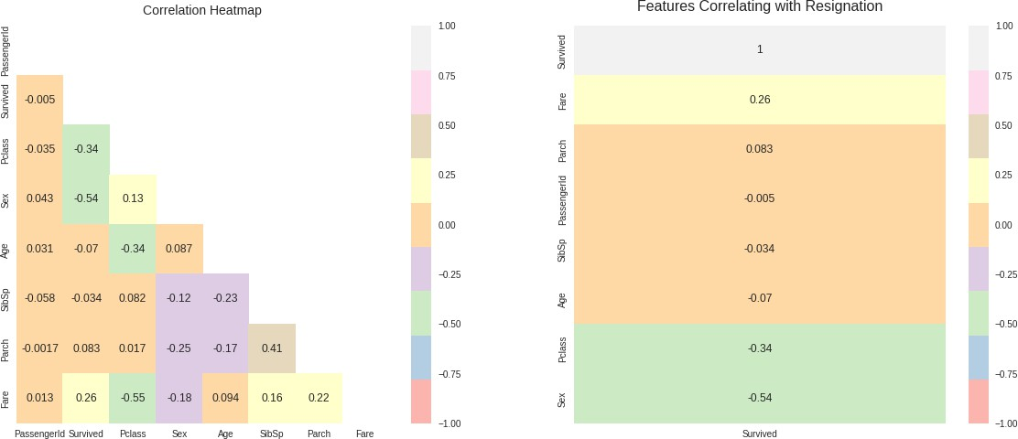

In [26]:

plt**.**figure(figsize**=**(9,7))

sns**.**heatmap(df**.**corr(),annot**=True**,cmap**=**'Pastel1') plt**.**show()

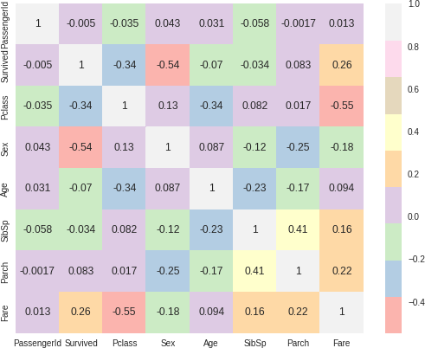

In [27]:

Out[27]:

In [28]:

X**=**df**.**drop(['Survived','Name','Ticket','Embarked'],axis**=**1) y**=**df['Survived']

sns**.**clustermap(df**.**corr(),annot**=True**,cmap**=**'Pastel1')

<seaborn.matrix.ClusterGrid at 0x7f5224c77ca0>

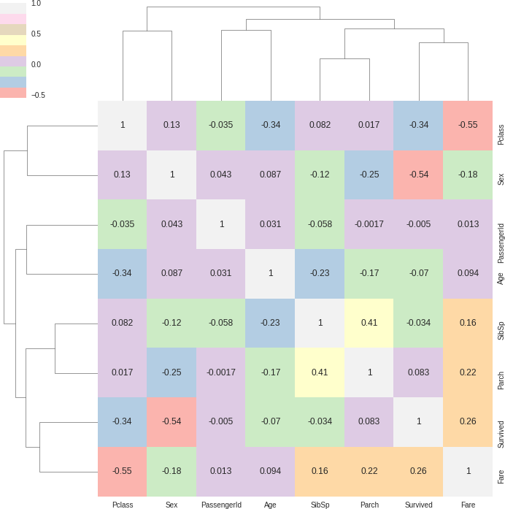

### Dataset Splitting

In [29]:

X[:3]

|  |  |  |  |  |  |  |  |
| --- | --- | --- | --- | --- | --- | --- | --- |
| Out[29]: | **PassengerId** | **Pclass** | **Sex** | **Age** | **SibSp** | **Parch** | **Fare** |
|  | **0** 1 | 3 | 1 | 22.0 | 1 | 0 | 7.2500 |
|  | **1** 2 | 1 | 0 | 38.0 | 1 | 0 | 71.2833 |
|  | **2** 3 | 3 | 0 | 26.0 | 0 | 0 | 7.9250 |

In [30]:

y[:5]

Out[30]:

|  |  |
| --- | --- |
| 0 | 0 |
| 1 | 1 |
| 2 | 1 |
| 3 | 1 |
| 4 | 0 |

Name: Survived, dtype: int64

In [31]:

**from** sklearn.model_selection **import** train_test_split

X_train,X_test,y_train,y_test **=** train_test_split(X,y,test_size**=**0.2,stratify**=**y,rand

### Gaussian Naive Bayes Calssifier

In [32]:

**from** sklearn.metrics **import** confusion_matrix, classification_report,accuracy_score

**from** sklearn.metrics **import** recall_score, precision_score, f1_score

In [33]:

**from** sklearn.naive_bayes **import** GaussianNB

In [34]:

gnb_clf**=**GaussianNB()

In [35]:

Out[35]:

GaussianNB()

gnb_clf**.**fit(X_train, y_train)

|  |  |  |
| --- | --- | --- |
| In | [36]: | y_pred **=** gnb_clf**.**predict(X_test) |
|  |  |  |
| In | [37]: | print("Accuracy Score :",accuracy_score(y_test,y_pred)) |
|  |  | Accuracy Score : 0.7921348314606742 |
| In | [38]: | print("Recall Score",recall_score(y_test,y_pred)) |
|  |  | Recall Score 0.7058823529411765 |
| In | [39]: | print("Precision Score :",precision_score(y_test,y_pred)) |
|  |  | Precision Score : 0.7384615384615385 |
| In | [40]: | print("F1 Score :",f1_score(y_test,y_pred)) |
|  |  | F1 Score : 0.7218045112781954  Confusion Matrix |
| In | [41]: | confusion_matrix(y_test, y_pred) |
| Out[41]: | | array([[93, 17],  [20, 48]]) |

In [42]:

print(classification_report(y_test,y_pred))

|  |  |  |  |  |
| --- | --- | --- | --- | --- |
|  | precision | recall | f1-score | support |
| 0 | 0.82 | 0.85 | 0.83 | 110 |
| 1 | 0.74 | 0.71 | 0.72 | 68 |
| accuracy |  |  | 0.79 | 178 |
| macro avg | 0.78 | 0.78 | 0.78 | 178 |
| weighted avg | 0.79 | 0.79 | 0.79 | 178 |

In [43]:

**import** yellowbrick **as** yb

plt**.**figure(figsize**=**(15,7))

visualizer **=** yb**.**classifier**.**classification_report(gnb_clf, X_train, y_train, X_test visualizer**.**show()

plt**.**show()

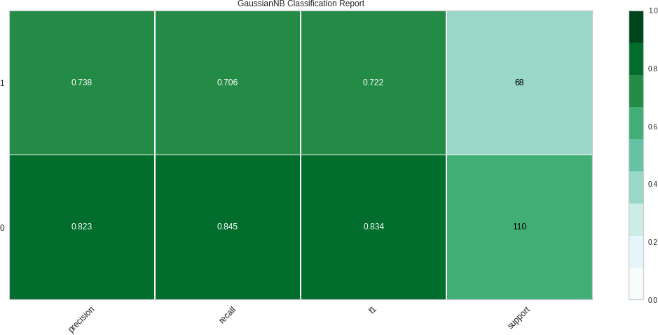

/usr/local/lib/python3.8/dist-packages/sklearn/base.py:450: UserWarning: X does no t have valid feature names, but GaussianNB was fitted with feature names

warnings.warn(

In [ ]:

### Write a program to implement Decision Tree and Random forest with Prediction, Test Score and Confusion Matrix.

In [1]:

**import** numpy **as** np

**import** pandas **as** pd

**import** matplotlib.pyplot **as** plt

**import** seaborn **as** sns

**from** sklearn.model_selection **import** train_test_split

**from** sklearn.ensemble **import** RandomForestRegressor

**from** sklearn **import** metrics

|  |  |  |
| --- | --- | --- |
|  | | Data Collection and Processing |
| In | [2]: | *# loading the csv data to a Pandas DataFrame*  gold_data **=** pd**.**read_csv('/content/gld_price_data.csv') |
|  |  |  |
| In | [3]: | *# print first 5 rows in the dataframe*  gold_data**.**head() |

|  |  |  |  |  |  |  |
| --- | --- | --- | --- | --- | --- | --- |
| Out[3]: | **Date** | **SPX** | **GLD** | **USO** | **SLV** | **EUR/USD** |
|  | **0** 1/2/2008 | 1447.160034 | 84.860001 | 78.470001 | 15.180 | 1.471692 |
|  | **1** 1/3/2008 | 1447.160034 | 85.570000 | 78.370003 | 15.285 | 1.474491 |
|  | **2** 1/4/2008 | 1411.630005 | 85.129997 | 77.309998 | 15.167 | 1.475492 |
|  | **3** 1/7/2008 | 1416.180054 | 84.769997 | 75.500000 | 15.053 | 1.468299 |
|  | **4** 1/8/2008 | 1390.189941 | 86.779999 | 76.059998 | 15.590 | 1.557099 |

In [4]:

*# print last 5 rows of the dataframe*

gold_data**.**tail()

|  |  |  |  |  |  |  |
| --- | --- | --- | --- | --- | --- | --- |
| Out[4]: | **Date** | **SPX** | **GLD** | **USO** | **SLV** | **EUR/USD** |
|  | **2285** 5/8/2018 | 2671.919922 | 124.589996 | 14.0600 | 15.5100 | 1.186789 |
|  | **2286** 5/9/2018 | 2697.790039 | 124.330002 | 14.3700 | 15.5300 | 1.184722 |
|  | **2287** 5/10/2018 | 2723.070068 | 125.180000 | 14.4100 | 15.7400 | 1.191753 |
|  | **2288** 5/14/2018 | 2730.129883 | 124.489998 | 14.3800 | 15.5600 | 1.193118 |
|  | **2289** 5/16/2018 | 2725.780029 | 122.543800 | 14.4058 | 15.4542 | 1.182033 |

In [5]:

*# number of rows and columns*

gold_data**.**shape

Out[5]:

In [6]:

*# getting some basic informations about the data*

gold_data**.**info()

(2290, 6)

<class 'pandas.core.frame.DataFrame'> RangeIndex: 2290 entries, 0 to 2289

Data columns (total 6 columns):

# Column Non-Null Count Dtype

* 1. Date 2290 non-null object
  2. SPX 2290 non-null float64
  3. GLD 2290 non-null float64
  4. USO 2290 non-null float64
  5. SLV 2290 non-null float64
  6. EUR/USD 2290 non-null float64 dtypes: float64(5), object(1)

memory usage: 107.5+ KB

In [7]:

*# checking the number of missing values*

gold_data**.**isnull()**.**sum()

Out[7]:

In [8]:

Date 0

SPX 0

GLD 0

USO 0

SLV 0

EUR/USD 0

dtype: int64

*# getting the statistical measures of the data*

gold_data**.**describe()

|  |  |  |  |  |  |  |
| --- | --- | --- | --- | --- | --- | --- |
| Out[8]: |  | **SPX** | **GLD** | **USO** | **SLV** | **EUR/USD** |
|  | **count** | 2290.000000 | 2290.000000 | 2290.000000 | 2290.000000 | 2290.000000 |
|  | **mean** | 1654.315776 | 122.732875 | 31.842221 | 20.084997 | 1.283653 |
|  | **std** | 519.111540 | 23.283346 | 19.523517 | 7.092566 | 0.131547 |
|  | **min** | 676.530029 | 70.000000 | 7.960000 | 8.850000 | 1.039047 |
|  | **25%** | 1239.874969 | 109.725000 | 14.380000 | 15.570000 | 1.171313 |
|  | **50%** | 1551.434998 | 120.580002 | 33.869999 | 17.268500 | 1.303297 |
|  | **75%** | 2073.010070 | 132.840004 | 37.827501 | 22.882500 | 1.369971 |
|  | **max** | 2872.870117 | 184.589996 | 117.480003 | 47.259998 | 1.598798 |

Correlation:

* + 1. Positive Correlation
    2. Negative Correlation

In [9]:

correlation **=** gold_data**.**corr()

In [10]:

*# constructing a heatmap to understand the correlatiom*

plt**.**figure(figsize **=** (8,8))

sns**.**heatmap(correlation, cbar**=True**, square**=True**, fmt**=**'.1f',annot**=True**, annot_kws**=**{

Out[10]:

<matplotlib.axes._subplots.AxesSubplot at 0x7f9593846100>

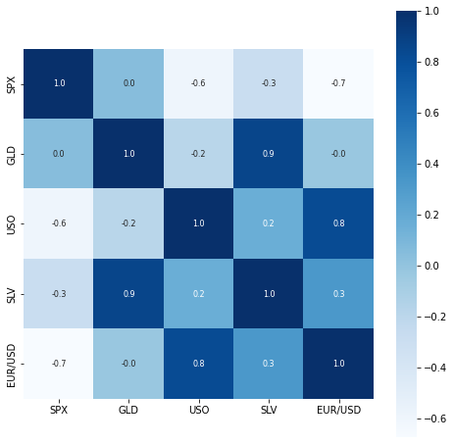

In [11]:

*# correlation values of GLD*

print(correlation['GLD'])

|  |  |
| --- | --- |
| SPX | 0.049345 |
| GLD | 1.000000 |
| USO | -0.186360 |
| SLV | 0.866632 |
| EUR/USD | -0.024375 |

Name: GLD, dtype: float64

In [12]:

*# checking the distribution of the GLD Price*

sns**.**distplot(gold_data['GLD'],color**=**'green')

/usr/local/lib/python3.8/dist-packages/seaborn/distributions.py:2619: FutureWarnin g: `distplot` is a deprecated function and will be removed in a future version. Pl ease adapt your code to use either `displot` (a figure-level function with similar flexibility) or `histplot` (an axes-level function for histograms).

warnings.warn(msg, FutureWarning)

Out[12]:

<matplotlib.axes._subplots.AxesSubplot at 0x7f959388e700>

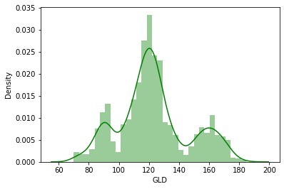

|  |  |  |
| --- | --- | --- |
|  | | Splitting the Features and Target |
| In | [13]: | X **=** gold_data**.**drop(['Date','GLD'],axis**=**1) Y **=** gold_data['GLD'] |
|  |  |  |
| In | [14]: | print(X) |

|  |  |  |  |  |
| --- | --- | --- | --- | --- |
|  | SPX | USO | SLV | EUR/USD |
| 0 | 1447.160034 | 78.470001 | 15.1800 | 1.471692 |
| 1 | 1447.160034 | 78.370003 | 15.2850 | 1.474491 |
| 2 | 1411.630005 | 77.309998 | 15.1670 | 1.475492 |
| 3 | 1416.180054 | 75.500000 | 15.0530 | 1.468299 |
| 4 | 1390.189941 | 76.059998 | 15.5900 | 1.557099 |
| ... | ... | ... | ... | ... |
| 2285 | 2671.919922 | 14.060000 | 15.5100 | 1.186789 |
| 2286 | 2697.790039 | 14.370000 | 15.5300 | 1.184722 |
| 2287 | 2723.070068 | 14.410000 | 15.7400 | 1.191753 |
| 2288 | 2730.129883 | 14.380000 | 15.5600 | 1.193118 |
| 2289 | 2725.780029 | 14.405800 | 15.4542 | 1.182033 |

[2290 rows x 4 columns]

In [15]:

print(Y)

|  |  |  |  |  |
| --- | --- | --- | --- | --- |
| 0 | | | 84.860001 |  |
| 1 | | | 85.570000 |
| 2 | | | 85.129997 |
| 3 | | | 84.769997 |
| 4  2285 | | | 86.779999  ...  124.589996 |
| 2286 | | | 124.330002 |
| 2287 | | | 125.180000 |
| 2288 | | | 124.489998 |
| 2289 | | | 122.543800 |
| Name: | | | GLD, Length: | 2290, dtype: float64 |
|  |  | Splitting into Training data and Test Data | | |
| In | [16]: | X_train, X_test, Y_train, Y_test **=** train_test_split(X, Y, test_size **=** 0.2, random_ | | |
|  |  | Model Training: Random Forest Regressor | | |
| In | [17]: | regressor **=** RandomForestRegressor(n_estimators**=**100) | | |

In [18]:

*# training the model*

regressor**.**fit(X_train,Y_train)

Out[18]:

In [19]:

*# prediction on Test Data*

test_data_prediction **=** regressor**.**predict(X_test)

RandomForestRegressor()

Model Evaluation

In [20]:

print(test_data_prediction)

[168.8024997 81.76539994 116.12460019 127.62850073 120.48470156

154.66519818 150.24759836 125.84670103 117.63599858 126.1703004

116.85650075 172.02970087 141.59679814 167.85919873 115.10210022

117.82960026 138.57680361 169.86320092 159.40210318 161.05689992

154.91850014 125.44000014 175.49340004 157.50830401 125.1320003

93.66869953 78.02370047 120.52970031 119.13349971 167.45739924

88.04280098 125.24589994 91.14940071 117.66750035 121.2089994

135.98950078 115.694701 115.04590048 146.44709943 106.99790111

104.82810278 87.04569765 126.48040045 118.10090015 152.68889877

119.61880008 108.28900029 108.03599864 93.27370055 127.08999789

75.02340024 113.68889914 121.17329996 111.22789913 118.92419886

120.5121995 160.02059918 168.33770156 147.09079678 85.83389886

94.36280034 86.79519902 90.50050024 119.04540061 126.49490095

127.72149976 171.15230023 122.4069992 117.51719915 98.86540018

167.9912021 143.15119877 132.31180264 121.23400213 121.05899936

119.94710073 114.55480113 118.34530054 106.96280105 128.01270153

113.95429968 107.48039984 116.68990078 119.65489935 88.99480029

88.26269898 146.4706018 127.41390019 113.40880057 110.5933987

108.00199893 77.71559894 169.88760205 114.04949917 121.74349888

127.43100145 154.88539843 91.87309932 135.033001 159.02880316

125.05030046 125.63790047 130.52790141 114.99450071 119.80359947

92.04919968 110.24699897 167.74819956 156.49949951 114.1226994

106.6976014 79.26499986 113.33470035 125.84690105 107.2521991

119.56700101 155.6990033 159.7409986 119.96249984 134.27220299

101.39339988 117.32829809 119.38200035 112.91350054 102.7760988

160.50779769 99.36290041 147.62240009 125.3281011 169.61439948

125.59379886 127.37199737 127.57160148 113.86039913 113.08560077

123.54299896 102.1041991 88.95689982 124.7889997 101.74339927

107.01119913 113.6225001 117.55810039 99.19359956 121.67850059

163.340599 87.33899855 106.7294999 117.2687009 127.77440158

124.01900058 80.77579923 120.57860031 156.91729846 87.98909965

110.27619958 119.03359907 172.69829885 102.98369909 105.86200059

122.34990023 156.93189786 87.64069835 93.04940034 112.69390038

177.21080023 114.45490017 119.43210034 94.66300117 125.65990073

165.93120159 115.08220066 116.62860131 88.28939885 149.1347014

120.4637994 89.55709972 112.78680013 117.15080065 118.7462013

88.20489995 94.05830011 117.15969981 118.50690153 120.33750005

126.66489866 121.92029971 148.99210006 165.73610109 118.56489973

120.48780117 150.76999997 118.35839864 172.53419942 105.24789919

104.968201 149.43500155 114.01530066 124.81940116 147.6377997

119.51870136 115.36640055 112.68490007 113.46520213 140.84430107

117.9862976 102.99780036 115.891301 104.04320214 98.71730056

117.41470054 90.71890031 91.57620083 153.45039876 102.69129976

154.46740059 114.34300187 138.92410158 90.10079834 115.48689965

114.68779993 123.29140081 121.83640046 165.45400081 92.95649931

135.85150099 121.29709917 120.67990072 104.71530006 141.99780292

121.78439933 116.78350033 113.30420113 126.92689804 122.36689966

125.76879951 121.1925002 86.81459914 132.35280162 145.49390165

92.57609963 157.42719961 159.22610235 126.34419887 165.00649977

108.79369928 110.51460074 103.81319825 94.44030088 127.45920238

106.85330056 160.44280034 121.61150058 132.07840053 130.55650141

160.3821997 90.11689866 175.32800211 127.7070003 126.8019989

86.36999907 124.59159927 150.31859705 89.73030008 106.9375

109.01819982 84.51399903 135.98869973 154.97860217 138.48350371

73.99380007 151.70510101 126.09000092 126.82530024 127.55489919

108.71409963 156.1334008 114.77340088 116.90080167 125.46199968

153.99840094 121.46409979 156.44939912 92.90840041 125.55970153

126.02880037 87.78300066 92.25049951 126.39029925 128.60650335

113.18820028 117.55219758 120.7733002 127.02999853 119.59820125

135.96440047 93.80519931 119.75460029 113.22380113 94.25969941

108.92519934 87.20519881 108.94899918 89.62599972 92.5899002

131.4442032 162.36510047 89.35050028 119.52930064 133.46600222

123.85570026 128.31960197 102.02209867 88.87959882 131.31090094

119.73370041 108.6379002 167.83540179 115.12450037 86.6030987

|  |  |  |  |  |
| --- | --- | --- | --- | --- |
| 118.81820093 | 91.06069994 | 162.07819985 | 116.63010042 | 121.49199974 |
| 160.18019772 | 120.12209912 | 112.79689913 | 108.42099855 | 126.74099978 |
| 76.11180024 | 102.97489994 | 127.08480207 | 121.75219942 | 92.58969992 |
| 131.91230033 | 118.03380151 | 116.19869968 | 154.46590275 | 160.02860093 |
| 110.24209944 | 156.64859782 | 119.32080091 | 160.58870059 | 118.61570049 |
| 158.23189948 | 115.24159956 | 116.4455005 | 149.64229906 | 114.91860058 |
| 125.655599 | 165.52139973 | 117.64900015 | 124.85989946 | 153.17650362 |
| 153.39210264 | 132.03060023 | 114.90310047 | 121.2380019 | 125.08720072 |
| 89.70290063 | 123.42919984 | 154.73330242 | 111.52600018 | 106.62440001 |
| 162.10980135 | 118.53599955 | 165.63710018 | 134.38040104 | 115.23589997 |
| 152.99509915 | 168.62709947 | 114.55610007 | 114.09480121 | 158.15769901 |
| 85.16059911 | 127.11650106 | 127.94040045 | 129.01919953 | 124.28710069 |
| 123.93290094 | 90.54930076 | 153.17020012 | 97.15369954 | 136.83959992 |
| 89.07429904 | 107.41179991 | 114.99410044 | 112.81100059 | 124.2679991 |
| 91.37529878 | 125.42780132 | 162.44889908 | 120.00079866 | 165.15160049 |
| 126.71939854 | 112.1334999 | 127.57619926 | 95.02019889 | 91.00459956 |
| 103.35769885 | 120.71540035 | 83.0787994 | 126.29580012 | 160.13240427 |
| 117.35450088 | 118.37429985 | 119.88980003 | 122.66529963 | 120.13190125 |
| 121.58870012 | 118.07590071 | 106.90810018 | 148.45260034 | 126.15509888 |
| 115.62890103 | 73.66800009 | 127.81950124 | 153.95840036 | 121.86300034 |
| 125.5668005 | 88.86170017 | 104.08609876 | 125.06970061 | 120.16880036 |
| 73.33340079 | 152.03700024 | 121.0907005 | 104.63079986 | 86.35239777 |
| 115.26989943 | 172.17669834 | 119.98030027 | 160.31919831 | 113.16560009 |
| 121.10420029 | 118.27880149 | 95.89909985 | 118.37110011 | 125.85890034 |
| 118.50799956 | 96.23690073 | 154.07480154 | 122.10479965 | 147.46699974 |
| 159.31840212 | 113.98780014 | 122.5353993 | 148.34009846 | 127.62480039 |
| 165.58640094 | 135.0120001 | 119.92969911 | 167.21709849 | 108.24659974 |
| 121.75059849 | 138.82410125 | 107.41269918] |  |  |

plt**.**plot(Y_test, color**=**'blue', label **=** 'Actual Value')

plt**.**plot(test_data_prediction, color**=**'green', label**=**'Predicted Value') plt**.**title('Actual Price vs Predicted Price')

plt**.**xlabel('Number of values') plt**.**ylabel('GLD Price')

plt**.**legend() plt**.**show()

|  |  |  |
| --- | --- | --- |
| In | [21]: | *# R squared error*  error_score **=** metrics**.**r2_score(Y_test, test_data_prediction) print("R squared error : ", error_score) |
|  |  | R squared error : 0.9897511997931183 |
|  |  | Compare the Actual Values and Predicted Values in a Plot |
| In | [22]: | Y_test **=** list(Y_test) |
| In | [23]: |  |

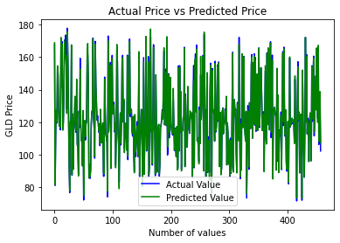

In [24]:

*# Decision Tree*

*# import the regressor*

**from** sklearn.tree **import** DecisionTreeRegressor

*# create a regressor object*

regressor **=** DecisionTreeRegressor(random_state **=** 0)

*# fit the regressor with X and Y data*

regressor**.**fit(X_train,Y_train)

Out[24]:

In [31]:

*# predicting a new value*

*# test the output*

y_pred **=** regressor**.**predict(X_test) y_pred

DecisionTreeRegressor(random_state=0)

Out[31]:

|  |  |  |  |  |  |  |
| --- | --- | --- | --- | --- | --- | --- |
| array([168.970001, | 86.089996, | 114.769997, | | 127.550003, | 121.730003, | |
| 155.669998, | 149.149994, | 126.809998, | | 117.389999, | 125.620003, | |
| 117.959999,  116.730003,  155.360001, | 174.580002,  134.100006,  126.610001, | 141.919998,  168.5 ,  177.210007, | | 167.179993,  159.570007,  157.339996, | 115.839996,  138.220001,  125.459999, | |
| 93.720001, | 73.080002, | 122.290001, | | 119.220001, | 167.990005, | |
| 87.370003,  135.410004,  104.370003, | 124.769997,  114.57 ,  87.239998, | 91.730003,  115.800003,  127.489998, | | 117.919998,  134.119995,  118.360001, | 121.300003,  105.720001,  157.779999, | |
| 119.959999, | 108.419998, | 107.839996, | | 93.459999, | 128.539993, | |
| 72.510002, | 113.260002, | 120.110001, | | 109.860001, | 118.919998, | |
| 120.730003, | 161.320007, | 161.520004, | | 146.869995, | 85.199997, | |
| 93.040001, | 86.879997, | 90.949997, | | 119.800003, | 126.139999, | |
| 127.400002, | 173.490005, | 122.970001, | | 116.209999, | 97.550003, | |
| 170.130005, | 142.050003, | 132.490005, | | 120.910004, | 122.879997, | |
| 119.190002, | 113.910004, | 118.82 , | | 106.260002, | 127.660004, | |
| 114.769997, | 108.470001, | 115.57 , | | 119.699997, | 89.910004, | |
| 87.989998, | 142.380005, | 127.150002, | | 114.209999, | 110.239998, | |
| 108.279999,  128.5 ,  124.43 , | 73.080002,  155.139999,  126.18 , | 173.020004,  91.769997,  130.369995, | | 113.639999,  134.410004,  113.910004, | 121.209999,  161.320007,  121.160004, | |
| 92.059998, 111.459999, | | 173.490005, | | 160.289993, | 113.639999, | |
| 107.040001, 81.989998, | | 113.669998, | | 125.540001, | 108.089996, | |
| 118.82 , 157.320007, | | 160.559998, | | 120.139999, | 132.850006, | |
| 101.849998, 116.029999, | | 118.959999, | | 112.440002, | 102.309998, | |
| 160.559998, 97.43 , 139.350006, | | | | 125.290001, | 171.509995, | |
| 123.730003, 128.539993, 128.380005, | | | | 115.199997, | 112.139999, | |
| 124.269997, 101.790001, 89.5 , 125.959999, | | | | | 99.669998, | |
| 107.040001, | 115.849998, | 116.730003, | | 97.699997, | 121.650002, | |
| 165.279999, | 87.089996, | 107.669998, | | 118.559998, | 127.660004, | |
| 125.18 , | 79.790001, | 121.470001, | | 160.619995, | 89.5 , | |
| 109.760002, | 118.279999, | 174.399994, | | 102.459999, 104.860001, | | |
| 122.599998, | 160.619995, | 86.610001, | | 92.760002, 111.57 , | | |
| 177.210007, | 114.720001, | 118.959999, | | 93.860001, 124.910004, | | |
| 166.630005, | 113.910004, | 117.260002, | | 88.419998, 150.410004, | | |
| 119.75 , 89.440002, | | 112.650002, | | 118.360001, | 118.860001, | |
| 87.690002, 94.599998, | | 114.459999, | | 118.230003, | 120.839996, | |
| 126.160004, 122.080002, 138. , 165.649994, | | | | | 119.32 | , |
| 120.730003, 151.440002, 120.559998, 174.399994, | | | | | 107.43 | , |
| 105.169998, | 150.410004, | 114.769997, | | 124.360001, | 146.589996, | |
| 119.730003, | 113.639999, | 112.650002, | | 112.220001, | 132.690002, | |
| 118.099998, | 103.150002, | 115.940002, | | 104.370003, | 98.360001, | |
| 118.360001, | 89.440002, | 91.980003, | | 154.449997, | 102.459999, | |
| 154.470001, | 115.050003, | 137.660004, | | 90.589996, | 115.139999, | |
| 108.860001, | 119.510002, | 122.709999, | | 166.490005, | 93.389999, | |
| 137.660004, 121.110001, | | 120.160004, | | 105.68 , | 135.020004, | |
| 122.169998, 116.470001, | | 113.5 , | | 128.789993, | 123.32 , | |
| 125.699997, 121.110001, | | 87.239998, | | 132.070007, | 135.380005, | |
| 91.5 , 161.520004, | | 161.320007, | | 126.949997, | 168.110001, | |
| 110.290001, | 108.550003, | 103.019997, | | 94.730003, | 129.740005, | |
| 107.040001, | 161.520004, | 121.650002, | | 131.740005, | 130.369995, | |
| 157.210007, | 90.610001, | 177.210007, | | 129.860001, | 126.160004, | |
| 84.769997, | 124.019997, | 150.479996, | | 89.440002, | 107.669998, | |
| 108.470001, 88.32 , 134.300003, 156.710007, 135.020004, | | | | | | |
| 72.5 , 151.440002, | | 126.809998, | | 127.169998, | 127.970001, | |
| 108.470001, 157.160004, | | 113.910004, | | 116.730003, | 123.389999, | |
| 154. , 122.760002, 156.479996, 92.93 , 125.379997, | | | | | | |
| 124.239998, | 88.580002, | 91.610001, | | 125.620003, | 129.710007, | |
| 112.589996, | 116.839996, | 120.779999, | | 128.789993, | 120.730003, | |
| 136.050003, | 92.949997, | 118.809998, | | 112.940002, | 94.599998, | |
| 109.129997, 88.32 , 108.949997, | | | | 90.809998, | 93.389999, | |
| 130.369995, 161.419998, | | 88.32 | , | 120.139999, | 134.25 | , |
| 124.389999, 129.710007, | | 101.419998, | | 91.309998, | 130.800003, | |
| 123.32 , 108.220001, | | 173.199997, | | 113.290001, | 86.510002, | |

118.540001, 91.25 , 161.589996, 118.360001, 123.620003,

|  |  |  |  |  |
| --- | --- | --- | --- | --- |
| 159.429993, | 120.559998, | 114.269997, | 108.309998, | 126.800003, |
| 75.650002, | 103.18 , | 129.740005, | 121.589996, | 92.730003, |
| 132.199997, | 118.559998, | 117.099998, | 154.470001, | 161.220001, |
| 110.809998, | 137.380005, | 119.330002, | 160.559998, | 117.449997, |
| 159.050003, | 114.860001, | 116.5 , | 147.179993, | 115.43 , |
| 127.779999, | 167.339996, | 117.139999, | 124.779999, | 152.300003, |
| 153.050003, | 132.009995, | 115.43 , | 121.559998, | 129.740005, |
| 90.279999, | 125.32 , | 157.320007, | 110.459999, | 107.669998, |
| 162.300003, | 118.769997, | 165.800003, | 134.75 , | 113.269997, |
| 152.589996, | 169.610001, | 117.769997, | 114.720001, | 161.449997, |
| 84.459999, | 127.120003, | 128.270004, | 128.110001, | 124.529999, |
| 124.400002, | 90.800003, | 151.910004, | 96.5 , | 136.050003, |
| 86.449997, | 108.470001, | 115. , | 111.75 , | 124.959999, |
| 91.610001, | 124.589996, | 161.419998, | 121.239998, | 167.580002, |
| 126.160004, | 112.970001, | 127.599998, | 95.449997, | 94.349998, |
| 102.279999, | 120.739998, | 84.279999, | 126.589996, | 160.460007, |
| 116.610001, | 118.68 , | 117.610001, | 124.389999, | 120.720001, |
| 120.940002, | 117.650002, | 107.040001, | 146.869995, | 123.730003, |
| 115.32 , | 74. , | 127.349998, | 157.779999, | 118. , |
| 125.540001, | 89.269997, | 102.199997, | 123.389999, | 121. , |
| 73.790001, | 151.050003, | 120.110001, | 103.93 , | 88.949997, |
| 114.769997, | 172.289993, | 121.470001, | 160.649994, | 113.669998, |
| 121.790001, | 118.559998, | 96.5 , | 119.169998, | 126.07 , |
| 118.239998, | 97.800003, | 157.779999, | 123.620003, | 146. , |
| 159.300003, | 114.730003, | 123.239998, | 145.729996, | 128.669998, |
| 166.130005, | 132.690002, | 120.980003, | 173.020004, | 109.199997, |
| 122.019997, | 135.410004, | 103.419998]) |  |  |

In [33]:

*# R squared error*

error_score **=** metrics**.**r2_score(Y_test, test_data_prediction)

print("R squared error : ", error_score)

R squared error : 0.9897511997931183

regressor**.**score(X_test, Y_test)

In [34]:

Out[34]:

In [ ]:

0.9854190298916252

# Practical 4

### For a given set of training data examples stored in a .CSV file implement Least Square Regression algorithm.

In [1]:

*# Import Libary*

**import** numpy **as** np

**import** pandas **as** pd

**import** matplotlib.pyplot **as** plt

In [2]:

*# read data*

df**=**pd**.**read_csv('headbrain.csv')

In [3]:

df**.**head()

|  |  |  |  |  |
| --- | --- | --- | --- | --- |
| Out[3]: | **Gender** | **Age Range** | **Head Size(cm^3)** | **Brain Weight(grams)** |
|  | **0** 1 | 1 | 4512 | 1530 |
|  | **1** 1 | 1 | 3738 | 1297 |
|  | **2** 1 | 1 | 4261 | 1335 |
|  | **3** 1 | 1 | 3777 | 1282 |
|  | **4** 1 | 1 | 4177 | 1590 |

In [4]:

*# Declare dependent variable(Y) and independent variable(X)*

X**=**df['Head Size(cm^3)']**.**values

Y **=** df['Brain Weight(grams)']**.**values

In [5]:

Out[5]:

In [6]:

array([[1. , 0.79956971],

np**.**corrcoef(X, Y)

[0.79956971, 1. ]])

*# Plot the Input Data*

plt**.**scatter(X, Y, c**=**'green', label**=**'Data points') plt**.**xlabel('Head Size in cm3')

plt**.**ylabel('Brain Weight in grams') plt**.**legend()

plt**.**show()

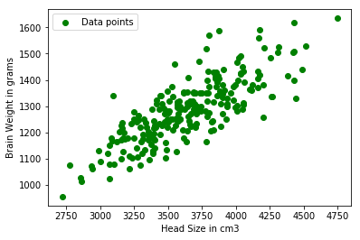

In [7]:

*# Calculating coefficient*

*# Mean X and Y*

mean_x **=** np**.**mean(X) mean_y **=** np**.**mean(Y)

*# Total number of values*

n **=** len(X)

*# Using the formula to calculate theta1 and theta2*

numer **=** 0

denom **=** 0

**for** i **in** range(n):

numer **+=** (X[i] **-** mean_x) **\*** (Y[i] **-** mean_y) denom **+=** (X[i] **-** mean_x) **\*\*** 2

b1 **=** numer **/** denom

b0 **=** mean_y **-** (b1 **\*** mean_x)

*# Printing coefficients*

print("coefficients for regression",b1, b0)

coefficients for regression 0.26342933948939945 325.57342104944223

In [8]:

*# Plotting Values and Regression Line*

**%matplotlib** inline

plt**.**rcParams['figure.figsize'] **=** (10.0, 5.0)

*# max_x = np.max(X) + 100 # min_x = np.min(X) - 100*

y **=** b0 **+** b1 **\*** X

*# Ploting Line*

plt**.**plot(X, y, color**=**'blue', label**=**'Regression Line')

*# Ploting Scatter Points*

plt**.**scatter(X, Y, c**=**'green', label**=**'Scatter data')

plt**.**xlabel('Head Size in cm3')

plt**.**ylabel('Brain Weight in grams') plt**.**legend()

plt**.**show()

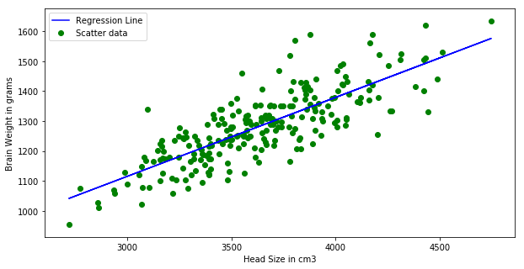

In [9]:

*# Calculating Root Mean Squares Error*

rmse **=** 0

**for** i **in** range(n):

y_pred **=** b0 **+** b1 **\*** X[i]

rmse **+=** (Y[i] **-** y_pred) **\*\*** 2

rmse **=** np**.**sqrt(rmse**/**n)

print("Root Mean Square Error is",rmse)

Root Mean Square Error is 72.1206213783709

In [10]:

*# Calculating R2 Score*

ss_tot **=** 0

ss_res **=** 0

**for** i **in** range(n):

y_pred **=** b0 **+** b1 **\*** X[i]

ss_tot **+=** (Y[i] **-** mean_y) **\*\*** 2 ss_res **+=** (Y[i] **-** y_pred) **\*\*** 2

r2 **=** 1 **-** (ss_res**/**ss_tot) print("R2 Score",r2)

R2 Score 0.6393117199570003

In [ ]:

## For a given set of training data examples stored in a .CSV file implement Logistic Regression algorithm.

In [12]:

*#import pandas*

**import** pandas **as** pd

*#col_names = ['pregnant', 'glucose', 'bp', 'skin', 'insulin', 'bmi', 'pedigree', 'a # load dataset*

pima **=** pd**.**read_csv("diabetes.csv")

In [13]:

pima**.**head()

|  |  |  |  |  |  |  |  |  |
| --- | --- | --- | --- | --- | --- | --- | --- | --- |
| Out[13]: | **Pregnancies** | **Glucose** | **BloodPressure** | **SkinThickness** | **Insulin** | **BMI** | **DiabetesPedigreeFunction** | **A** |
|  | **0** 6 | 148 | 72 | 35 | 0 | 33.6 | 0.627 |  |
|  | **1** 1 | 85 | 66 | 29 | 0 | 26.6 | 0.351 |  |
|  | **2** 8 | 183 | 64 | 0 | 0 | 23.3 | 0.672 |  |
|  | **3** 1 | 89 | 66 | 23 | 94 | 28.1 | 0.167 |  |
|  | **4** 0 | 137 | 40 | 35 | 168 | 43.1 | 2.288 |  |

In [15]:

*#split dataset in features and target variable*

feature_cols **=** ['Pregnancies', 'Insulin', 'BMI', 'Age','Glucose','BloodPressure','

X **=** pima[feature_cols] *# Features*

y **=** pima**.**Outcome *# Target variable*

In [17]:

*# split X and y into training and testing sets*

**from** sklearn.model_selection **import** train_test_split

X_train,X_test,y_train,y_test**=**train_test_split(X,y,test_size**=**0.25,random_state**=**0)

Model Development and Prediction

First, import the Logistic Regression module and create a Logistic Regression classifier object using LogisticRegression() function.

Then, fit your model on the train set using fit() and perform prediction on the test set using predict().

In [23]:

*# import the class*

**from** sklearn.linear_model **import** LogisticRegression

In [24]:

*# instantiate the model (using the default parameters)*

logreg **=** LogisticRegression()

*# fit the model with data*

logreg**.**fit(X_train,y_train)

C:\Users\h103196\Anaconda3\lib\site-packages\sklearn\linear_model\_logistic.py:94 0: ConvergenceWarning: lbfgs failed to converge (status=1):

STOP: TOTAL NO. of ITERATIONS REACHED LIMIT.

Increase the number of iterations (max_iter) or scale the data as shown in: https://scikit-learn.org/stable/modules/preprocessing.html

Please also refer to the documentation for alternative solver options:

https://scikit-learn.org/stable/modules/linear_model.html#logistic-regression extra_warning_msg=_LOGISTIC_SOLVER_CONVERGENCE_MSG)

Out[24]:

In [25]:

LogisticRegression(C=1.0, class_weight=None, dual=False, fit_intercept=True, intercept_scaling=1, l1_ratio=None, max_iter=100,

multi_class='auto', n_jobs=None, penalty='l2',

random_state=None, solver='lbfgs', tol=0.0001, verbose=0, warm_start=False)

*# predict the model*

y_pred**=**logreg**.**predict(X_test)

In [ ]:

In [26]:

*# import the metrics class*

**from** sklearn **import** metrics

cnf_matrix **=** metrics**.**confusion_matrix(y_test, y_pred) cnf_matrix

### Model Evaluation using Confusion Matrix

A confusion matrix is a table that is used to evaluate the performance of a classification model. You can also visualize the performance of an algorithm.

The fundamental of a confusion matrix is the number of correct and incorrect predictions are summed up class-wise.

Out[26]:

In [27]:

*# import required modules*

**import** numpy **as** np

**import** matplotlib.pyplot **as** plt

**import** seaborn **as** sns

**%matplotlib** inline

array([[117, 13],

[ 24, 38]], dtype=int64)

Here, you can see the confusion matrix in the form of the array object. The dimension of this matrix is 2*2 because this model is binary classification.

You have two classes 0 and 1. Diagonal values represent accurate predictions, while non- diagonal elements are inaccurate predictions.

In the output, 117 and 38 are actual predictions, and 24 and 13 are incorrect predictions.

### Visualizing Confusion Matrix using Heatmap

Let's visualize the results of the model in the form of a confusion matrix using matplotlib and seaborn.

In [21]:

class_names**=**[0,1] *# name of classes*

fig, ax **=** plt**.**subplots()

tick_marks **=** np**.**arange(len(class_names)) plt**.**xticks(tick_marks, class_names)

plt**.**yticks(tick_marks, class_names)

*# create heatmap*

sns**.**heatmap(pd**.**DataFrame(cnf_matrix), annot**=True**, cmap**=**"YlGnBu" ,fmt**=**'g') ax**.**xaxis**.**set_label_position("top")

plt**.**tight_layout()

plt**.**title('Confusion matrix', y**=**1.1) plt**.**ylabel('Actual label')

plt**.**xlabel('Predicted label')

Out[21]:

In [22]:

Text(0.5, 257.44, 'Predicted label')

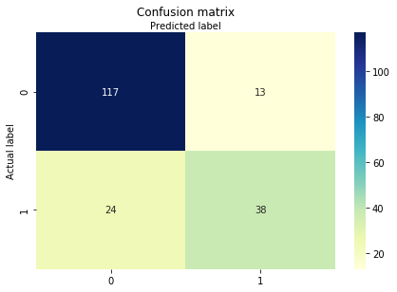

### Confusion Matrix Evaluation Metrics

Let's evaluate the model using model evaluation metrics such as accuracy, precision, and recall.

Accuracy: 0.8072916666666666

print("Accuracy:",metrics**.**accuracy_score(y_test, y_pred))

print("Precision:",metrics**.**precision_score(y_test, y_pred)) print("Recall:",metrics**.**recall_score(y_test, y_pred))

Precision: 0.7450980392156863

Recall: 0.6129032258064516

Well, you got a classification rate of 80%, considered as good accuracy.

Precision: Precision is about being precise, i.e., how accurate your model is. In other words, you can say, when a model makes a prediction, how often it is correct. In your prediction

case, when your Logistic Regression model predicted patients are going to suffer from

diabetes, that patients have 74% of the time.

Recall: If there are patients who have diabetes in the test set and your Logistic Regression model can identify it 61% of the time.

### ROC Curve

Receiver Operating Characteristic(ROC) curve is a plot of the true positive rate against the false positive rate. It shows the tradeoff between sensitivity and specificity.

In [28]:

y_pred_proba **=** logreg**.**predict_proba(X_test)[::,1]

fpr, tpr, _ **=** metrics**.**roc_curve(y_test, y_pred_proba) auc **=** metrics**.**roc_auc_score(y_test, y_pred_proba)

plt**.**plot(fpr,tpr,label**=**"data 1, auc="**+**str(auc))

plt**.**legend(loc**=**4) plt**.**show()

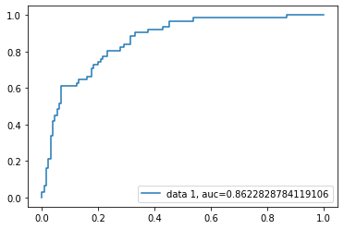

AUC score for the case is 0.86. AUC score 1 represents perfect classifier, and 0.5 represents a worthless classifier.

In [ ]:

# Practical 5

**def** entropy(probs):

**import** math

**return** sum( [**-**prob**\***math**.**log(prob, 2) **for** prob **in** probs] )

*#Function to calulate the entropy of the given Data Sets/List with respect to targe*

**def** entropy_of_list(a_list):

*#print("A-list",a_list)*

**from** collections **import** Counter

cnt **=** Counter(x **for** x **in** a_list) *# Counter calculates the propotion of class*

num_instances **=** len(a_list)**\***1.0 *# = 14*

print("\n Number of Instances of the Current Sub Class is {0}:"**.**format(num_inst probs **=** [x **/** num_instances **for** x **in** cnt**.**values()] *# x means no of YES/NO*

print("\n Classes:",min(cnt),max(cnt))

print(" \n Probabilities of Class {0} is {1}:"**.**format(min(cnt),min(probs))) print(" \n Probabilities of Class {0} is {1}:"**.**format(max(cnt),max(probs))) **return** entropy(probs) *# Call Entropy :*

*# The initial entropy of the YES/NO attribute for our dataset.*

print("\n INPUT DATA SET FOR ENTROPY CALCULATION:\n", df_tennis['PlayTennis']) total_entropy **=** entropy_of_list(df_tennis['PlayTennis'])

print("\n Total Entropy of PlayTennis Data Set:",total_entropy)

### Write a program to demonstrate the working of the decision tree based ID3 algorithm. Use an appropriate data set for building the decision tree and apply this knowledge to classify a new sample.

In [17]:

*#Importing important libraries*

**import** pandas **as** pd

**from** pandas **import** DataFrame

*#Reading Dataset*

df_tennis **=** pd**.**read_csv('/content/PlayTennis.csv') print( df_tennis)

|  |  |  |  |  |  |  |  |  |
| --- | --- | --- | --- | --- | --- | --- | --- | --- |
| Unnamed: 0 PlayTennis | | | | | Outlook | Temperature | Humidity | Wind |
|  |  | 0 | 0 | No | Sunny | Hot | High | Weak |
|  |  | 1 | 1 | No | Sunny | Hot | High | Strong |
|  |  | 2 | 2 | Yes | Overcast | Hot | High | Weak |
|  |  | 3 | 3 | Yes | Rain | Mild | High | Weak |
|  |  | 4 | 4 | Yes | Rain | Cool | Normal | Weak |
|  |  | 5 | 5 | No | Rain | Cool | Normal | Strong |
|  |  | 6 | 6 | Yes | Overcast | Cool | Normal | Strong |
|  |  | 7 | 7 | No | Sunny | Mild | High | Weak |
|  |  | 8 | 8 | Yes | Sunny | Cool | Normal | Weak |
|  |  | 9 | 9 | Yes | Rain | Mild | Normal | Weak |
|  |  | 10 | 10 | Yes | Sunny | Mild | Normal | Strong |
|  |  | 11 | 11 | Yes | Overcast | Mild | High | Strong |
|  |  | 12 | 12 | Yes | Overcast | Hot | Normal | Weak |
|  |  | 13 | 13 | No | Rain | Mild | High | Strong |
| In | [18]: |  |  |  |  |  |  |  |

INPUT DATA SET FOR ENTROPY CALCULATION:

0 No

* 1. No
  2. Yes
  3. Yes
  4. Yes
  5. No
  6. Yes
  7. No
  8. Yes
  9. Yes
  10. Yes
  11. Yes
  12. Yes
  13. No

Name: PlayTennis, dtype: object

Number of Instances of the Current Sub Class is 14.0: Classes: No Yes

Probabilities of Class No is 0.35714285714285715:

Probabilities of Class Yes is 0.6428571428571429:

Total Entropy of PlayTennis Data Set: 0.9402859586706309

In [19]:

**def** information_gain(df, split_attribute_name, target_attribute_name, trace**=**0): print("Information Gain Calculation of ",split_attribute_name)

'''

Takes a DataFrame of attributes, and quantifies the entropy of a target

attribute after performing a split along the values of another attribute. '''

*# Split Data by Possible Vals of Attribute:*

df_split **=** df**.**groupby(split_attribute_name)

*# Calculate Entropy for Target Attribute, as well as # Proportion of Obs in Each Data-Split*

nobs **=** len(df**.**index) **\*** 1.0

df_agg_ent **=** df_split**.**agg({target_attribute_name : [entropy_of_list, **lambda** x: df_agg_ent**.**columns **=** ['Entropy', 'PropObservations']

*#if trace: # helps understand what fxn is doing:*

*# print(df_agg_ent)*

*# Calculate Information Gain:*

new_entropy **=** sum( df_agg_ent['Entropy'] **\*** df_agg_ent['PropObservations'] ) old_entropy **=** entropy_of_list(df[target_attribute_name])

**return** old_entropy **-** new_entropy

print('Info-gain for Outlook is :'**+**str( information_gain(df_tennis, 'Outlook', 'Pla print('\n Info-gain for Humidity is: ' **+** str( information_gain(df_tennis, 'Humidity print('\n Info-gain for Wind is:' **+** str( information_gain(df_tennis, 'Wind', 'PlayT print('\n Info-gain for Temperature is:' **+** str( information_gain(df_tennis, 'Temper

Information Gain Calculation of Outlook

Number of Instances of the Current Sub Class is 4.0: Classes: Yes Yes

Probabilities of Class Yes is 1.0:

Probabilities of Class Yes is 1.0:

Number of Instances of the Current Sub Class is 5.0: Classes: No Yes

Probabilities of Class No is 0.4:

Probabilities of Class Yes is 0.6:

Number of Instances of the Current Sub Class is 5.0: Classes: No Yes

Probabilities of Class No is 0.4:

Probabilities of Class Yes is 0.6:

Number of Instances of the Current Sub Class is 14.0: Classes: No Yes

Probabilities of Class No is 0.35714285714285715:

Probabilities of Class Yes is 0.6428571428571429: Info-gain for Outlook is :0.2467498197744391

Information Gain Calculation of Humidity

Number of Instances of the Current Sub Class is 7.0: Classes: No Yes

Probabilities of Class No is 0.42857142857142855:

Probabilities of Class Yes is 0.5714285714285714:

Number of Instances of the Current Sub Class is 7.0: Classes: No Yes

Probabilities of Class No is 0.14285714285714285:

Probabilities of Class Yes is 0.8571428571428571:

Number of Instances of the Current Sub Class is 14.0: Classes: No Yes

Probabilities of Class No is 0.35714285714285715:

Probabilities of Class Yes is 0.6428571428571429: Info-gain for Humidity is: 0.15183550136234136

Information Gain Calculation of Wind

Number of Instances of the Current Sub Class is 6.0: Classes: No Yes

Probabilities of Class No is 0.5:

Probabilities of Class Yes is 0.5:

Number of Instances of the Current Sub Class is 8.0: Classes: No Yes

Probabilities of Class No is 0.25:

Probabilities of Class Yes is 0.75:

Number of Instances of the Current Sub Class is 14.0: Classes: No Yes

Probabilities of Class No is 0.35714285714285715:

Probabilities of Class Yes is 0.6428571428571429: Info-gain for Wind is:0.04812703040826927

Information Gain Calculation of Temperature

Number of Instances of the Current Sub Class is 4.0: Classes: No Yes

Probabilities of Class No is 0.25:

Probabilities of Class Yes is 0.75:

Number of Instances of the Current Sub Class is 4.0: Classes: No Yes

Probabilities of Class No is 0.5:

Probabilities of Class Yes is 0.5:

Number of Instances of the Current Sub Class is 6.0: Classes: No Yes

Probabilities of Class No is 0.3333333333333333:

Probabilities of Class Yes is 0.6666666666666666:

Number of Instances of the Current Sub Class is 14.0: Classes: No Yes

Probabilities of Class No is 0.35714285714285715:

Probabilities of Class Yes is 0.6428571428571429: Info-gain for Temperature is:0.029222565658954647

In [20]:

**def** id3(df, target_attribute_name, attribute_names, default_class**=None**):

*## Tally target attribute:*

**from** collections **import** Counter

cnt **=** Counter(x **for** x **in** df[target_attribute_name])*# class of YES /NO*

*## First check: Is this split of the dataset homogeneous?*

**if** len(cnt) **==** 1:

**return** next(iter(cnt)) *# next input data set, or raises StopIteration when*

*## Second check: Is this split of the dataset empty? # if yes, return a default value*

**elif** df**.**empty **or** (**not** attribute_names):

**return** default_class *# Return None for Empty Data Set*

*## Otherwise: This dataset is ready to be devied up!*

**else**:

*# Get Default Value for next recursive call of this function:*

default_class **=** max(cnt**.**keys()) *#No of YES and NO Class # Compute the Information Gain of the attributes:*

gainz **=** [information_gain(df, attr, target_attribute_name) **for** attr **in** att index_of_max **=** gainz**.**index(max(gainz)) *# Index of Best Attribute*

*# Choose Best Attribute to split on:*

best_attr **=** attribute_names[index_of_max]

*# Create an empty tree, to be populated in a moment*

tree **=** {best_attr:{}} *# Iniiate the tree with best attribute as a node*

remaining_attribute_names **=** [i **for** i **in** attribute_names **if** i **!=** best_attr]

*# Split dataset*

*# On each split, recursively call this algorithm. # populate the empty tree with subtrees, which*

*# are the result of the recursive call*

**for** attr_val, data_subset **in** df**.**groupby(best_attr): subtree **=** id3(data_subset,

target_attribute_name,

remaining_attribute_names, default_class)

tree[best_attr][attr_val] **=** subtree

**return** tree

Predicting from all Attributes given

In [21]:

*# Get Predictor Names (all but 'class')*

attribute_names **=** list(df_tennis**.**columns)

print("List of Attributes:", attribute_names)

attribute_names**.**remove('PlayTennis') *#Remove the class attribute*

print("Predicting Attributes:", attribute_names)

List of Attributes: ['Unnamed: 0', 'PlayTennis', 'Outlook', 'Temperature', 'Humidi ty', 'Wind']

Predicting Attributes: ['Unnamed: 0', 'Outlook', 'Temperature', 'Humidity', 'Win

d']

In [22]:

*# Run Algorithm:*

**from** pprint **import** pprint

tree **=** id3(df_tennis,'PlayTennis',attribute_names) print("\n\nThe Resultant Decision Tree is :\n")

*#print(tree)*

pprint(tree)

attribute **=** next(iter(tree))

print("Best Attribute :\n",attribute)

print("Tree Keys:\n",tree[attribute]**.**keys())

Information Gain Calculation of Unnamed: 0

Number of Instances of the Current Sub Class is 1.0: Classes: No No

Probabilities of Class No is 1.0:

Probabilities of Class No is 1.0:

Number of Instances of the Current Sub Class is 1.0: Classes: No No

Probabilities of Class No is 1.0:

Probabilities of Class No is 1.0:

Number of Instances of the Current Sub Class is 1.0: Classes: Yes Yes

Probabilities of Class Yes is 1.0:

Probabilities of Class Yes is 1.0:

Number of Instances of the Current Sub Class is 1.0: Classes: Yes Yes

Probabilities of Class Yes is 1.0:

Probabilities of Class Yes is 1.0:

Number of Instances of the Current Sub Class is 1.0: Classes: Yes Yes

Probabilities of Class Yes is 1.0:

Probabilities of Class Yes is 1.0:

Number of Instances of the Current Sub Class is 1.0: Classes: No No

Probabilities of Class No is 1.0:

Probabilities of Class No is 1.0:

Number of Instances of the Current Sub Class is 1.0: Classes: Yes Yes

Probabilities of Class Yes is 1.0:

Probabilities of Class Yes is 1.0:

Number of Instances of the Current Sub Class is 1.0: Classes: No No

Probabilities of Class No is 1.0:

Probabilities of Class No is 1.0:

Number of Instances of the Current Sub Class is 1.0: Classes: Yes Yes

Probabilities of Class Yes is 1.0:

Probabilities of Class Yes is 1.0:

Number of Instances of the Current Sub Class is 1.0: Classes: Yes Yes

Probabilities of Class Yes is 1.0:

Probabilities of Class Yes is 1.0:

Number of Instances of the Current Sub Class is 1.0: Classes: Yes Yes

Probabilities of Class Yes is 1.0:

Probabilities of Class Yes is 1.0:

Number of Instances of the Current Sub Class is 1.0: Classes: Yes Yes

Probabilities of Class Yes is 1.0:

Probabilities of Class Yes is 1.0:

Number of Instances of the Current Sub Class is 1.0: Classes: Yes Yes

Probabilities of Class Yes is 1.0:

Probabilities of Class Yes is 1.0:

Number of Instances of the Current Sub Class is 1.0: Classes: No No

Probabilities of Class No is 1.0:

Probabilities of Class No is 1.0:

Number of Instances of the Current Sub Class is 14.0: Classes: No Yes

Probabilities of Class No is 0.35714285714285715:

Probabilities of Class Yes is 0.6428571428571429: Information Gain Calculation of Outlook

Number of Instances of the Current Sub Class is 4.0: Classes: Yes Yes

Probabilities of Class Yes is 1.0:

Probabilities of Class Yes is 1.0:

Number of Instances of the Current Sub Class is 5.0: Classes: No Yes

Probabilities of Class No is 0.4:

Probabilities of Class Yes is 0.6:

Number of Instances of the Current Sub Class is 5.0: Classes: No Yes

Probabilities of Class No is 0.4:

Probabilities of Class Yes is 0.6:

Number of Instances of the Current Sub Class is 14.0: Classes: No Yes

Probabilities of Class No is 0.35714285714285715:

Probabilities of Class Yes is 0.6428571428571429: Information Gain Calculation of Temperature

Number of Instances of the Current Sub Class is 4.0: Classes: No Yes

Probabilities of Class No is 0.25:

Probabilities of Class Yes is 0.75:

Number of Instances of the Current Sub Class is 4.0: Classes: No Yes

Probabilities of Class No is 0.5:

Probabilities of Class Yes is 0.5:

Number of Instances of the Current Sub Class is 6.0: Classes: No Yes

Probabilities of Class No is 0.3333333333333333:

Probabilities of Class Yes is 0.6666666666666666:

Number of Instances of the Current Sub Class is 14.0: Classes: No Yes

Probabilities of Class No is 0.35714285714285715:

Probabilities of Class Yes is 0.6428571428571429: Information Gain Calculation of Humidity

Number of Instances of the Current Sub Class is 7.0: Classes: No Yes

Probabilities of Class No is 0.42857142857142855: Probabilities of Class Yes is 0.5714285714285714:

Number of Instances of the Current Sub Class is 7.0:

Classes: No Yes

Probabilities of Class No is 0.14285714285714285: Probabilities of Class Yes is 0.8571428571428571:

Number of Instances of the Current Sub Class is 14.0:

Classes: No Yes

Probabilities of Class No is 0.35714285714285715:

Probabilities of Class Yes is 0.6428571428571429: Information Gain Calculation of Wind

Number of Instances of the Current Sub Class is 6.0: Classes: No Yes

Probabilities of Class No is 0.5:

Probabilities of Class Yes is 0.5:

Number of Instances of the Current Sub Class is 8.0: Classes: No Yes

Probabilities of Class No is 0.25:

Probabilities of Class Yes is 0.75:

Number of Instances of the Current Sub Class is 14.0: Classes: No Yes

Probabilities of Class No is 0.35714285714285715: Probabilities of Class Yes is 0.6428571428571429:

The Resultant Decision Tree is :

{'Unnamed: 0': {0: 'No',

1: 'No',

2: 'Yes',

3: 'Yes',

4: 'Yes',

5: 'No',

6: 'Yes',

7: 'No',

8: 'Yes',

9: 'Yes',

10: 'Yes',

11: 'Yes',

12: 'Yes',

13: 'No'}}

Best Attribute :

Unnamed: 0 Tree Keys:

dict_keys([0, 1, 2, 3, 4, 5, 6, 7, 8, 9, 10, 11, 12, 13])

Check Accuracy for the same

Classification Accuracy for Training and Testing Set

In [23]:

training_data **=** df_tennis**.**iloc[1:**-**4] *# all but last four instances*

test_data **=** df_tennis**.**iloc[**-**4:] *# just the last four*

train_tree **=** id3(training_data, 'PlayTennis', attribute_names)

test_data['predicted2'] **=** test_data**.**apply(classify, *# <---- test_data source*

axis**=**1,

args**=**(train_tree,'Yes') ) *# <* *train_d*

print ('\n\n Accuracy is : ' **+** str( sum(test_data['PlayTennis']**==**test_data['predic

Information Gain Calculation of Unnamed: 0

Number of Instances of the Current Sub Class is 1.0: Classes: No No

Probabilities of Class No is 1.0:

Probabilities of Class No is 1.0:

Number of Instances of the Current Sub Class is 1.0: Classes: Yes Yes

Probabilities of Class Yes is 1.0:

Probabilities of Class Yes is 1.0:

Number of Instances of the Current Sub Class is 1.0: Classes: Yes Yes

Probabilities of Class Yes is 1.0:

Probabilities of Class Yes is 1.0:

Number of Instances of the Current Sub Class is 1.0: Classes: Yes Yes

Probabilities of Class Yes is 1.0:

Probabilities of Class Yes is 1.0:

Number of Instances of the Current Sub Class is 1.0: Classes: No No

Probabilities of Class No is 1.0:

Probabilities of Class No is 1.0:

Number of Instances of the Current Sub Class is 1.0: Classes: Yes Yes

Probabilities of Class Yes is 1.0:

Probabilities of Class Yes is 1.0:

Number of Instances of the Current Sub Class is 1.0: Classes: No No

Probabilities of Class No is 1.0:

Probabilities of Class No is 1.0:

Number of Instances of the Current Sub Class is 1.0: Classes: Yes Yes

Probabilities of Class Yes is 1.0:

Probabilities of Class Yes is 1.0:

Number of Instances of the Current Sub Class is 1.0: Classes: Yes Yes

Probabilities of Class Yes is 1.0:

Probabilities of Class Yes is 1.0:

Number of Instances of the Current Sub Class is 9.0: Classes: No Yes

Probabilities of Class No is 0.3333333333333333:

Probabilities of Class Yes is 0.6666666666666666: Information Gain Calculation of Outlook

Number of Instances of the Current Sub Class is 2.0: Classes: Yes Yes

Probabilities of Class Yes is 1.0:

Probabilities of Class Yes is 1.0:

Number of Instances of the Current Sub Class is 4.0: Classes: No Yes

Probabilities of Class No is 0.25:

Probabilities of Class Yes is 0.75:

Number of Instances of the Current Sub Class is 3.0: Classes: No Yes

Probabilities of Class No is 0.3333333333333333: Probabilities of Class Yes is 0.6666666666666666:

Number of Instances of the Current Sub Class is 9.0: Classes: No Yes

Probabilities of Class No is 0.3333333333333333:

Probabilities of Class Yes is 0.6666666666666666: Information Gain Calculation of Temperature

Number of Instances of the Current Sub Class is 4.0: Classes: No Yes

Probabilities of Class No is 0.25:

Probabilities of Class Yes is 0.75:

Number of Instances of the Current Sub Class is 2.0: Classes: No Yes

Probabilities of Class No is 0.5:

Probabilities of Class Yes is 0.5:

Number of Instances of the Current Sub Class is 3.0: Classes: No Yes

Probabilities of Class No is 0.3333333333333333:

Probabilities of Class Yes is 0.6666666666666666:

Number of Instances of the Current Sub Class is 9.0: Classes: No Yes

Probabilities of Class No is 0.3333333333333333:

Probabilities of Class Yes is 0.6666666666666666: Information Gain Calculation of Humidity

Number of Instances of the Current Sub Class is 4.0: Classes: No Yes

Probabilities of Class No is 0.5:

Probabilities of Class Yes is 0.5:

Number of Instances of the Current Sub Class is 5.0: Classes: No Yes

Probabilities of Class No is 0.2:

Probabilities of Class Yes is 0.8:

Number of Instances of the Current Sub Class is 9.0: Classes: No Yes

Probabilities of Class No is 0.3333333333333333:

Probabilities of Class Yes is 0.6666666666666666: Information Gain Calculation of Wind

Number of Instances of the Current Sub Class is 3.0: Classes: No Yes

Probabilities of Class No is 0.3333333333333333: Probabilities of Class Yes is 0.6666666666666666:

Number of Instances of the Current Sub Class is 6.0: Classes: No Yes

Probabilities of Class No is 0.16666666666666666: Probabilities of Class Yes is 0.8333333333333334:

Number of Instances of the Current Sub Class is 9.0:

Classes: No Yes

Probabilities of Class No is 0.3333333333333333:

Probabilities of Class Yes is 0.6666666666666666: Key: dict_keys(['Unnamed: 0'])

Attribute: Unnamed: 0

Key: dict_keys(['Unnamed: 0'])

Attribute: Unnamed: 0

Key: dict_keys(['Unnamed: 0'])

Attribute: Unnamed: 0

Key: dict_keys(['Unnamed: 0'])

Attribute: Unnamed: 0

Accuracy is : 0.75

<ipython-input-23-8576c8cc24da>:5: SettingWithCopyWarning:

A value is trying to be set on a copy of a slice from a DataFrame. Try using .loc[row_indexer,col_indexer] = value instead

See the caveats in the documentation: https://pandas.pydata.org/pandas-docs/stabl e/user_guide/indexing.html#returning-a-view-versus-a-copy

test_data['predicted2'] = test_data.apply(classify, # <---- test_data source

The Accuracy is 0.75 ie, 75%

In [23]:

### Write a program to implement k-Nearest Neighbour algorithm to classify the iris data set

In [38]:

**import** numpy **as** np

**import** matplotlib.pyplot **as** plt

**import** pandas **as** pd

In [39]:

url **=** "https://archive.ics.uci.edu/ml/machine-learning-databases/iris/iris.data"

*# Assign colum names to the dataset*

names **=** ['sepal-length', 'sepal-width', 'petal-length', 'petal-width', 'Class']

*# Read dataset to pandas dataframe*

dataset **=** pd**.**read_csv(url, names**=**names)

In [40]:

dataset**.**head()

|  |  |  |  |  |  |
| --- | --- | --- | --- | --- | --- |
| Out[40]: | **sepal-length** | **sepal-width** | **petal-length** | **petal-width** | **Class** |
|  | **0** 5.1 | 3.5 | 1.4 | 0.2 | Iris-setosa |
|  | **1** 4.9 | 3.0 | 1.4 | 0.2 | Iris-setosa |
|  | **2** 4.7 | 3.2 | 1.3 | 0.2 | Iris-setosa |
|  | **3** 4.6 | 3.1 | 1.5 | 0.2 | Iris-setosa |
|  | **4** 5.0 | 3.6 | 1.4 | 0.2 | Iris-setosa |

In [41]:

dataset**.**info()

<class 'pandas.core.frame.DataFrame'> RangeIndex: 150 entries, 0 to 149

Data columns (total 5 columns):

# Column Non-Null Count Dtype

|  |  |  |  |  |  |  |
| --- | --- | --- | --- | --- | --- | --- |
| 0 |  | sepal-length | 150 | non-null |  | float64 |
| 1 |  | sepal-width | 150 | non-null |  | float64 |
| 2 |  | petal-length | 150 | non-null |  | float64 |
| 3 |  | petal-width | 150 | non-null |  | float64 |
| 4 |  | Class | 150 | non-null |  | object |

dtypes: float64(4), object(1) memory usage: 6.0+ KB

In [42]:

dataset**.**describe()

|  |  |  |  |  |  |
| --- | --- | --- | --- | --- | --- |
| Out[42]: |  | **sepal-length** | **sepal-width** | **petal-length** | **petal-width** |
|  | **count** | 150.000000 | 150.000000 | 150.000000 | 150.000000 |
|  | **mean** | 5.843333 | 3.054000 | 3.758667 | 1.198667 |
|  | **std** | 0.828066 | 0.433594 | 1.764420 | 0.763161 |
|  | **min** | 4.300000 | 2.000000 | 1.000000 | 0.100000 |
|  | **25%** | 5.100000 | 2.800000 | 1.600000 | 0.300000 |
|  | **50%** | 5.800000 | 3.000000 | 4.350000 | 1.300000 |
|  | **75%** | 6.400000 | 3.300000 | 5.100000 | 1.800000 |
|  | **max** | 7.900000 | 4.400000 | 6.900000 | 2.500000 |

In [43]:

dataset**.**isnull()**.**sum()

|  |  |  |  |
| --- | --- | --- | --- |
| Out[43]: | | sepal-length  sepal-width | 0  0 |
|  | | petal-length | 0 |
|  | | petal-width | 0 |
|  | | Class | 0 |
|  | | dtype: int64 |  |
| In | [44]: | X **=** dataset**.**iloc[:, :**-**1]**.**values y **=** dataset**.**iloc[:, 4]**.**values | |
|  |  | The X variable contains the first four columns of the dataset (i.e. attributes) while y contains | |
|  |  | the labels. | |
|  |  | Train Test Split | |
| In | [45]: | **from** sklearn.model_selection **import** train_test_split | |
|  |  | X_train, X_test, y_train, y_test **=** train_test_split(X, y, test_size**=**0.20) | |
|  |  | Feature Scaling | |
| In | [46]: | **from** sklearn.preprocessing **import** StandardScaler | |
|  |  | scaler **=** StandardScaler() | |
|  |  | scaler**.**fit(X_train) | |
|  |  | X_train **=** scaler**.**transform(X_train) | |
|  |  | X_test **=** scaler**.**transform(X_test) | |
|  |  |  | |
| In | [47]: | X_train | |

Out[47]:

|  |  |  |  |
| --- | --- | --- | --- |
| array([[-0.39871148, | 1.08700609, | -1.40772509, | -1.30672051], |
| [-0.28028233, | -0.13664054, | 0.17738091, | 0.12708753], |
| [-0.87242809, | 1.82119407, | -1.29450323, | -1.17637432], |
| [ 0.90400919, | -0.38136987, | 0.46043555, | 0.12708753], |
| [-1.10928639, | 0.10808879, | -1.29450323, | -1.43706669], |
| [-0.04342402, | -0.87082852, | 0.74349019, | 0.90916464], |
| [-1.583003 , | -1.84974582, | -1.40772509, | -1.17637432], |
| [-0.75399893, | 2.55538205, | -1.29450323, | -1.43706669], |
| [ 0.19343428, | -0.13664054, | 0.57365741, | 0.77881846], |
| [-1.70143215, | 0.35281811, | -1.40772509, | -1.30672051], |
| [-0.28028233, | -0.13664054, | 0.40382462, | 0.3877799 ], |
| [-0.99085724, | -0.13664054, | -1.2378923 , | -1.30672051], |
| [ 0.19343428, | -2.09447515, | 0.68687927, | 0.3877799 ], |
| [ 0.19343428, | -0.38136987, | 0.40382462, | 0.3877799 ], |
| [-0.04342402, | -0.87082852, | 0.17738091, | -0.26395103], |
| [-1.22771554, | 0.10808879, | -1.2378923 , | -1.30672051], |
| [ 1.25929665, | 0.10808879, | 0.74349019, | 1.43054938], |
| [-0.87242809, | 1.82119407, | -1.06805952, | -1.04602814], |
| [-0.39871148, | -1.84974582, | 0.12076998, | 0.12708753], |
| [ 1.49615495, | -0.13664054, | 1.19637762, | 1.16985701], |
| [ 1.02243834, | 0.10808879, | 0.51704648, | 0.3877799 ], |
| [-0.99085724, | 1.08700609, | -1.40772509, | -1.17637432], |
| [-0.99085724, | -2.5839338 , | -0.16228466, | -0.26395103], |
| [-0.75399893, | 0.84227676, | -1.35111416, | -1.30672051], |
| [ 1.6145841 , | 1.33173542, | 1.30959948, | 1.69124175], |
| [-0.63556978, | 1.57646474, | -1.29450323, | -1.30672051], |
| [ 1.02243834, | 0.59754744, | 1.08315577, | 1.69124175], |
| [ 0.31186343, | -0.38136987, | 0.51704648, | 0.25743372], |
| [-1.22771554, | -0.13664054, | -1.35111416, | -1.43706669], |
| [ 2.44358817, | 1.82119407, | 1.47943226, | 1.03951083], |
| [-1.46457384, | 0.84227676, | -1.35111416, | -1.17637432], |
| [ 0.54872174, | -0.87082852, | 0.63026834, | 0.77881846], |
| [-1.10928639, | -1.36028717, | 0.40382462, | 0.64847227], |
| [-0.99085724, | 1.08700609, | -1.2378923 , | -0.78533577], |
| [ 1.73301326, | -0.38136987, | 1.42282134, | 0.77881846], |
| [-0.99085724, | 0.84227676, | -1.2378923 , | -1.04602814], |
| [-1.22771554, | 0.84227676, | -1.2378923 , | -1.30672051], |
| [-0.16185317, | -1.11555785, | -0.16228466, | -0.26395103], |
| [-0.51714063, | 2.0659234 , | -1.40772509, | -1.04602814], |
| [-0.87242809, | 0.59754744, | -1.18128137, | -0.91568195], |
| [-1.8198613 , | -0.13664054, | -1.52094695, | -1.43706669], |
| [ 0.54872174, | 0.59754744, | 1.25298855, | 1.69124175], |
| [ 1.02243834, | -0.13664054, | 0.80010112, | 1.43054938], |
| [-1.34614469, | 0.35281811, | -1.40772509, | -1.30672051], |
| [ 1.6145841 , | -0.13664054, | 1.13976669, | 0.51812609], |
| [ 0.43029259, | 0.84227676, | 0.91332298, | 1.43054938], |
| [ 1.02243834, | 0.59754744, | 1.08315577, | 1.16985701], |
| [-0.75399893, | -0.87082852, | 0.06415905, | 0.25743372], |
| [-0.39871148, | -1.36028717, | 0.12076998, | 0.12708753], |
| [ 0.78558004, | -0.62609919, | 0.46043555, | 0.3877799 ], |
| [-0.51714063, | -0.13664054, | 0.40382462, | 0.3877799 ], |
| [ 1.6145841 , | 0.35281811, | 1.25298855, | 0.77881846], |
| [-0.51714063, | 1.57646474, | -1.29450323, | -1.30672051], |
| [ 1.85144241, | -0.62609919, | 1.30959948, | 0.90916464], |
| [ 0.31186343, | -0.62609919, | 0.12076998, | 0.12708753], |
| [-0.16185317, | -1.36028717, | 0.68687927, | 1.03951083], |
| [-0.16185317, | -0.13664054, | 0.23399184, | -0.00325865], |
| [-1.46457384, | 0.35281811, | -1.35111416, | -1.30672051], |
| [-1.10928639, | 0.10808879, | -1.29450323, | -1.43706669], |
| [ 1.02243834, | -1.36028717, | 1.13976669, | 0.77881846], |
| [ 1.25929665, | 0.10808879, | 0.91332298, | 1.16985701], |
| [ 0.78558004, | -0.13664054, | 0.96993391, | 0.77881846], |
| [ 0.31186343, | -0.13664054, | 0.46043555, | 0.25743372], |
| [-0.04342402, | -0.87082852, | 0.06415905, | -0.00325865], |

|  |  |  |  |  |  |
| --- | --- | --- | --- | --- | --- |
|  | | [ 0.66715089, | 0.35281811, | 0.85671205, | 1.43054938], |
| [-0.16185317, | -0.62609919, | 0.40382462, | 0.12708753], |
| [ 0.66715089, | -0.87082852, | 0.85671205, | 0.90916464], |
| [-0.39871148, | -1.6050165 , | 0.00754812, | -0.13360484], |
| [ 0.43029259, | -0.38136987, | 0.29060277, | 0.12708753], |
| [-0.75399893, | 1.08700609, | -1.29450323, | -1.30672051], |
| [ 0.78558004, | -0.13664054, | 0.80010112, | 1.03951083], |
| [-0.99085724, | 1.33173542, | -1.35111416, | -1.30672051], |
| [ 0.54872174, | 0.84227676, | 1.02654484, | 1.56089557], |
| [ 1.1408675 , | -0.62609919, | 0.57365741, | 0.25743372], |
| [ 0.66715089, | -0.38136987, | 0.29060277, | 0.12708753], |
| [ 0.31186343, | -1.11555785, | 1.02654484, | 0.25743372], |
| [ 0.19343428, | 0.84227676, | 0.40382462, | 0.51812609], |
| [-0.87242809, | 1.57646474, | -1.29450323, | -1.04602814], |
| [ 2.20672986, | 1.82119407, | 1.64926505, | 1.3002032 ], |
| [ 0.66715089, | 0.10808879, | 0.96993391, | 0.77881846], |
| [-0.99085724, | -1.84974582, | -0.27550652, | -0.26395103], |
| [ 2.20672986, | -1.11555785, | 1.76248691, | 1.43054938], |
| [ 0.54872174, | -1.36028717, | 0.63026834, | 0.3877799 ], |
| [-0.87242809, | 1.82119407, | -1.2378923 , | -1.30672051], |
| [ 0.19343428, | -0.87082852, | 0.74349019, | 0.51812609], |
| [ 0.43029259, | -0.62609919, | 0.57365741, | 0.77881846], |
| [-0.99085724, | 0.84227676, | -1.29450323, | -1.30672051], |
| [-1.10928639, | -0.13664054, | -1.35111416, | -1.30672051], |
| [-0.28028233, | -0.62609919, | 0.63026834, | 1.03951083], |
| [ 1.3777258 , | 0.35281811, | 0.51704648, | 0.25743372], |
| [-1.22771554, | 0.84227676, | -1.06805952, | -1.30672051], |
| [-1.10928639, | 0.10808879, | -1.29450323, | -1.43706669], |
| [-1.46457384, | 0.10808879, | -1.29450323, | -1.30672051], |
| [-1.70143215, | -0.38136987, | -1.35111416, | -1.30672051], |
| [ 0.66715089, | -0.62609919, | 1.02654484, | 1.3002032 ], |
| [-0.87242809, | 0.84227676, | -1.29450323, | -1.30672051], |
| [-0.39871148, | 2.80011138, | -1.35111416, | -1.30672051], |
| [-0.87242809, | -1.36028717, | -0.4453393 , | -0.13360484], |
| [ 0.54872174, | 0.59754744, | 0.51704648, | 0.51812609], |
| [ 0.54872174, | -0.38136987, | 1.02654484, | 0.77881846], |
| [ 0.54872174, | -0.62609919, | 0.74349019, | 0.3877799 ], |
| [-0.99085724, | 0.59754744, | -1.35111416, | -1.30672051], |
| [-0.28028233, | -0.38136987, | -0.10567373, | 0.12708753], |
| [ 0.90400919, | -0.13664054, | 0.34721369, | 0.25743372], |
| [-0.87242809, | 1.08700609, | -1.35111416, | -1.30672051], |
| [ 1.25929665, | 0.35281811, | 1.08315577, | 1.43054938], |
| [ 2.08830071, | -0.13664054, | 1.59265412, | 1.16985701], |
| [ 0.66715089, | -0.62609919, | 1.02654484, | 1.16985701], |
| [ 1.1408675 , | 0.35281811, | 1.19637762, | 1.43054938], |
| [-1.34614469, | 0.35281811, | -1.2378923 , | -1.30672051], |
| [ 0.54872174, | -1.84974582, | 0.34721369, | 0.12708753], |
| [-0.04342402, | -0.87082852, | 0.74349019, | 0.90916464], |
| [ 0.66715089, | 0.35281811, | 0.40382462, | 0.3877799 ], |
| [-0.39871148, | -1.11555785, | 0.34721369, | -0.00325865], |
| [ 2.20672986, | -0.13664054, | 1.30959948, | 1.43054938], |
| [-0.04342402, | -1.11555785, | 0.12076998, | -0.00325865], |
| [-0.51714063, | 0.84227676, | -1.18128137, | -1.30672051], |
| [ 0.07500513, | -0.13664054, | 0.23399184, | 0.3877799 ], |
| [-0.16185317, | -0.38136987, | 0.23399184, | 0.12708753], |
| [ 0.07500513, | 0.35281811, | 0.57365741, | 0.77881846]]) |
| In [48]: | X_test |  |  |  |  |

Out[48]:

array([[-2.80282326e-01, -8.70828519e-01, 2.33991838e-01, 1.27087531e-01],

[-1.70143215e+00, -1.36640541e-01, -1.40772509e+00,

-1.30672051e+00],

[-4.34240223e-02, -6.26099193e-01, 7.43490194e-01, 1.56089557e+00],

[ 1.02243834e+00, 1.08088786e-01, 3.47213695e-01, 2.57433716e-01],

[ 3.11863433e-01, -1.36640541e-01, 6.30268337e-01, 7.78818457e-01],

[-1.61853174e-01, 3.28957003e+00, -1.29450323e+00,

-1.04602814e+00],

[-1.61853174e-01, 1.82119407e+00, -1.18128137e+00,

-1.17637432e+00],

[ 1.25929665e+00, 1.08088786e-01, 6.30268337e-01, 3.87779901e-01],

[ 1.14086750e+00, -1.36640541e-01, 9.69933908e-01, 1.16985701e+00],

[-1.10928639e+00, -1.60501650e+00, -2.75506519e-01,

-2.63951025e-01],

[ 3.11863433e-01, -6.26099193e-01, 5.17046480e-01,

-3.25865463e-03],

[-5.17140630e-01, 2.06592340e+00, -1.18128137e+00,

-1.04602814e+00],

[-3.98711478e-01, -1.60501650e+00, -4.90628047e-02,

-2.63951025e-01],

[ 5.48721737e-01, -1.36028717e+00, 6.86879266e-01, 9.09164643e-01],

[-8.72428085e-01, 1.08700609e+00, -1.35111416e+00,

-1.17637432e+00],

[ 2.20672986e+00, -6.26099193e-01, 1.64926505e+00, 1.03951083e+00],

[-4.34240223e-02, 2.31065272e+00, -1.46433602e+00,

-1.30672051e+00],

[ 1.02243834e+00, -1.36640541e-01, 6.86879266e-01, 6.48472272e-01],

[ 7.85580041e-01, -1.36640541e-01, 1.13976669e+00, 1.30020320e+00],

[-5.17140630e-01, 8.42276765e-01, -1.29450323e+00,

-1.04602814e+00],

[ 1.02243834e+00, 1.08088786e-01, 1.02654484e+00, 1.56089557e+00],

[-1.61853174e-01, -6.26099193e-01, 1.77380909e-01, 1.27087531e-01],

[ 1.93434281e-01, -2.09447515e+00, 1.20769981e-01,

-2.63951025e-01],

[-9.90857237e-01, 3.52818112e-01, -1.46433602e+00,

-1.30672051e+00],

[ 4.30292585e-01, -2.09447515e+00, 4.03824623e-01, 3.87779901e-01],

[ 7.50051295e-02, -1.36640541e-01, 7.43490194e-01, 7.78818457e-01],

[-1.46457384e+00, 1.33173542e+00, -1.57755787e+00,

-1.30672051e+00],

[ 7.85580041e-01, 3.52818112e-01, 7.43490194e-01, 1.03951083e+00],

[-2.80282326e-01, -1.36028717e+00, 6.41590523e-02,

-1.33604840e-01],

[-1.22771554e+00, -1.36640541e-01, -1.35111416e+00,

-1.17637432e+00]])

Training and Predictions

In [49]:

**from** sklearn.neighbors **import** KNeighborsClassifier

classifier **=** KNeighborsClassifier(n_neighbors**=**5) classifier**.**fit(X_train, y_train)

Out[49]:

In [50]:

y_pred **=** classifier**.**predict(X_test)

KNeighborsClassifier(algorithm='auto', leaf_size=30, metric='minkowski', metric_params=None, n_jobs=None, n_neighbors=5, p=2, weights='uniform')

The first step is to import the KNeighborsClassifier class from the sklearn.neighbors library. In the second line, this class is initialized with one parameter, i.e. n_neigbours.

This is basically the value for the K.

There is no ideal value for K and it is selected after testing and evaluation, however to start out, 5 seems to be the most commonly used value for KNN algorithm.

The final step is to make predictions on our test data.

In [51]:

Out[51]:

In [52]:

**from** sklearn.metrics **import** classification_report, confusion_matrix

print(confusion_matrix(y_test, y_pred)) print()

print("*****************************************************************") print()

print(classification_report(y_test, y_pred))

array(['Iris-versicolor', 'Iris-setosa', 'Iris-virginica',

y_pred

'Iris-versicolor', 'Iris-virginica', 'Iris-setosa', 'Iris-setosa', 'Iris-versicolor', 'Iris-virginica', 'Iris-versicolor',

'Iris-versicolor', 'Iris-setosa', 'Iris-versicolor',

'Iris-virginica', 'Iris-setosa', 'Iris-virginica', 'Iris-setosa', 'Iris-virginica', 'Iris-virginica', 'Iris-setosa',

'Iris-virginica', 'Iris-versicolor', 'Iris-versicolor',

'Iris-setosa', 'Iris-versicolor', 'Iris-versicolor', 'Iris-setosa', 'Iris-virginica', 'Iris-versicolor', 'Iris-setosa'], dtype=object)

Evaluating the Algorithm

|  |  |  |
| --- | --- | --- |
| [[10 | 0 | 0] |
| [ 0 | 10 | 1] |
| [ 0 | 1 | 8]] |

*****************************************************************

|  |  |  |  |  |
| --- | --- | --- | --- | --- |
|  | precision | recall | f1-score | support |
| Iris-setosa | 1.00 | 1.00 | 1.00 | 10 |
| Iris-versicolor | 0.91 | 0.91 | 0.91 | 11 |
| Iris-virginica | 0.89 | 0.89 | 0.89 | 9 |
| accuracy |  |  | 0.93 | 30 |
| macro avg | 0.93 | 0.93 | 0.93 | 30 |
| weighted avg | 0.93 | 0.93 | 0.93 | 30 |

## Comparing Error Rate with the K Value

In [53]:

error **=** []

*# Calculating error for K values between 1 and 40*

**for** i **in** range(1, 40):

knn **=** KNeighborsClassifier(n_neighbors**=**i) knn**.**fit(X_train, y_train)

pred_i **=** knn**.**predict(X_test)

error**.**append(np**.**mean(pred_i **!=** y_test))

we will plot the mean error for the predicted values of test set for all the K values between 1 and 40.

The above script executes a loop from 1 to 40. In each iteration the mean error for predicted values of test set is calculated and the result is appended to the error list.

The next step is to plot the error values against K values. Execute the following script to create the plot:

In [54]:

plt**.**figure(figsize**=**(12, 6))

plt**.**plot(range(1, 40), error, color**=**'red', linestyle**=**'dashed', marker**=**'o', markerfacecolor**=**'blue', markersize**=**10)

plt**.**title('Error Rate K Value') plt**.**xlabel('K Value')

plt**.**ylabel('Mean Error')

Out[54]:

In [54]:

Text(0, 0.5, 'Mean Error')

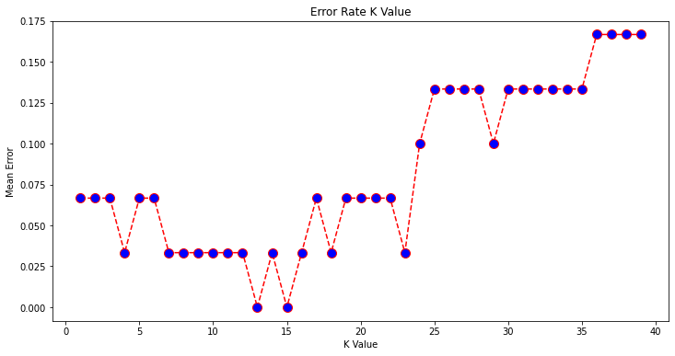

# Practical 6

### Implement the different Distance methods (Euclidean) with Prediction, Test Score and Confusion Matrix.

In [1]:

*# Importing the libraries*

**import** numpy **as** np

**import** matplotlib.pyplot **as** plt

**import** pandas **as** pd

In [2]:

*# Importing the dataset*

dataset **=** pd**.**read_csv('Social_Network_Ads.csv')

X **=** dataset**.**iloc[:, [2, 3]]**.**values y **=** dataset**.**iloc[:, **-**1]**.**values

In [3]:

*# Splitting the dataset into the Training set and Test set*

**from** sklearn.model_selection **import** train_test_split

X_train, X_test, y_train, y_test **=** train_test_split(X, y, test_size **=** 0.20, random

In [4]:

*# Feature Scaling*

**from** sklearn.preprocessing **import** StandardScaler sc **=** StandardScaler()

X_train **=** sc**.**fit_transform(X_train) X_test **=** sc**.**transform(X_test)

In [5]:

*# Training the K-NN model on the Training set*

**from** sklearn.neighbors **import** KNeighborsClassifier

classifier **=** KNeighborsClassifier(n_neighbors **=** 5, metric **=** 'minkowski', p **=** 2) classifier**.**fit(X_train, y_train)

Out[5]:

KNeighborsClassifier()

We are using 3 parameters in the model creation. n_neighbors is setting as 5, which means 5 neighborhood points are required for classifying a given point. The distance metric we are using is Minkowski, the equation for it is given below

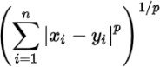

As per the equation, we have to select the p-value also. p = 1 , Manhattan Distance

p = 2 , Euclidean Distance

p = infinity , Cheybchev Distance

In our problem, we are choosing the p as 2 (also u can choose the metric as “euclidean”) Our Model is created, now we have to predict the output for the test set

In [6]:

*# Predicting the Test set results*

y_pred **=** classifier**.**predict(X_test)

In [10]:

y_pred

Out[10]:

|  |  |  |  |  |  |  |  |  |  |  |  |  |  |  |  |  |  |  |  |  |  |
| --- | --- | --- | --- | --- | --- | --- | --- | --- | --- | --- | --- | --- | --- | --- | --- | --- | --- | --- | --- | --- | --- |
| array([0, | 0, | 0, | 0, | 0, | 0, | 0, | 1, | 0, | 1, | 0, | 0, | 0, | 0, | 0, | 1, | 0, | 0, | 1, | 0, | 0, | 1, |
| 0, | 1, | 0, | 1, | 0, | 0, | 0, | 0, | 0, | 0, | 1, | 0, | 0, | 0, | 0, | 0, | 0, | 1, | 0, | 0, | 0, | 0, |
| 1, | 0, | 0, | 1, | 0, | 1, | 1, | 0, | 0, | 1, | 1, | 1, | 0, | 0, | 1, | 0, | 0, | 1, | 0, | 1, | 0, | 1, |
| 0, | 0, | 0, | 0, | 1, | 0, | 0, | 1, | 0, | 0, | 0, | 0, | 1, | 1]) |  |  |  |  |  |  |  |  |

In [7]:

*# Making the Confusion Matrix*

**from** sklearn.metrics **import** confusion_matrix, accuracy_score cm **=** confusion_matrix(y_test, y_pred)

ac **=** accuracy_score(y_test, y_pred)

In [8]:

Out[8]:

In [9]:

Out[9]:

In [ ]:

array([[55, 3],

cm

[ 1, 21]])

ac

0.95

## Implement the classification model using clustering for the following techniques with K means clustering with Prediction, Test Score and Confusion Matrix.

In [2]:

**import** numpy **as** np *# linear algebra*

**import** pandas **as** pd *# data processing, CSV file I/O (e.g. pd.read_csv)*

**import** matplotlib.pyplot **as** plt

**import** seaborn **as** sns

In [3]:

*# Importing the dataset*

dataset **=** pd**.**read_csv('/content/Mall_Customers.csv')

In [4]:

dataset**.**head()

|  |  |  |  |  |  |
| --- | --- | --- | --- | --- | --- |
| Out[4]: | **CustomerID** | **Genre** | **Age** | **Annual_Income_(k$)** | **Spending_Score** |
|  | **0** 1 | Male | 19 | 15 | 39 |
|  | **1** 2 | Male | 21 | 15 | 81 |
|  | **2** 3 | Female | 20 | 16 | 6 |
|  | **3** 4 | Female | 23 | 16 | 77 |
|  | **4** 5 | Female | 31 | 17 | 40 |

In [5]:

dataset**.**tail()

|  |  |  |  |  |  |
| --- | --- | --- | --- | --- | --- |
| Out[5]: | **CustomerID** | **Genre** | **Age** | **Annual_Income_(k$)** | **Spending_Score** |
|  | **195** 196 | Female | 35 | 120 | 79 |
|  | **196** 197 | Female | 45 | 126 | 28 |
|  | **197** 198 | Male | 32 | 126 | 74 |
|  | **198** 199 | Male | 32 | 137 | 18 |
|  | **199** 200 | Male | 30 | 137 | 83 |

In [6]:

Out[6]:

In [7]:

dataset**.**info()

(200, 5)

dataset**.**shape

<class 'pandas.core.frame.DataFrame'> RangeIndex: 200 entries, 0 to 199

Data columns (total 5 columns):

# Column Non-Null Count Dtype

|  |  |  |  |  |  |  |
| --- | --- | --- | --- | --- | --- | --- |
| 0 |  | CustomerID | 200 | non-null |  | int64 |
| 1 |  | Genre | 200 | non-null |  | object |
| 2 |  | Age | 200 | non-null |  | int64 |
| 3 |  | Annual_Income_(k$) | 200 | non-null |  | int64 |
| 4 |  | Spending_Score | 200 | non-null |  | int64 |

dtypes: int64(4), object(1) memory usage: 7.9+ KB

In [8]:

dataset**.**describe()

|  |  |  |  |  |  |
| --- | --- | --- | --- | --- | --- |
| Out[8]: |  | **CustomerID** | **Age** | **Annual_Income_(k$)** | **Spending_Score** |
|  | **count** | 200.000000 | 200.000000 | 200.000000 | 200.000000 |
|  | **mean** | 100.500000 | 38.850000 | 60.560000 | 50.200000 |
|  | **std** | 57.879185 | 13.969007 | 26.264721 | 25.823522 |
|  | **min** | 1.000000 | 18.000000 | 15.000000 | 1.000000 |
|  | **25%** | 50.750000 | 28.750000 | 41.500000 | 34.750000 |
|  | **50%** | 100.500000 | 36.000000 | 61.500000 | 50.000000 |
|  | **75%** | 150.250000 | 49.000000 | 78.000000 | 73.000000 |
|  | **max** | 200.000000 | 70.000000 | 137.000000 | 99.000000 |

In [9]:

Out[9]:

In [10]:

Out[10]:

In [11]:

data**=**dataset[['Annual_Income_(k$)','Spending_Score']]

CustomerID 0

dataset**.**isnull()**.**sum()

Genre 0

Age 0

Annual_Income_(k$) 0

Spending_Score 0

dtype: int64

dataset**.**columns

Index(['CustomerID', 'Genre', 'Age', 'Annual_Income_(k$)', 'Spending_Score'], dtyp e='object')

No Nans found! Great

In [12]:

data

|  |  |  |  |
| --- | --- | --- | --- |
| Out[12]: |  | **Annual_Income_(k$)** | **Spending_Score** |
|  | **0** | 15 | 39 |
|  | **1** | 15 | 81 |
|  | **2** | 16 | 6 |
|  | **3** | 16 | 77 |
|  | **4** | 17 | 40 |
|  | **...** | ... | ... |
|  | **195** | 120 | 79 |
|  | **196** | 126 | 28 |
|  | **197** | 126 | 74 |
|  | **198** | 137 | 18 |
|  | **199** | 137 | 83 |

200 rows × 2 columns

In [13]:

Out[13]:

In [14]:

data**.**values

(200, 2)

data**.**shape

Out[14]:

|  |  |  |
| --- | --- | --- |
| array([[ | 15, | 39], |
| [ | 15, | 81], |
| [ | 16, | 6], |
| [ | 16, | 77], |
| [ | 17, | 40], |
| [ | 17, | 76], |
| [ | 18, | 6], |
| [ | 18, | 94], |
| [ | 19, | 3], |
| [ | 19, | 72], |
| [ | 19, | 14], |
| [ | 19, | 99], |
| [ | 20, | 15], |
| [ | 20, | 77], |
| [ | 20, | 13], |
| [ | 20, | 79], |
| [ | 21, | 35], |
| [ | 21, | 66], |
| [ | 23, | 29], |
| [ | 23, | 98], |
| [ | 24, | 35], |
| [ | 24, | 73], |
| [ | 25, | 5], |
| [ | 25, | 73], |
| [ | 28, | 14], |
| [ | 28, | 82], |
| [ | 28, | 32], |
| [ | 28, | 61], |
| [ | 29, | 31], |
| [ | 29, | 87], |
| [ | 30, | 4], |
| [ | 30, | 73], |
| [ | 33, | 4], |
| [ | 33, | 92], |
| [ | 33, | 14], |
| [ | 33, | 81], |
| [ | 34, | 17], |
| [ | 34, | 73], |
| [ | 37, | 26], |
| [ | 37, | 75], |
| [ | 38, | 35], |
| [ | 38, | 92], |
| [ | 39, | 36], |
| [ | 39, | 61], |
| [ | 39, | 28], |
| [ | 39, | 65], |
| [ | 40, | 55], |
| [ | 40, | 47], |
| [ | 40, | 42], |
| [ | 40, | 42], |
| [ | 42, | 52], |
| [ | 42, | 60], |
| [ | 43, | 54], |
| [ | 43, | 60], |
| [ | 43, | 45], |
| [ | 43, | 41], |
| [ | 44, | 50], |
| [ | 44, | 46], |
| [ | 46, | 51], |
| [ | 46, | 46], |
| [ | 46, | 56], |
| [ | 46, | 55], |
| [ | 47, | 52], |
| [ | 47, | 59], |

|  |  |  |
| --- | --- | --- |
| [ | 48, | 51], |
| [ | 48, | 59], |
| [ | 48, | 50], |
| [ | 48, | 48], |
| [ | 48, | 59], |
| [ | 48, | 47], |
| [ | 49, | 55], |
| [ | 49, | 42], |
| [ | 50, | 49], |
| [ | 50, | 56], |
| [ | 54, | 47], |
| [ | 54, | 54], |
| [ | 54, | 53], |
| [ | 54, | 48], |
| [ | 54, | 52], |
| [ | 54, | 42], |
| [ | 54, | 51], |
| [ | 54, | 55], |
| [ | 54, | 41], |
| [ | 54, | 44], |
| [ | 54, | 57], |
| [ | 54, | 46], |
| [ | 57, | 58], |
| [ | 57, | 55], |
| [ | 58, | 60], |
| [ | 58, | 46], |
| [ | 59, | 55], |
| [ | 59, | 41], |
| [ | 60, | 49], |
| [ | 60, | 40], |
| [ | 60, | 42], |
| [ | 60, | 52], |
| [ | 60, | 47], |
| [ | 60, | 50], |
| [ | 61, | 42], |
| [ | 61, | 49], |
| [ | 62, | 41], |
| [ | 62, | 48], |
| [ | 62, | 59], |
| [ | 62, | 55], |
| [ | 62, | 56], |
| [ | 62, | 42], |
| [ | 63, | 50], |
| [ | 63, | 46], |
| [ | 63, | 43], |
| [ | 63, | 48], |
| [ | 63, | 52], |
| [ | 63, | 54], |
| [ | 64, | 42], |
| [ | 64, | 46], |
| [ | 65, | 48], |
| [ | 65, | 50], |
| [ | 65, | 43], |
| [ | 65, | 59], |
| [ | 67, | 43], |
| [ | 67, | 57], |
| [ | 67, | 56], |
| [ | 67, | 40], |
| [ | 69, | 58], |
| [ | 69, | 91], |
| [ | 70, | 29], |
| [ | 70, | 77], |
| [ | 71, | 35], |
| [ | 71, | 95], |

|  |  |  |
| --- | --- | --- |
| [ | 71, | 11], |
| [ | 71, | 75], |
| [ | 71, | 9], |
| [ | 71, | 75], |
| [ | 72, | 34], |
| [ | 72, | 71], |
| [ | 73, | 5], |
| [ | 73, | 88], |
| [ | 73, | 7], |
| [ | 73, | 73], |
| [ | 74, | 10], |
| [ | 74, | 72], |
| [ | 75, | 5], |
| [ | 75, | 93], |
| [ | 76, | 40], |
| [ | 76, | 87], |
| [ | 77, | 12], |
| [ | 77, | 97], |
| [ | 77, | 36], |
| [ | 77, | 74], |
| [ | 78, | 22], |
| [ | 78, | 90], |
| [ | 78, | 17], |
| [ | 78, | 88], |
| [ | 78, | 20], |
| [ | 78, | 76], |
| [ | 78, | 16], |
| [ | 78, | 89], |
| [ | 78, | 1], |
| [ | 78, | 78], |
| [ | 78, | 1], |
| [ | 78, | 73], |
| [ | 79, | 35], |
| [ | 79, | 83], |
| [ | 81, | 5], |
| [ | 81, | 93], |
| [ | 85, | 26], |
| [ | 85, | 75], |
| [ | 86, | 20], |
| [ | 86, | 95], |
| [ | 87, | 27], |
| [ | 87, | 63], |
| [ | 87, | 13], |
| [ | 87, | 75], |
| [ | 87, | 10], |
| [ | 87, | 92], |
| [ | 88, | 13], |
| [ | 88, | 86], |
| [ | 88, | 15], |
| [ | 88, | 69], |
| [ | 93, | 14], |
| [ | 93, | 90], |
| [ | 97, | 32], |
| [ | 97, | 86], |
| [ | 98, | 15], |
| [ | 98, | 88], |
| [ | 99, | 39], |
| [ | 99, | 97], |
| [101, | | 24], |
| [101, | | 68], |
| [103, | | 17], |
| [103, | | 85], |
| [103, | | 23], |
| [103, | | 69], |

|  |  |
| --- | --- |
| [113, | 8], |
| [113, | 91], |
| [120, | 16], |
| [120, | 79], |
| [126, | 28], |
| [126, | 74], |
| [137, | 18], |
| [137, | 83]]) |

In [17]:

*#we always assume the max number of cluster would be 10 #you can judge the number of clusters by doing averaging ###Static code to get max no of clusters*

X **=** dataset**.**iloc[:, [2, 3]]**.**values

In [18]:

*# Using the elbow method to find the optimal number of clusters*

**from** sklearn.cluster **import** KMeans wc_ss **=** []

**for** i **in** range(1, 11):

kmeans_clu **=** KMeans(n_clusters **=** i, random_state **=** 56) kmeans_clu**.**fit(X)

*# inertia method returns wcss for that model*

wc_ss**.**append(kmeans_clu**.**inertia_)

In [19]:

plt**.**figure(figsize**=**(10,5))

plt**.**plot(range(1,11), wc_ss) plt**.**title('The Elbow Method')

plt**.**xlabel('Number of clusters') plt**.**ylabel('WCSS')

plt**.**show()

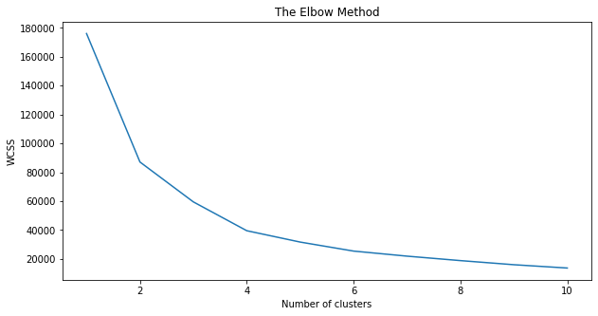

this curve is telling you that last elbow comes at k=5 no matter what range we select ex- (1,21) also i will see the same behaviour but if we chose higher range it is little difficult to visualize the ELBOW that is why we usually prefer range (1,11) Finally we got that k=5

In [20]:

*# Fitting K-Means to the dataset*

kmeans **=** KMeans(n_clusters **=** 5, random_state **=** 56) y_kmeans **=** kmeans**.**fit_predict(X)

7. Visualisation

|  |  |  |  |  |  |  |  |  |  |  |  |  |  |  |
| --- | --- | --- | --- | --- | --- | --- | --- | --- | --- | --- | --- | --- | --- | --- |
| In [21]: | plt**.**scatter(X[y_kmeans | **==** | 0, | 0], | X[y_kmeans | **==** | 0, | 1], | s | **=** | 100, | c | **=** | 'pink', label **=** |
|  | plt**.**scatter(X[y_kmeans | **==** | 1, | 0], | X[y_kmeans | **==** | 1, | 1], | s | **=** | 100, | c | **=** | 'yellow', label |
|  | plt**.**scatter(X[y_kmeans | **==** | 2, | 0], | X[y_kmeans | **==** | 2, | 1], | s | **=** | 100, | c | **=** | 'red', label **=** |
|  | plt**.**scatter(X[y_kmeans | **==** | 3, | 0], | X[y_kmeans | **==** | 3, | 1], | s | **=** | 100, | c | **=** | 'orange', label |
|  | plt**.**scatter(X[y_kmeans | **==** | 4, | 0], | X[y_kmeans | **==** | 4, | 1], | s | **=** | 100, | c | **=** | 'green', label |
|  | plt**.**scatter(kmeans**.**cluster_centers_[:, 0], kmeans**.**cluster_centers_[:, 1], s **=** 300, plt**.**title('Clusters of customers')  plt**.**xlabel('Annual Income (k$)')  plt**.**ylabel('Spending Score (1-100)') plt**.**legend()  plt**.**show() | | | | | | | | | | | | | |

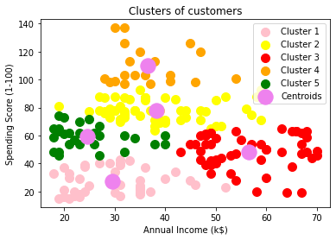

# Practical 7

## Implement the classification model using clustering for the following techniques with hierarchical clustering with Prediction, Test Score and Confusion Matrix

In [1]:

**import** numpy **as** np

**import** matplotlib.pyplot **as** plt

**import** pandas **as** pd

In [3]:

dataset **=** pd**.**read_csv('Mall_Customers.csv')

In [7]:

dataset**.**head()

|  |  |  |  |  |  |
| --- | --- | --- | --- | --- | --- |
| Out[7]: | **CustomerID** | **Genre** | **Age** | **Annual_Income_(k$)** | **Spending_Score** |
|  | **0** 1 | Male | 19 | 15 | 39 |
|  | **1** 2 | Male | 21 | 15 | 81 |
|  | **2** 3 | Female | 20 | 16 | 6 |
|  | **3** 4 | Female | 23 | 16 | 77 |
|  | **4** 5 | Female | 31 | 17 | 40 |

Our goal is to cluster the customers based on their Spending score. That’s why CustomerID and Genre are useless. So we remove both columns.

In [8]:

X **=** dataset**.**iloc[:, [3, 4]]**.**values

Now, we have only Annual Income and Spending Score Column.

In [9]:

X

Out[9]:

|  |  |  |
| --- | --- | --- |
| array([[ | 15, | 39], |
| [ | 15, | 81], |
| [ | 16, | 6], |
| [ | 16, | 77], |
| [ | 17, | 40], |
| [ | 17, | 76], |
| [ | 18, | 6], |
| [ | 18, | 94], |
| [ | 19, | 3], |
| [ | 19, | 72], |
| [ | 19, | 14], |
| [ | 19, | 99], |
| [ | 20, | 15], |
| [ | 20, | 77], |
| [ | 20, | 13], |
| [ | 20, | 79], |
| [ | 21, | 35], |
| [ | 21, | 66], |
| [ | 23, | 29], |
| [ | 23, | 98], |
| [ | 24, | 35], |
| [ | 24, | 73], |
| [ | 25, | 5], |
| [ | 25, | 73], |
| [ | 28, | 14], |
| [ | 28, | 82], |
| [ | 28, | 32], |
| [ | 28, | 61], |
| [ | 29, | 31], |
| [ | 29, | 87], |
| [ | 30, | 4], |
| [ | 30, | 73], |
| [ | 33, | 4], |
| [ | 33, | 92], |
| [ | 33, | 14], |
| [ | 33, | 81], |
| [ | 34, | 17], |
| [ | 34, | 73], |
| [ | 37, | 26], |
| [ | 37, | 75], |
| [ | 38, | 35], |
| [ | 38, | 92], |
| [ | 39, | 36], |
| [ | 39, | 61], |
| [ | 39, | 28], |
| [ | 39, | 65], |
| [ | 40, | 55], |
| [ | 40, | 47], |
| [ | 40, | 42], |
| [ | 40, | 42], |
| [ | 42, | 52], |
| [ | 42, | 60], |
| [ | 43, | 54], |
| [ | 43, | 60], |
| [ | 43, | 45], |
| [ | 43, | 41], |
| [ | 44, | 50], |
| [ | 44, | 46], |
| [ | 46, | 51], |
| [ | 46, | 46], |
| [ | 46, | 56], |
| [ | 46, | 55], |
| [ | 47, | 52], |
| [ | 47, | 59], |

|  |  |  |
| --- | --- | --- |
| [ | 48, | 51], |
| [ | 48, | 59], |
| [ | 48, | 50], |
| [ | 48, | 48], |
| [ | 48, | 59], |
| [ | 48, | 47], |
| [ | 49, | 55], |
| [ | 49, | 42], |
| [ | 50, | 49], |
| [ | 50, | 56], |
| [ | 54, | 47], |
| [ | 54, | 54], |
| [ | 54, | 53], |
| [ | 54, | 48], |
| [ | 54, | 52], |
| [ | 54, | 42], |
| [ | 54, | 51], |
| [ | 54, | 55], |
| [ | 54, | 41], |
| [ | 54, | 44], |
| [ | 54, | 57], |
| [ | 54, | 46], |
| [ | 57, | 58], |
| [ | 57, | 55], |
| [ | 58, | 60], |
| [ | 58, | 46], |
| [ | 59, | 55], |
| [ | 59, | 41], |
| [ | 60, | 49], |
| [ | 60, | 40], |
| [ | 60, | 42], |
| [ | 60, | 52], |
| [ | 60, | 47], |
| [ | 60, | 50], |
| [ | 61, | 42], |
| [ | 61, | 49], |
| [ | 62, | 41], |
| [ | 62, | 48], |
| [ | 62, | 59], |
| [ | 62, | 55], |
| [ | 62, | 56], |
| [ | 62, | 42], |
| [ | 63, | 50], |
| [ | 63, | 46], |
| [ | 63, | 43], |
| [ | 63, | 48], |
| [ | 63, | 52], |
| [ | 63, | 54], |
| [ | 64, | 42], |
| [ | 64, | 46], |
| [ | 65, | 48], |
| [ | 65, | 50], |
| [ | 65, | 43], |
| [ | 65, | 59], |
| [ | 67, | 43], |
| [ | 67, | 57], |
| [ | 67, | 56], |
| [ | 67, | 40], |
| [ | 69, | 58], |
| [ | 69, | 91], |
| [ | 70, | 29], |
| [ | 70, | 77], |
| [ | 71, | 35], |
| [ | 71, | 95], |

|  |  |  |
| --- | --- | --- |
| [ | 71, | 11], |
| [ | 71, | 75], |
| [ | 71, | 9], |
| [ | 71, | 75], |
| [ | 72, | 34], |
| [ | 72, | 71], |
| [ | 73, | 5], |
| [ | 73, | 88], |
| [ | 73, | 7], |
| [ | 73, | 73], |
| [ | 74, | 10], |
| [ | 74, | 72], |
| [ | 75, | 5], |
| [ | 75, | 93], |
| [ | 76, | 40], |
| [ | 76, | 87], |
| [ | 77, | 12], |
| [ | 77, | 97], |
| [ | 77, | 36], |
| [ | 77, | 74], |
| [ | 78, | 22], |
| [ | 78, | 90], |
| [ | 78, | 17], |
| [ | 78, | 88], |
| [ | 78, | 20], |
| [ | 78, | 76], |
| [ | 78, | 16], |
| [ | 78, | 89], |
| [ | 78, | 1], |
| [ | 78, | 78], |
| [ | 78, | 1], |
| [ | 78, | 73], |
| [ | 79, | 35], |
| [ | 79, | 83], |
| [ | 81, | 5], |
| [ | 81, | 93], |
| [ | 85, | 26], |
| [ | 85, | 75], |
| [ | 86, | 20], |
| [ | 86, | 95], |
| [ | 87, | 27], |
| [ | 87, | 63], |
| [ | 87, | 13], |
| [ | 87, | 75], |
| [ | 87, | 10], |
| [ | 87, | 92], |
| [ | 88, | 13], |
| [ | 88, | 86], |
| [ | 88, | 15], |
| [ | 88, | 69], |
| [ | 93, | 14], |
| [ | 93, | 90], |
| [ | 97, | 32], |
| [ | 97, | 86], |
| [ | 98, | 15], |
| [ | 98, | 88], |
| [ | 99, | 39], |
| [ | 99, | 97], |
| [101, | | 24], |
| [101, | | 68], |
| [103, | | 17], |
| [103, | | 85], |
| [103, | | 23], |
| [103, | | 69], |

|  |  |
| --- | --- |
| [113, | 8], |
| [113, | 91], |
| [120, | 16], |
| [120, | 79], |
| [126, | 28], |
| [126, | 74], |
| [137, | 18], |
| [137, | 83]]) |

We have loaded dataset. Now its time to find the optimal number of clusters. And for that we need to create a Dendrogram.

In [10]:

*# Create Dendrogram to find the Optimal Number of Clusters*

**import** scipy.cluster.hierarchy **as** sch

dendro **=** sch**.**dendrogram(sch**.**linkage(X, method **=** 'ward')) plt**.**title('Dendrogram')

plt**.**xlabel('Customers')

plt**.**ylabel('Euclidean distances') plt**.**show()

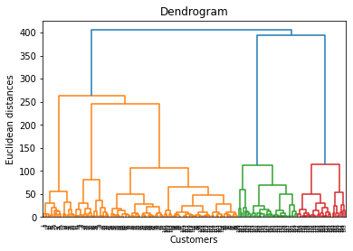

Here in the code “sch” is the short code for scipy.cluster.hierarchy.”

“dendro” is the variable name. It may be anything. And “Dendrogram” is the function name. So, after implementing this code, we will get our Dendrogram.

As I discussed that cut the horizontal line with longest line that traverses maximum distance up and down without intersecting the merging points.

In that dendrogram, the optimal number of clusters are 5. Now let’s fit our Agglomerative model with 5 clusters.

In [11]:

*# Fitting Agglomerative Hierarchical Clustering to the dataset*

**from** sklearn.cluster **import** AgglomerativeClustering

hc **=** AgglomerativeClustering(n_clusters **=** 5, affinity **=** 'euclidean', linkage **=** 'wa y_hc **=** hc**.**fit_predict(X)

Now our model has been trained. If you want to see different clusters, you can do it by simply writing print.

In [12]:

print(y_hc)

|  |  |  |  |  |  |  |  |  |  |  |  |  |  |  |  |  |  |  |  |  |  |  |  |  |  |  |  |  |  |  |  |  |  |  |  |  |
| --- | --- | --- | --- | --- | --- | --- | --- | --- | --- | --- | --- | --- | --- | --- | --- | --- | --- | --- | --- | --- | --- | --- | --- | --- | --- | --- | --- | --- | --- | --- | --- | --- | --- | --- | --- | --- |
| [4 | 3 | 4 | 3 | 4 | 3 | 4 | 3 | 4 | 3 | 4 | 3 | 4 | 3 | 4 | 3 | 4 | 3 | 4 | 3 | 4 | 3 | 4 | 3 | 4 | 3 | 4 | 3 | 4 | 3 | 4 | 3 | 4 | 3 | 4 | 3 | 4 |
| 3 | 4 | 3 | 4 | 3 | 4 | 1 | 4 | 1 | 1 | 1 | 1 | 1 | 1 | 1 | 1 | 1 | 1 | 1 | 1 | 1 | 1 | 1 | 1 | 1 | 1 | 1 | 1 | 1 | 1 | 1 | 1 | 1 | 1 | 1 | 1 | 1 |
| 1 | 1 | 1 | 1 | 1 | 1 | 1 | 1 | 1 | 1 | 1 | 1 | 1 | 1 | 1 | 1 | 1 | 1 | 1 | 1 | 1 | 1 | 1 | 1 | 1 | 1 | 1 | 1 | 1 | 1 | 1 | 1 | 1 | 1 | 1 | 1 | 1 |
| 1 | 1 | 1 | 1 | 1 | 1 | 1 | 1 | 1 | 1 | 1 | 1 | 2 | 1 | 2 | 1 | 2 | 0 | 2 | 0 | 2 | 1 | 2 | 0 | 2 | 0 | 2 | 0 | 2 | 0 | 2 | 1 | 2 | 0 | 2 | 1 | 2 |
| 0 | 2 | 0 | 2 | 0 | 2 | 0 | 2 | 0 | 2 | 0 | 2 | 1 | 2 | 0 | 2 | 0 | 2 | 0 | 2 | 0 | 2 | 0 | 2 | 0 | 2 | 0 | 2 | 0 | 2 | 0 | 2 | 0 | 2 | 0 | 2 | 0 |
| 2 | 0 | 2 | 0 | 2 | 0 | 2 | 0 | 2 | 0 | 2 | 0 | 2 | 0 | 2] |  |  |  |  |  |  |  |  |  |  |  |  |  |  |  |  |  |  |  |  |  |  |
| Now, its time to visualize the clusters. | | | | | | | | | | | | | | | | | | | | | | | | | | | | | | | | | | | | |
| *# Visualise the clusters* | | | | | | | | | | | | | | | | | | | | | | | | | | | | | | | | | | | | |
| plt**.**scatter(X[y_hc | | | | | | | | | **==** | 0, | | 0], | | X[y_hc | | | **==** | | 0, | 1], | | s | | **=** | 100, | | c | **=** | 'red', label **=** 'Cluster | | | | | | | |
| plt**.**scatter(X[y_hc | | | | | | | | | **==** | 1, | | 0], | | X[y_hc | | | **==** | | 1, | 1], | | s | | **=** | 100, | | c | **=** | 'blue', label **=** 'Cluste | | | | | | | |
| plt**.**scatter(X[y_hc | | | | | | | | | **==** | 2, | | 0], | | X[y_hc | | | **==** | | 2, | 1], | | s | | **=** | 100, | | c | **=** | 'green', label **=** 'Clust | | | | | | | |
| plt**.**scatter(X[y_hc | | | | | | | | | **==** | 3, | | 0], | | X[y_hc | | | **==** | | 3, | 1], | | s | | **=** | 100, | | c | **=** | 'cyan', label **=** 'Cluste | | | | | | | |
| plt**.**scatter(X[y_hc | | | | | | | | | **==** | 4, | | 0], | | X[y_hc | | | **==** | | 4, | 1], | | s | | **=** | 100, | | c | **=** | 'magenta', label **=** 'Clu | | | | | | | |
| plt**.**title('Clusters of customers') plt**.**xlabel('Annual Income (k$)')  plt**.**ylabel('Spending Score (1-100)') plt**.**legend()  plt**.**show() | | | | | | | | | | | | | | | | | | | | | | | | | | | | | | | | | | | | |

In [13]:

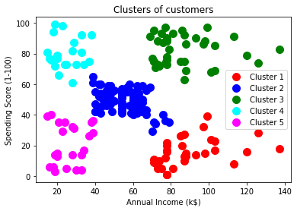

In [ ]:

# Practical 8

## A. Exploratory Data Analysis (EDA)

Objective to achieve, understand and implement following topics

* Handle Missing value
* Removing duplicates
* Outlier Treatment
* Normalizing and Scaling( Numerical Variables)
* Encoding Categorical variables( Dummy Variables)
* Bivariate Analysis

In [61]:

*# Importing all the necessary libraries* **import** numpy **as** np *# numerial python* **import** pandas **as** pd *# dataframe working*

**import** matplotlib.pyplot **as** plt *# plotting*

**import** seaborn **as** sn *# advance plotting*

**%matplotlib** inline

In [22]:

df_car **=** pd**.**read_excel("/content/EDA Cars.xlsx") df_car**.**head(30)

Out[22]:

|  |  |  |  |  |  |  |  |  |  |
| --- | --- | --- | --- | --- | --- | --- | --- | --- | --- |
| **INDEX** | | **INCOME** | **MARITAL STATUS** | **SEX** | **EDUCATION** | **JOB** | **TRAVEL**  **TIME** | **USE** | **MILES CLOCKED** |
| **0** | 1 | 125301 | No | F | Bachelors | Blue Collar | 45.703013 | Commercial | 17430.0 |
| **1** | 2 | 50815.4 | No | M | High School | NaN | 20.591628 | Private | 18930.0 |
| **2** | 3 | 62977.8 | NaN | F | Bachelors | Clerical | 33.639949 | Private | NaN |
| **3** | 4 | 77100 | No | F | NaN | Lawyer | 15.415676 | NaN | 18300.0 |
| **4** | 5 | 130795 | No | M | High School | NaN | NaN | Commercial | 28340.0 |
| **5** | 6 | NaN | NaN | F | High School | Home Maker | 48.360191 | NaN | 6000.0 |
| **6** | 7 | 87460.1 | No | M | High School | Manager | 45.000488 | NaN | 15420.0 |
| **7** | 8 | NaN | Yes | F | High School | Blue Collar | 15.665947 | NaN | 11290.0 |
| **8** | 9 | @@ | NaN | F | NaN | Clerical | 26.392961 | NaN | 10030.0 |
| **9** | 10 | @@ | Yes | M | High School | Blue Collar | 27.490749 | NaN | NaN |
| **10** | 11 | 16988.7 | No | M | High School | Blue Collar | 20.450016 | NaN | NaN |
| **11** | 12 | @@ | No | F | High School | Blue Collar | 61.603208 | Commercial | 9360.0 |
| **12** | 13 | 16352 | Yes | F | NaN | Home Maker | NaN | Private | 10520.0 |
| **13** | 14 | 63952.2 | Yes | F | Masters | Lawyer | 49.576895 | Private | 32340.0 |
| **14** | 15 | 24059.7 | No | M | Bachelors | Clerical | 24.430198 | Private | 14220.0 |
| **15** | 16 | 20821.8 | Yes | F | High School | Home Maker | 45.907713 | Private | 6880.0 |
| **16** | 17 | @@ | No | F | High School | Blue Collar | 42.500815 | Private | NaN |
| **17** | 18 | 137103 | NaN | F | NaN | Manager | 28.800357 | Private | 19510.0 |
| **18** | 19 | 102393 | No | M | Bachelors | Professional | 24.867970 | NaN | 1500.0 |
| **19** | 20 | 40656.4 | Yes | F | High School | NaN | 57.091375 | Private | 9170.0 |
| **20** | 21 | @@ | Yes | F | Bachelors | Blue Collar | NaN | Commercial | 5200.0 |
| **21** | 22 | 31773.1 | Yes | M | High School | Clerical | 14.459323 | Commercial | 9640.0 |
| **22** | 23 | 38035.6 | Yes | F | High School | Blue Collar | 32.180285 | Commercial | 13140.0 |
| **23** | 24 | 0 | Yes | F | High School | Home Maker | 24.520001 | Private | 11740.0 |
| **24** | 25 | 0 | NaN | M | High School | Student | 13.662860 | Commercial | 15090.0 |
| **25** | 26 | NaN | Yes | F | Bachelors | Student | 48.143336 | Commercial | 12850.0 |
| **26** | 27 | 44705.2 | Yes | F | Bachelors | Professional | 50.088976 | Private | 12840.0 |
| **27** | 28 | 31738.4 | Yes | M | High School | Blue Collar | 23.286841 | Commercial | NaN |

|  |  |  |  |  |  |  |  |  |  |
| --- | --- | --- | --- | --- | --- | --- | --- | --- | --- |
|  | **INDEX** | **INCOME** | **MARITAL STATUS** | **SEX** | **EDUCATION** | **JOB** | **TRAVEL**  **TIME** | **USE** | **MILES CLOCKED** |
| **28** | 29 | 64013.8 | Yes | M | High School | Blue Collar | 32.717234 | Commercial | 7900.0 |
| **29** | 30 | 53244.4 | No | M | Bachelors | Professional | 27.551402 | NaN | 20920.0 |

In [23]:

Out[23]:

In [24]:

(303, 13)

df_car**.**shape

<class 'pandas.core.frame.DataFrame'> RangeIndex: 303 entries, 0 to 302

df_car**.**info()

Data columns (total 13 columns):

# Column Non-Null Count Dtype

|  |  |  |  |  |  |  |  |
| --- | --- | --- | --- | --- | --- | --- | --- |
| 0 |  | INDEX |  | 303 | non-null |  | int64 |
| 1 |  | INCOME |  | 265 | non-null |  | object |
| 2 |  | MARITAL | STATUS | 275 | non-null |  | object |
| 3 |  | SEX |  | 297 | non-null |  | object |
| 4 | EDUCATION | | | 259 | non-null | object | |
| 5 | JOB | | | 257 | non-null | object | |
| 6 | TRAVEL TIME | | | 262 | non-null | float64 | |
| 7 | USE | | | 250 | non-null | object | |
| 8 | MILES CLOCKED | | | 278 | non-null | float64 | |
| 9 | CAR TYPE | | | 293 | non-null | object | |
| 10 | CAR AGE | | | 283 | non-null | float64 | |
| 11 | CITY | | | 297 | non-null | object | |
| 12 | POSTAL CODE | | | 300 | non-null | float64 | |

dtypes: float64(4), int64(1), object(8) memory usage: 30.9+ KB

In [16]:

df_car**.**describe()

|  |  |  |  |  |  |  |
| --- | --- | --- | --- | --- | --- | --- |
| Out[16]: |  | **INDEX** | **TRAVEL TIME** | **MILES CLOCKED** | **CAR AGE** | **POSTAL CODE** |
|  | **count** | 303.000000 | 262.000000 | 278.000000 | 283.000000 | 300.000000 |
|  | **mean** | 139.640264 | 34.282098 | 13591.978417 | 6.265018 | 50712.196667 |
|  | **std** | 85.178422 | 14.910178 | 7167.328655 | 5.111218 | 24141.029290 |
|  | **min** | 1.000000 | 5.000000 | 1500.000000 | 1.000000 | 11435.000000 |
|  | **25%** | 62.500000 | 24.449874 | 7900.000000 | 1.000000 | 42420.000000 |
|  | **50%** | 138.000000 | 33.564757 | 12065.000000 | 6.000000 | 47150.000000 |
|  | **75%** | 213.500000 | 43.907339 | 18240.000000 | 10.000000 | 61701.000000 |
|  | **max** | 289.000000 | 83.617643 | 38000.000000 | 20.000000 | 90049.000000 |

In [25]:

df_car**.**describe(include**=**['object', 'int','float'])

Out[25]:

|  |  |  |  |  |  |  |  |  |  |
| --- | --- | --- | --- | --- | --- | --- | --- | --- | --- |
|  | **INDEX IN** | **COME** | **MARITAL STATUS** | **SEX EDUCATION** | | **JOB** | **TRAVEL**  **TIME** | **USE** | **MIL CLOCKE** |
| **count** | 303.000000 | 265.0 | 275 | 297 | 259 | 257 | 262.000000 | 250 | 278.0000 |
| **unique** | NaN | 222.0 | 2 | 2 | 4 | 8 | NaN | 2 | Na |
| **top** NaN 0.0 No F High School Blue NaN Private Na | | | | | | | | | |

|  |  |  |  |  |  |  |  |  |  |
| --- | --- | --- | --- | --- | --- | --- | --- | --- | --- |
|  | | | | | | Collar |  | | |
| **freq** | NaN | 25.0 | 151 | 165 | 161 | 96 | NaN | 133 | Na |
| **mean** | 139.640264 | NaN | NaN | NaN | NaN | NaN | 34.282098 | NaN | 13591.9784 |
| **std** | 85.178422 | NaN | NaN | NaN | NaN | NaN | 14.910178 | NaN | 7167.3286 |
| **min** | 1.000000 | NaN | NaN | NaN | NaN | NaN | 5.000000 | NaN | 1500.0000 |
| **25%** | 62.500000 | NaN | NaN | NaN | NaN | NaN | 24.449874 | NaN | 7900.0000 |
| **50%** | 138.000000 | NaN | NaN | NaN | NaN | NaN | 33.564757 | NaN | 12065.0000 |
| **75%** | 213.500000 | NaN | NaN | NaN | NaN | NaN | 43.907339 | NaN | 18240.0000 |
| **max** | 289.000000 | NaN | NaN | NaN | NaN | NaN | 83.617643 | NaN | 38000.0000 |

In [26]:

Out[26]:

0 125301

df_car**.**INCOME

1 50815.4

2 62977.8

3 77100

4 130795

...

298 15251.5

299 18408.4

1. NaN
2. NaN

302 0

Name: INCOME, Length: 303, dtype: object

df_car[df_car['INCOME'] **==** '@@']

In [27]:

Out[27]:

**INDEX INCOME MARITAL**

**STATUS**

**SEX EDUCATION JOB TRAVEL**

**TIME**

**USE MILES CA CLOCKED TY**

**8** 9 @@ NaN F NaN Clerical 26.392961 NaN 10030.0 SU

ue lar

27.490749

NaN

NaN Pan Tru

ue lar

ue lar

42.500815

Private

NaN SU

|  |  |  |  |  |  |
| --- | --- | --- | --- | --- | --- |
| **9** | 10 | @@ | Yes | M | High School Bl Col |
| **11** | 12 | @@ | No | F | High School Bl Col |
| **16** | 17 | @@ | No | F | High School Bl Col |
| **20** | 21 | @@ | Yes | F | Bachelors Bl |

ue Collar

61.603208 Commercial 9360.0 Spo

C

NaN Commercial 5200.0 SU

In [19]:

In [29]:

df_car['INCOME'] **=** df_car['INCOME']**.**replace(to_replace **=** '@@', value**=** np**.**nan)

df_car['INCOME'] **=** df_car['INCOME']**.**astype(float)

In [30]:

Out[30]:

In [31]:

*#df_car['TRAVEL TIME'] = df_car['TRAVEL TIME'].replace(to_replace = '*****', value*

**INDEX INCOME MARITAL**

df_car[df_car['INCOME'] **==** '@@']

**STATUS**

**SEX EDUCATION JOB TRAVEL**

**TIME**

**USE MILES CLOCKED**

**CAR TYPE**

**CAR AGE**

**CITY**

In [32]:

df_car['TRAVEL TIME'] **=** df_car['TRAVEL TIME']**.**astype(float)

In [35]:

*#df_car['MILES CLOCKED'] = df_car['MILES CLOCKED'].replace(to_replace = 'Na', value #df_car['MILES CLOCKED'] = df_car['MILES CLOCKED'].replace(to_replace = '*****', va #df_car['MILES CLOCKED'] = df_car['MILES CLOCKED'].astype(float)*

|  |  |  |
| --- | --- | --- |
| In | [34]: | *#df_car.replace(to_replace='*****', value= np.nan, inplace = True)* |
|  |  |  |
| In | [33]: | df_car**.**info() |
|  |  | <class 'pandas.core.frame.DataFrame'> RangeIndex: 303 entries, 0 to 302 |

Data columns (total 13 columns):

# Column Non-Null Count Dtype

|  |  |  |  |  |  |  |  |
| --- | --- | --- | --- | --- | --- | --- | --- |
| 0 |  | INDEX |  | 303 | non-null |  | int64 |
| 1 |  | INCOME |  | 260 | non-null |  | float64 |
| 2 |  | MARITAL | STATUS | 275 | non-null |  | object |
| 3 |  | SEX |  | 297 | non-null |  | object |
| 4 | EDUCATION | | | 259 | non-null | object | |
| 5 | JOB | | | 257 | non-null | object | |
| 6 | TRAVEL TIME | | | 262 | non-null | float64 | |
| 7 | USE | | | 250 | non-null | object | |
| 8 | MILES CLOCKED | | | 278 | non-null | float64 | |
| 9 | CAR TYPE | | | 293 | non-null | object | |
| 10 | CAR AGE | | | 283 | non-null | float64 | |
| 11 | CITY | | | 297 | non-null | object | |
| 12 | POSTAL CODE | | | 300 | non-null | float64 | |

dtypes: float64(5), int64(1), object(7) memory usage: 30.9+ KB

In [36]:

*# Check for missing values in any column or Handling missing values in dataset*

df_car**.**isnull()**.**sum()

Out[36]:

INDEX 0

INCOME 43

MARITAL STATUS 28

SEX 6

|  |  |
| --- | --- |
| EDUCATION | 44 |
| JOB | 46 |
| TRAVEL TIME | 41 |
| USE | 53 |
| MILES CLOCKED | 25 |
| CAR TYPE | 10 |
| CAR AGE | 20 |
| CITY | 6 |
| POSTAL CODE  dtype: int64 | 3 |

### We can see that we have various missing values in the respective columns. There are various ways of treating your missing values in the data set. And which technique to use when is actually dependent on the type of data you are dealing with.

 Drop the missing values: In this case, we drop the missing values from those variables.

In case there are very few missing values you can drop those values.

 Impute with mean value: For the numerical column, you can replace the missing values with mean values. Before replacing with mean value, it is advisable to check that the

variable shouldn’t have extreme values .i.e. outliers.

 Impute with median value: For the numerical column, you can also replace the missing values with median values. In case you have extreme values such as outliers it is

advisable to use the median approach.

 Impute with mode value: For the categorical column, you can replace the missing values with mode values i.e the frequent ones.

In [37]:

*# In this exercise, we will replace the numerical columns with median values and fo*

*#Replacing the NULL Values in numerical columns using MEDIAN*

median_income **=** df_car['INCOME']**.**median()

median_travel_time **=** df_car['TRAVEL TIME']**.**median()

median_miles_clocked **=** df_car['MILES CLOCKED']**.**median() median_car_age **=** df_car['CAR AGE']**.**median()

median_postal_code **=** df_car['POSTAL CODE']**.**median()

df_car['INCOME']**.**replace(np**.**nan, median_income, inplace **= True**)

df_car['TRAVEL TIME']**.**replace(np**.**nan, median_travel_time, inplace **= True**)

df_car['MILES CLOCKED']**.**replace(np**.**nan, median_miles_clocked, inplace **= True**) df_car['CAR AGE']**.**replace(np**.**nan, median_car_age, inplace **= True**)

df_car['POSTAL CODE']**.**replace(np**.**nan, median_postal_code, inplace **= True**)

In [38]:

*# Replacing the NULL values in categorical columns using MODE*

mode_sex **=** df_car['SEX']**.**mode()**.**values[0]

mode_martial_status **=** df_car['MARITAL STATUS']**.**mode()**.**values[0] mode_education **=** df_car['EDUCATION']**.**mode()**.**values[0]

mode_job **=** df_car['JOB']**.**mode()**.**values[0]

mode_use **=** df_car['USE']**.**mode()**.**values[0] mode_city **=** df_car['CITY']**.**mode()**.**values[0]

mode_car_type **=** df_car['CAR TYPE']**.**mode()**.**values[0]

df_car['SEX']**=** df_car['SEX']**.**replace(np**.**nan, mode_sex)

df_car['MARITAL STATUS']**=** df_car['MARITAL STATUS']**.**replace(np**.**nan, mode_martial_sta df_car['EDUCATION']**=** df_car['EDUCATION']**.**replace(np**.**nan, mode_education)

df_car['JOB']**=** df_car['JOB']**.**replace(np**.**nan, mode_job) df_car['USE']**=** df_car['USE']**.**replace(np**.**nan, mode_use)

df_car['CITY']**=** df_car['CITY']**.**replace(np**.**nan, mode_city)

df_car['CAR TYPE']**=** df_car['CAR TYPE']**.**replace(np**.**nan, mode_car_type)

In [39]:

Out[39]:

In [40]:

df_car**.**isnull()**.**sum()

INDEX 0

INCOME 0

MARITAL STATUS 0

SEX 0

EDUCATION 0

JOB 0

TRAVEL TIME 0

USE 0

MILES CLOCKED 0

CAR TYPE 0

CAR AGE 0

CITY 0

POSTAL CODE 0

dtype: int64

*# Handling Duplicate Records*

duplicate **=** df_car**.**duplicated() print(duplicate**.**sum())

df_car[duplicate]

14

Out[40]:

**INDEX INCOME MARITAL**

**STATUS**

**SEX EDUCATION JOB TRAVEL**

**TIME**

**USE MILES**

**CLOCKED T**

**69** 29 64013.81632 Yes M High School Blue

Collar

32.717234 Commercial 7900.0 Pi

**70**

29 64013.81632

Yes M High School

Blue Collar

32.717234 Commercial

7900.0 Pi

**71** 29 64013.81632 Yes M High School Blue

Collar

32.717234 Commercial 7900.0 Pi

**72**

29 64013.81632

Yes M High School

Blue Collar

32.717234 Commercial

7900.0 Pi

**73** 29 64013.81632 Yes M High School Blue

Collar

32.717234 Commercial 7900.0 Pi

**74**

29 64013.81632

Yes M High School

Blue Collar

32.717234 Commercial

7900.0 Pi

**75** 29 64013.81632 Yes M High School Blue

Collar

32.717234 Commercial 7900.0 Pi

**76**

29 64013.81632

Yes M High School

Blue Collar

32.717234 Commercial

7900.0 Pi

**77** 29 64013.81632 Yes M High School Blue

Collar

32.717234 Commercial 7900.0 Pi

**78**

29 64013.81632

Yes M High School

Blue Collar

32.717234 Commercial

7900.0 Pi

**79** 29 64013.81632 Yes M High School Blue

Collar

32.717234 Commercial 7900.0 Pi

**80**

29 64013.81632

Yes M High School

Blue Collar

32.717234 Commercial

7900.0 Pi

**81** 29 64013.81632 Yes M High School Blue

Collar

32.717234 Commercial 7900.0 Pi

**82**

29 64013.81632

Yes M High School

Blue Collar

32.717234 Commercial

7900.0 Pi

Since we have 14 duplicate records in the data, we will remove this from the data set so that we get only distinct records.

Post removing the duplicate, we will check whether the duplicates have been removed from the data set or not.

In [41]:

*# code to drop the duplicate*

df_car**.**drop_duplicates(inplace**=True**)

In [42]:

dup **=** df_car**.**duplicated() dup**.**sum()

Out[42]:

0

#### Handling Outlier

Outliers, being the most extreme observations, may include the sample maximum or sample minimum, or both, depending on whether they are extremely high or low.

However, the sample maximum and minimum are not always outliers because they may not be unusually far from other observations.

We Generally identify outliers with the help of boxplot, so here box plot shows some of the data points outside the range of the data.

In [43]:

df_car**.**boxplot(column**=**['INCOME']) plt**.**show()

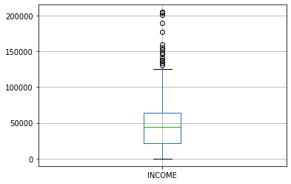

Looking at the box plot, it seems that the variables INCOME, have outlier present in the variables. These outliers value needs to be teated and there are several ways of treating them:

 Drop the outlier value

 Replace the outlier value using the IQR

In [44]:

*# creating a user defined function called remove_outlier for getting the threshold*

**def** remove_outlier(col): sorted(col)

Q1, Q3 **=** col**.**quantile([0.25, 0.75])

IQR **=** Q3**-**Q1

lower_range **=** Q1**-**(1.5 **\*** IQR) upper_range **=** Q3**+**(1.5 **\*** IQR)

**return** lower_range, upper_range

In [45]:

lower_income, upper_income **=** remove_outlier(df_car['INCOME'])

df_car['INCOME'] **=** np**.**where(df_car['INCOME'] **>** upper_income, upper_income, df_car[ df_car['INCOME'] **=** np**.**where(df_car['INCOME'] **<** lower_income, lower_income, df_car[

After removing outlier, let us check it with boxplot

In [46]:

df_car**.**boxplot(column**=**['INCOME']) plt**.**show()

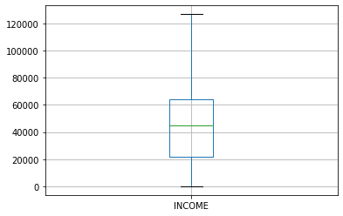

#### Bivariate Analysis

When we talk about bivariate analysis, it means **analyzing 2 variables**. Since we know there are numerical and categorical variables, there is a way of analyzing these variables as shown below:

#### Numerical vs. Numerical

1. Scatterplot
2. Line plot
3. Heatmap for correlation
4. Joint plot

#### Categorical vs. Numerical

1. Bar chart
2. Violin plot
3. Categorical box plot 4.Swarm plot Two Categorical Variables
4. Bar chart
5. Grouped bar chart
6. Point plot

In [47]:

*# if we need to find the correlation*

df_car**.**corr()

Out[47]:

In [48]:

|  |  |  |  |  |  |  |
| --- | --- | --- | --- | --- | --- | --- |
|  | **INDEX** | **INCOME** | **TRAVEL**  **TIME** | **MILES CLOCKED** | **CAR AGE** | **POSTAL CODE** |
| **INDEX** | 1.000000 | -0.044968 | 0.016710 | 0.042880 | -0.027206 | -0.244783 |
| **INCOME** | -0.044968 | 1.000000 | 0.062594 | 0.342164 | 0.267087 | 0.034204 |
| **TRAVEL TIME** | 0.016710 | 0.062594 | 1.000000 | 0.026915 | 0.140511 | 0.021390 |
| **MILES CLOCKED** | 0.042880 | 0.342164 | 0.026915 | 1.000000 | 0.127137 | -0.111283 |
| **CAR AGE** | -0.027206 | 0.267087 | 0.140511 | 0.127137 | 1.000000 | -0.099449 |
| **POSTAL CODE** | -0.244783 | 0.034204 | 0.021390 | -0.111283 | -0.099449 | 1.000000 |

#### Normalizing and Scaling

Often the variables of the data set **are of different scales i.e. one variable is in millions and others in only 100.**

For e.g. in our data set Income is having values in thousands and age in just two digits. Since the data in these variables are of different scales, it is tough to compare these variables.

Feature scaling (also known as data normalization) is the method used to standardize the range of features of data.

Since the range of values of data may vary widely, it becomes a necessary step in data preprocessing while using machine learning algorithms.

In this method, we convert variables with different scales of measurements into a single scale.

StandardScaler normalizes the data using the formula (x-mean)/standard deviation. So we will be doing this only for the numerical variables.

*# we use sklearn preprocessing using the function Standard Scaler*

**from** sklearn.preprocessing **import** StandardScaler std_scale **=** StandardScaler()

std_scale

Out[48]:

In [49]:

df_car['INCOME'] **=** std_scale**.**fit_transform(df_car[['INCOME']])

df_car['TRAVEL TIME'] **=** std_scale**.**fit_transform(df_car[['TRAVEL TIME']]) df_car['CAR AGE'] **=** std_scale**.**fit_transform(df_car[['CAR AGE']])

df_car['POSTAL CODE'] **=** std_scale**.**fit_transform(df_car[['POSTAL CODE']])

df_car['MILES CLOCKED'] **=** std_scale**.**fit_transform(df_car[['MILES CLOCKED']])

StandardScaler(copy=True, with_mean=True, with_std=True)

In [50]:

df_car**.**head()

Out[50]:

**INDEX INCOME MARITAL**

**STATUS**

**SEX EDUCATION JOB TRAVEL**

**TIME**

**USE MILES CA**

**CLOCKED TY**

**0** 1 2.330448 No F Bachelors Blue

Collar

0.807947 Commercial 0.534077 Spo

C

Collar Tru

|  |  |  |  |  |  |  |  |  |  |
| --- | --- | --- | --- | --- | --- | --- | --- | --- | --- |
| **1**  **2** | 2  3 | 0.120293  0.481177 | No  No | M  F | High School  Bachelors | Blue Collar  Clerical | -0.964473  -0.043492 | Private  Private | 0.750925 Miniv  -0.241513 SU |
| **3** | 4 | 0.900212 | No | F | High School | Lawyer | -1.329803 | Private | 0.659849 Spo C |
| **4** 5 2.377524 No M High School Blue -0.048799 Commercial 2.111280 Pan | | | | | | | | | |

#### ENCODING

One-Hot-Encoding is used to create dummy variables to replace the categories in a categorical variable into features of each category and represent it using 1 or 0 based on the presence or absence of the categorical value in the record.

This is required to do since the machine learning algorithms only work on the numerical data.

That is why there is a need to convert the categorical column into a numerical one.

**get_dummies is the method** that creates a dummy variable for each categorical variable.

In [54]:

dummies **=** pd**.**get_dummies(df_car[['MARITAL STATUS', 'SEX', 'EDUCATION', 'JOB', 'USE

columns **=** ['MARITAL STATUS', 'SEX', 'EDUCATION', 'JOB', '

prefix **=** ['married', 'sex', 'education', 'job', 'use', 'c

In [55]:

dummies**.**head()

Out[55]:

**married_Yes sex_M education_High**

**School**

**education_Masters education_PhD job_Clerical job_Docto**

**0** 0 0 0 0 0 0

**1** 0 1 1 0 0 0

**2** 0 0 0 0 0 1

**3** 0 0 1 0 0 0

**4** 0 1 1 0 0 0

In [59]:

columns **=** ["MARITAL STATUS", "SEX", "EDUCATION","JOB","USE", "CAR TYPE", "CITY"]

df_car **=** pd**.**concat([df_car, dummies], axis**=**1)

*# drop original column 'fuel type' from df*

df_car**.**drop(columns, axis**=** 1, inplace**=True** )

In [60]:

df_car**.**head()

Out[60]:

|  |  |  |  |  |  |  |  |  |  |
| --- | --- | --- | --- | --- | --- | --- | --- | --- | --- |
|  | **INDEX** | **INCOME** | **TRAVEL**  **TIME** | **MILES CLOCKED** | **CAR AGE** | **POSTAL CODE** | **married_Yes** | **sex_M** | **education_Hig**  **Scho** |
| **0** | 1 | 2.330448 | 0.807947 | 0.534077 | 0.137267 | -0.277291 | 0.0 | 0.0 | 0 |
| **1** | 2 | 0.120293 | -0.964473 | 0.750925 | -1.052842 | -0.277291 | 0.0 | 1.0 | 1 |
| **2** | 3 | 0.481177 | -0.043492 | -0.241513 | -1.052842 | -0.277291 | 0.0 | 0.0 | 0 |
| **3** | 4 | 0.900212 | -1.329803 | 0.659849 | 0.930674 | -0.277291 | 0.0 | 0.0 | 1 |
| **4** | 5 | 2.377524 | -0.048799 | 2.111280 | 0.732322 | -0.277291 | 0.0 | 1.0 | 1 |

5 rows × 90 columns

In [ ]:

## B.Time Series Analysis

Getting Google Trends data of keywords such as 'diet' and 'gym' and see how they vary over time while learning about trends and seasonality in time series data.

We will go through the code that we put together during the session step by step. You're not going to do much mathematics but you are going to do the following:

 Source your data

 Wrangle your data

 Exploratory Data Analysis

 Trends and seasonality in time series data *Identifying Trends*Seasonal patterns *First Order Differencing*Periodicity and Autocorrelation

In [1]:

*# Import packages*

**import** numpy **as** np

**import** pandas **as** pd

**import** matplotlib.pyplot **as** plt

**import** seaborn **as** sns

**%matplotlib** inline sns**.**set()

In [4]:

df **=** pd**.**read_csv('/content/multiTimeline.csv', skiprows**=**1) df**.**head()

|  |  |  |  |  |
| --- | --- | --- | --- | --- |
| Out[4]: | **Month** | **diet: (Worldwide)** | **gym: (Worldwide)** | **finance: (Worldwide)** |
|  | **0** 2004-01 | 100 | 31 | 48 |
|  | **1** 2004-02 | 75 | 26 | 49 |
|  | **2** 2004-03 | 67 | 24 | 47 |
|  | **3** 2004-04 | 70 | 22 | 48 |
|  | **4** 2004-05 | 72 | 22 | 43 |

In [5]:

df**.**info()

<class 'pandas.core.frame.DataFrame'> RangeIndex: 168 entries, 0 to 167

Data columns (total 4 columns):

# Column Non-Null Count Dtype

|  |  |  |  |  |
| --- | --- | --- | --- | --- |
| 0 Month | 168 | non-null |  | object |
| 1 diet: (Worldwide) | 168 | non-null |  | int64 |
| 2 gym: (Worldwide) | 168 | non-null |  | int64 |
| 3 finance: (Worldwide) | 168 | non-null |  | int64 |

dtypes: int64(3), object(1) memory usage: 5.4+ KB

Wrangle Your Data

The first thing that you want to do is rename the columns of your DataFrame df so that they have no whitespaces in them. There are multiple ways to do this, but for now, you'll reassign

to df.columns a list of what you want the columns to be called.

Double check the result of your reassignment by calling df.head():

In [6]:

df**.**columns **=** ['month', 'diet', 'gym', 'finance'] df**.**head()

|  |  |  |  |  |
| --- | --- | --- | --- | --- |
| Out[6]: | **month** | **diet** | **gym** | **finance** |
|  | **0** 2004-01 | 100 | 31 | 48 |
|  | **1** 2004-02 | 75 | 26 | 49 |
|  | **2** 2004-03 | 67 | 24 | 47 |
|  | **3** 2004-04 | 70 | 22 | 48 |
|  | **4** 2004-05 | 72 | 22 | 43 |

Next, you'll turn the **'month' column** into a DateTime data type and make it the index of the DataFrame.

Note that you do this because you saw in the result of the .**info()** method that the **'Month' column** was actually an of data type object. Now, that generic data type encapsulates

everything from strings to integers, etc. That's not exactly what you want when you want to

be looking at time series data. That's why you'll use **.to_datetime()** to convert the **'month' column** in your DataFrame to a DateTime.

Be careful! Make sure to include the inplace argument when you're setting the index of the DataFrame df so that you actually alter the original index and set it to the 'month' column.

In [7]:

df**.**month **=** pd**.**to_datetime(df**.**month) df**.**set_index('month', inplace**=True**)

|  |  |  |  |  |  |
| --- | --- | --- | --- | --- | --- |
| In [8]: | df**.**head() |  | | | |
| Out[8]: | **month** | **diet** | **gym** | **finance** |  |
|  | **2004-01-01** | 100 | 31 | 48 |  |
|  | **2004-02-01** | 75 | 26 | 49 |  |
|  | **2004-03-01** | 67 | 24 | 47 |  |
|  | **2004-04-01** | 70 | 22 | 48 |  |
|  | **2004-05-01** | 72 | 22 | 43 |  |

#### A bit of Exploratory Data Analysis (EDA)

You can use a built-in pandas visualization method .plot() to plot your data as 3 line plots on a single figure (one for each column, namely, **'diet', 'gym', and 'finance'**).

Note that you can also specify some arguments to this method, such as **figsize, linewidthand fontsize** to set the figure size, line width and font size of the plot, respectively.

Additionally, you'll see that what you see on the x-axis is not the months, as the default label suggests, but the years. To make your plot a bit more accurate, you'll specify the label on the x-axis to 'Year' and also set the font size to 20.

In [9]:

df**.**plot(figsize**=**(20,10), linewidth**=**5, fontsize**=**20) plt**.**xlabel('Year', fontsize**=**20);

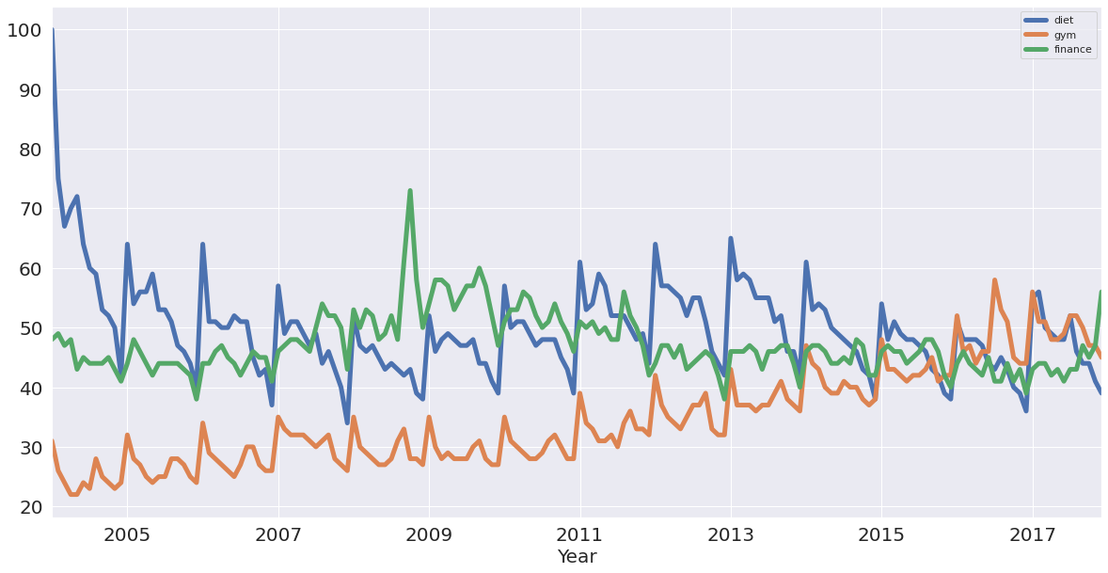

Numbers represent search interest relative to the highest point on the chart for the given

region and time. A value of 100 is the peak popularity for the term. A value of 50 means that the term is half as popular. Likewise a score of 0 means the term was less than 1% as popular as the peak.

#### If you want, you can also plot the 'diet' column by itself as a time series:

In [10]:

df[['diet']]**.**plot(figsize**=**(20,10), linewidth**=**5, fontsize**=**20) plt**.**xlabel('Year', fontsize**=**20);

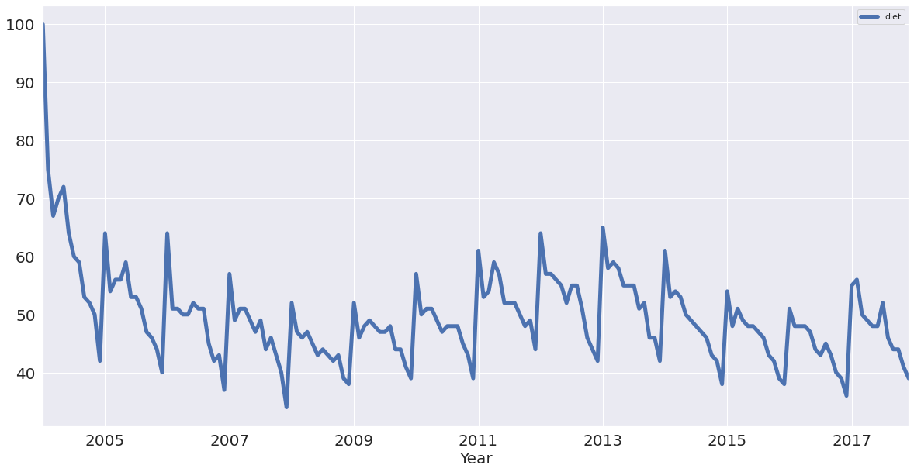

Note: the first thing to notice is that there is seasonality: each January, there's a big jump. Also, there seems to be a trend: it seems to go slightly up, then down, back up and then

back down. In other words, it looks like there are trends and seasonal components to these time series.

With this in mind, you'll learn how to identify trends in your time series!

#### Identifying Trends in Time Series

There are several ways to think about identifying trends in time series. One popular way is by taking a rolling average, which means that, for each time point, you take the average of the points on either side of it. Note that the number of points is specified by a window size,

which you need to choose.

What happens then because you take the average is it tends to smooth out noise and

seasonality. You'll see an example of that right now. Check out this rolling average of 'diet' using the built-in pandas methods.

When it comes to determining the window size, here, it makes sense to first try out one of twelve months, as you're talking about yearly seasonality.

In [11]:

diet **=** df[['diet']]

diet**.**rolling(12)**.**mean()**.**plot(figsize**=**(20,10), linewidth**=**5, fontsize**=**20) plt**.**xlabel('Year', fontsize**=**20);

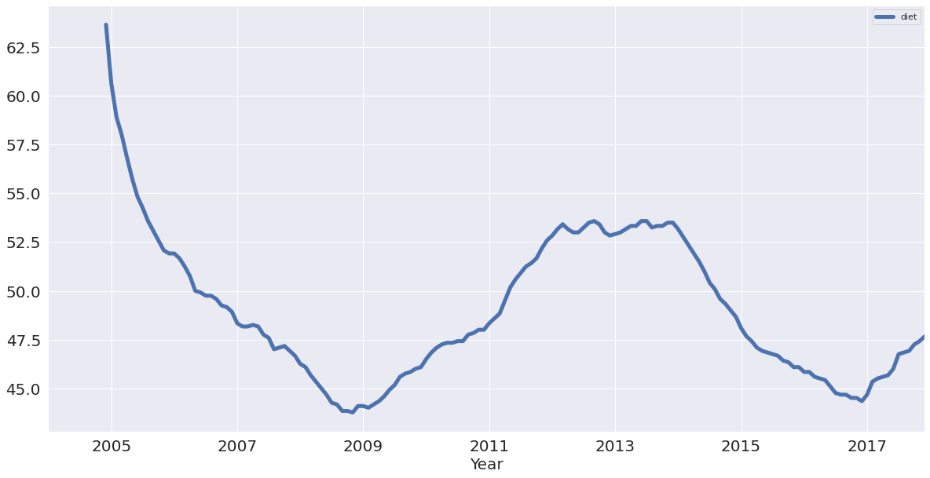

Note that in the code chunk above you used two sets of squared brackets to extract the 'diet' column as a DataFrame;

If you would have used one set, like df['diet'], you would have created a pandas Series.

In the code chunk above, you also chained methods: you called methods on an object one after another. Method chaining is pretty popular and pandas is one of the packages that

really allows you to use that style of programming to the max!

Now you have the trend that you're looking for! You have removed most of the seasonality compared to the previous plot.

You can also plot the rolling average of 'gym' using built-in pandas methods with the same window size as you took for the 'diet' data:

In [12]:

gym **=** df[['gym']]

gym**.**rolling(12)**.**mean()**.**plot(figsize**=**(20,10), linewidth**=**5, fontsize**=**20) plt**.**xlabel('Year', fontsize**=**20);

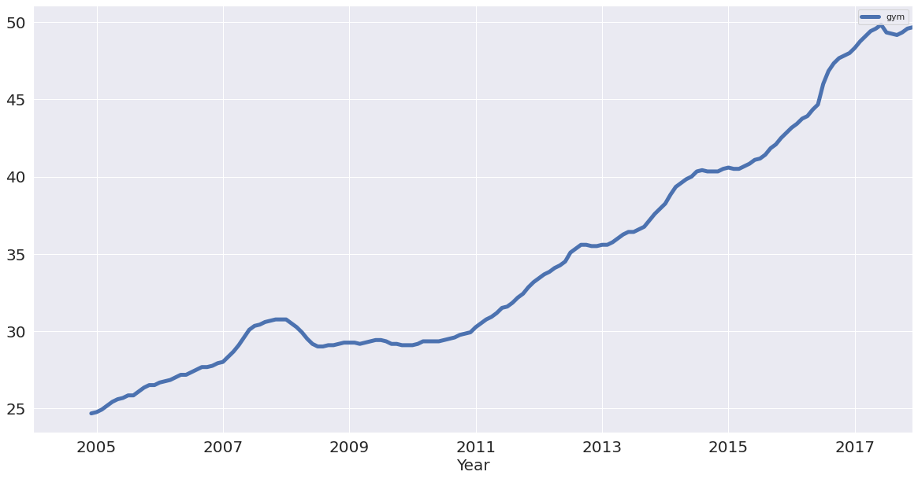

You have successfully removed the seasonality and you see an upward trend for "gym"! But how do these two search terms compare?

You can figure this out by plotting the trends of 'gym' and 'diet' on a single figure:

In [13]:

df_rm **=** pd**.**concat([diet**.**rolling(12)**.**mean(), gym**.**rolling(12)**.**mean()], axis**=**1) df_rm**.**plot(figsize**=**(20,10), linewidth**=**5, fontsize**=**20)

plt**.**xlabel('Year', fontsize**=**20);

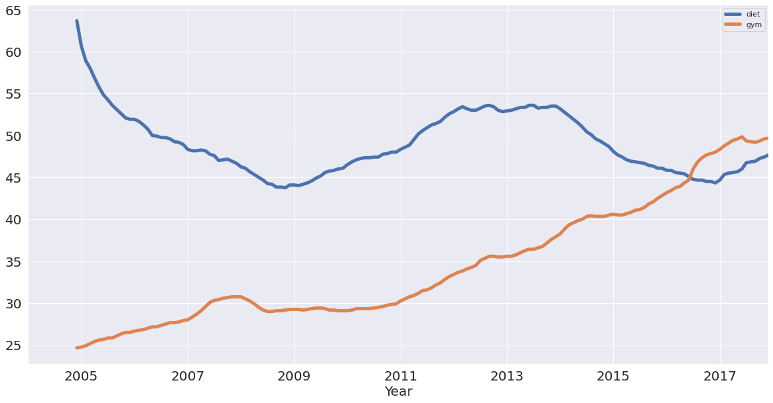

You created a new DataFrame df_rm that has two columns with the rolling average of 'diet' and 'gym'. You used the pd.concat() function, which takes a list of the columns as a first

argument and, since you want to concatenate them as columns, you also added the axis

argument, which you set to 1.

Next, you plotted the DataFrame with the plot() method, just like you did before! So now, removing the seasonality, you see that diet potentially has some form of seasonality,

whereas gym is actually increasing!

With the trends in the data identified, it's time to think about seasonality, which is the

repetitive nature of your time series. As you saw in the beginning of this tutorial, it looked like there were trends and seasonal components to the time series of the data.

#### Seasonal Patterns in Time Series Data

One way to think about the seasonal components to the time series of your data is to

remove the trend from a time series, so that you can more easily investigate seasonality. To remove the trend, you can subtract the trend you computed above (rolling mean) from the original signal. This, however, will be dependent on how many data points you averaged

over.

Another way to remove the trend is called "differencing", where you look at the difference between successive data points (called "first-order differencing", because you're only

looking at the difference between one data point and the one before it).

#### First-order differencing

You can use pandas and the diff() and plot() methods to compute and plot the first order difference of the 'diet' Series:

In [14]:

diet**.**diff()**.**plot(figsize**=**(20,10), linewidth**=**5, fontsize**=**20) plt**.**xlabel('Year', fontsize**=**20);

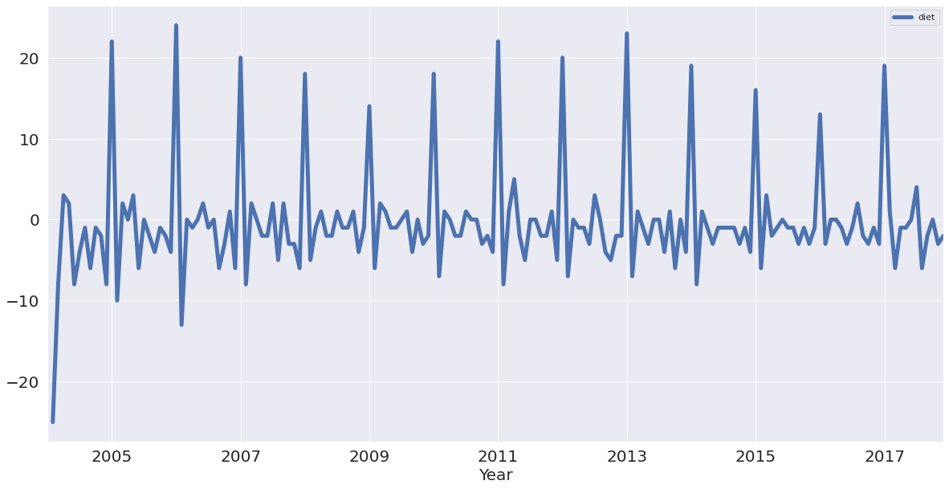

See that you have removed much of the trend and you can really see the peaks in January every year. Each January, there is a huge spike of 20 or more percent on the highest search item you've seen!

#### Periodicity and Autocorrelation

A time series is periodic if it repeats itself at equally spaced intervals, say, every 12 months.

Another way to think of this is that if the time series has a peak somewhere, then it will have a peak 12 months after that and, if it has a trough somewhere, it will also have a trough 12 months after that.

Yet another way of thinking about this is that the time series is correlated with itself shifted by 12 months. That means that, if you took the time series and moved it 12 months

backwards or forwards, it would map onto itself in some way.

To start off, plot all your time series again to remind yourself of what they look like:

In [15]:

df**.**plot(figsize**=**(20,10), linewidth**=**5, fontsize**=**20) plt**.**xlabel('Year', fontsize**=**20);



In [16]:

df**.**corr()

|  |  |  |  |  |
| --- | --- | --- | --- | --- |
| Out[16]: |  | **diet** | **gym** | **finance** |
|  | **diet** | 1.000000 | -0.100764 | -0.034639 |
|  | **gym** | -0.100764 | 1.000000 | -0.284279 |
|  | **finance** | -0.034639 | -0.284279 | 1.000000 |

#### Now, what does this above tell you?

Let's focus on 'diet' and 'gym'; They are negatively correlated.

That's very interesting! Remember that you have a seasonal and a trend component. From the correlation coefficient, 'diet' and 'gym' are negatively correlated.

However, from looking at the times series, it looks as though their seasonal components

would be positively correlated and their trends negatively correlated. The actual correlation coefficient is actually capturing both of those.

What you want to do now is plot the first-order differences of these time series and then compute the correlation of those because that will be the correlation of the seasonal

components, approximately.

Remember that removing the trend may reveal correlation in seasonality.

Start off by plotting the first-order differences with the help of .diff() and .plot():

In [17]:

df**.**diff()**.**plot(figsize**=**(20,10), linewidth**=**5, fontsize**=**20) plt**.**xlabel('Year', fontsize**=**20);

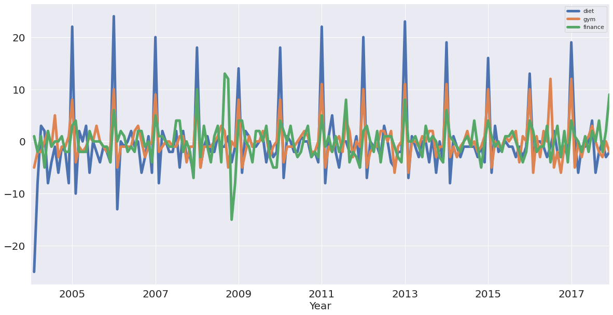

You see that 'diet' and 'gym' are incredibly correlated once you remove the trend. Now, you'll compute the correlation coefficients of the first-order differences of these time series:

In [18]:

df**.**diff()**.**corr()

|  |  |  |  |  |
| --- | --- | --- | --- | --- |
| Out[18]: |  | **diet** | **gym** | **finance** |
|  | **diet** | 1.000000 | 0.758707 | 0.373828 |
|  | **gym** | 0.758707 | 1.000000 | 0.301111 |
|  | **finance** | 0.373828 | 0.301111 | 1.000000 |

Note that once again, there was a slight negative correlation when you were thinking about the trend and the seasonal component. Now, you can see that with the seasonal component, 'diet' and 'gym' are highly correlated, with a coefficient of 0.76.

#### Autocorrelation

Now you've taken a dive into correlation of variables and correlation of time series, it's time to plot the autocorrelation of the 'diet' series: on the x-axis, you have the lag and on the y- axis, you have how correlated the time series is with itself at that lag.

#### So, this means that if the original time series repeats itself every two days, you would expect to see a spike in the autocorrelation function at 2 days.

**Here, you'll look at the plot and what you should expect to see here is a spike in the autocorrelation function at 12 months: the time series is correlated with itself shifted by twelve months.**

Use the plotting interface of pandas, which has the autocorrelation_plot() function. You can use this function to plot the time series 'diet':

In [19]:

pd**.**plotting**.**autocorrelation_plot(diet);

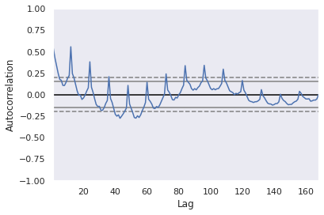

If you included more lags in your axes, you'd see that it is 12 months at which you have this huge peak in correlation.

You have another peak at a 24 month interval, where it's also correlated with itself.

You have another peak at 36, but as you move further away, there's less and less of a correlation.

Of course, you have a correlation of itself with itself at a lag of 0.

The dotted lines in the above plot actually tell you about the statistical significance of the correlation.

In this case, you can say that the 'diet' series is genuinely autocorrelated with a lag of twelve months.

You have identified the seasonality of this 12 month repetition!

In [ ]:

# Practical 9

## Aim: Assuming a set of documents that need to be classified, use the naïve Bayesian Classifier model to perform this task.

Code

In [10]:

**import** pandas **as** pd

**from** sklearn.model_selection **import** train_test_split

**from** sklearn.feature_extraction.text **import** CountVectorizer

**from** sklearn.naive_bayes **import** MultinomialNB

**from** sklearn **import** metrics

In [11]:

msg**=**pd**.**read_csv('naivetext.csv',names**=**['message','label'])

In [12]:

print('The dimensions of the dataset',msg**.**shape)

The dimensions of the dataset (18, 2)

In [13]:

msg['labelnum']**=**msg**.**label**.**map({'pos':1,'neg':0})

X**=**msg**.**message y**=**msg**.**labelnum

In [14]:

*#splitting the dataset into train and test data*

xtrain,xtest,ytrain,ytest**=**train_test_split(X,y)

print ('\n the total number of Training Data :',ytrain**.**shape) print ('\n the total number of Test Data :',ytest**.**shape)

the total number of Training Data : (13,) the total number of Test Data : (5,)

In [15]:

*#output the words or Tokens in the text documents*

cv **=** CountVectorizer()

xtrain_dtm **=** cv**.**fit_transform(xtrain) xtest_dtm**=**cv**.**transform(xtest)

print('\n The words or Tokens in the text documents \n')

print(cv**.**get_feature_names())

df**=**pd**.**DataFrame(xtrain_dtm**.**toarray(),columns**=**cv**.**get_feature_names())

The words or Tokens in the text documents

['about', 'am', 'amazing', 'an', 'and', 'awesome', 'bad', 'beers', 'boss', 'can',

'deal', 'enemy', 'feel', 'good', 'great', 'he', 'holiday', 'horrible', 'house', 'i

s', 'locality', 'love', 'my', 'of', 'place', 'sandwich', 'sick', 'stay', 'stuff',

'sworn', 'that', 'these', 'this', 'tired', 'to', 'today', 'very', 'view', 'went', 'what', 'with']

/usr/local/lib/python3.8/dist-packages/sklearn/utils/deprecation.py:87: FutureWarn ing: Function get_feature_names is deprecated; get_feature_names is deprecated in

1.0 and will be removed in 1.2. Please use get_feature_names_out instead. warnings.warn(msg, category=FutureWarning)

In [16]:

*# Training Naive Bayes (NB) classifier on training data.*

clf **=** MultinomialNB()**.**fit(xtrain_dtm,ytrain) predicted **=** clf**.**predict(xtest_dtm)

In [17]:

*#printing accuracy, Confusion matrix, Precision and Recall*

print('\n Accuracy of the classifier is',metrics**.**accuracy_score(ytest,predicted)) print('\n Confusion matrix')

print(metrics**.**confusion_matrix(ytest,predicted))

print('\n The value of Precision', metrics**.**precision_score(ytest,predicted)) print('\n The value of Recall', metrics**.**recall_score(ytest,predicted))

Accuracy of the classifier is 0.6 Confusion matrix

[[2 0]

[2 1]]

The value of Precision 1.0

The value of Recall 0.3333333333333333

In [17]:

# Practical 10

## Aim: Perform Text pre-processing, Text clustering, classification with Prediction, Test Score and Confusion Matrix

In [7]:

**import** nltk

nltk**.**download('wordnet') nltk**.**download('omw-1.4')

[nltk_data] Downloading package wordnet to /root/nltk_data... [nltk_data] Package wordnet is already up-to-date!

[nltk_data] Downloading package omw-1.4 to /root/nltk_data...

Out[7]:

In [1]:

**import** numpy **as** np

**import** re

**import** nltk

**from** sklearn.datasets **import** load_files nltk**.**download('stopwords')

**import** pickle

**from** nltk.corpus **import** stopwords

True

[nltk_data] Downloading package stopwords to /root/nltk_data... [nltk_data] Unzipping corpora/stopwords.zip.

In [2]:

movie_data **=** load_files(r"/content/sample_data/txt_sentoken") X, y **=** movie_data**.**data, movie_data**.**target

In [8]:

documents **=** []

**from** nltk.stem **import** WordNetLemmatizer stemmer **=** WordNetLemmatizer()

**for** sen **in** range(0, len(X)):

*# Remove all the special characters*

document **=** re**.**sub(r'\W', ' ', str(X[sen]))

*# remove all single characters*

document **=** re**.**sub(r'\s+[a-zA-Z]\s+', ' ', document)

*# Remove single characters from the start*

document **=** re**.**sub(r'\^[a-zA-Z]\s+', ' ', document)

*# Substituting multiple spaces with single space*

document **=** re**.**sub(r'\s+', ' ', document, flags**=**re**.**I)

*# Removing prefixed 'b'*

document **=** re**.**sub(r'^b\s+', '', document)

*# Converting to Lowercase*

document **=** document**.**lower()

*# Lemmatization*

document **=** document**.**split()

document **=** [stemmer**.**lemmatize(word) **for** word **in** document] document **=** ' '**.**join(document)

documents**.**append(document)

In [9]:

**from** sklearn.feature_extraction.text **import** CountVectorizer

vectorizer **=** CountVectorizer(max_features**=**1500, min_df**=**5, max_df**=**0.7, stop_words**=**s

X **=** vectorizer**.**fit_transform(documents)**.**toarray()

In [12]:

**from** sklearn.feature_extraction.text **import** TfidfTransformer tfidfconverter **=** TfidfTransformer()

X **=** tfidfconverter**.**fit_transform(X)**.**toarray()

In [13]:

**from** sklearn.feature_extraction.text **import** TfidfVectorizer

tfidfconverter **=** TfidfVectorizer(max_features**=**1500, min_df**=**5, max_df**=**0.7, stop_wor

X **=** tfidfconverter**.**fit_transform(documents)**.**toarray()

In [14]:

**from** sklearn.model_selection **import** train_test_split

X_train, X_test, y_train, y_test **=** train_test_split(X, y, test_size**=**0.2, random_st

In [16]:

**from** sklearn.ensemble **import** RandomForestClassifier

classifier **=** RandomForestClassifier(n_estimators**=**1000, random_state**=**0) classifier**.**fit(X_train, y_train)

Out[16]:

In [17]:

y_pred **=** classifier**.**predict(X_test)

RandomForestClassifier(n_estimators=1000, random_state=0)

In [18]:

**from** sklearn.metrics **import** classification_report, confusion_matrix, accuracy_score

print(confusion_matrix(y_test,y_pred))

print(classification_report(y_test,y_pred)) print(accuracy_score(y_test, y_pred))

[[197 0]

[ 76 9]]

|  |  |  |  |  |
| --- | --- | --- | --- | --- |
|  | precision | recall | f1-score | support |
| 1 | 0.72 | 1.00 | 0.84 | 197 |
| 2 | 1.00 | 0.11 | 0.19 | 85 |
| accuracy |  |  | 0.73 | 282 |
| macro avg | 0.86 | 0.55 | 0.51 | 282 |
| weighted avg | 0.81 | 0.73 | 0.64 | 282 |

0.7304964539007093

In [ ]: